**Assignment: Final Project**

**Project: Tourism Management System**

**Group: Final Project 96**

**Snehitha Sai Sappa - 1229965310**

**Hitesh Koneru - 12229943847**

IFT 530: Advanced Data Base Management Systems

Professor: Dr. Ashish Gulati

Due Date: April 26 ,2024

**Project Title: Tourism Management System**



/*

Group_Name: Final Project 96

Names: Snehitha Sai Sappa, Hitesh Koneru

Class: IFT 530

Date :04/24/2024

Assignment: Final Project

*/

DROP SCHEMA IF EXISTS Tourism_Management_System;

CREATE SCHEMA Tourism_Management_System;

CREATE TABLE Tourist (

TouristID INT AUTO_INCREMENT PRIMARY KEY,

Fname VARCHAR(10) NOT NULL,

Lname VARCHAR(10) NOT NULL,

Email VARCHAR(20) NOT NULL,

Phone NUMERIC(10) NOT NULL,

IsActive BOOLEAN DEFAULT TRUE,

Gender CHAR(1) CHECK (Gender IN ('M', 'F', 'O')),

Age INT

);

CREATE TABLE BOOKING (

BID INT PRIMARY KEY AUTO_INCREMENT,

TouristID INT NOT NULL,

Booking_Date TIMESTAMP DEFAULT CURRENT_TIMESTAMP,

TripStart_Date DATE NOT NULL,

TripEnd_Date DATE NOT NULL,

Amount FLOAT,

FOREIGN KEY (TouristID) REFERENCES Tourist(TouristID) ON DELETE CASCADE

);

CREATE TABLE PACKAGE (

PACKAGEID INT PRIMARY KEY AUTO_INCREMENT,

TITLE VARCHAR(15) NOT NULL,

DURATION INT,

NO_OF_PEOPLE INT,

IsActive BOOLEAN DEFAULT TRUE,

AMOUNT FLOAT

);

CREATE TABLE TOURIST_SPOTS (

SPOTID INT PRIMARY KEY AUTO_INCREMENT,

Name VARCHAR(20) NOT NULL,

SEASON VARCHAR(10),

RATINGS FLOAT CHECK (RATINGS >= 0 AND RATINGS <= 5),

ADDRESS VARCHAR(100),

PINCODE NUMERIC(6)

);

CREATE TABLE GUIDE (

GUIDEID INT PRIMARY KEY AUTO_INCREMENT,

Fname VARCHAR(10) NOT NULL,

Lname VARCHAR(10) NOT NULL,

Email VARCHAR(20),

Phone NUMERIC(10) NOT NULL,

Gender CHAR(1) CHECK (Gender IN ('M', 'F', 'O')),

Age INT,

ADDRESS VARCHAR(100),

PINCODE NUMERIC(6)

);

CREATE TABLE RESTAURANT (

RID INT PRIMARY KEY AUTO_INCREMENT,

Name VARCHAR(50) NOT NULL,

Phone NUMERIC(10),

FoodType VARCHAR(20) CHECK (FoodType IN ('VEG', 'NON-VEG', 'BOTH')),

Ratings FLOAT CHECK (Ratings >= 0 AND Ratings <= 5),

Address VARCHAR(100),

Pincode NUMERIC(6)

);

CREATE TABLE HOTEL (

HOTELID INT PRIMARY KEY AUTO_INCREMENT,

Name VARCHAR(50) NOT NULL,

City VARCHAR(50) NOT NULL,

PHONE NUMERIC(10),

FOODTYPE VARCHAR(20) CHECK (FOODTYPE IN ('VEG', 'NON-VEG', 'BOTH')),

RATINGS FLOAT CHECK (RATINGS >= 0 AND RATINGS <= 5),

ADDRESS VARCHAR(100),

IsActive BOOLEAN DEFAULT TRUE,

PINCODE NUMERIC(6)

);

CREATE TABLE ROOM (

HOTELID INT NOT NULL,

ROOM_NO DECIMAL(3, 0) NOT NULL,

Type VARCHAR(6) CHECK (Type IN ('AC', 'NON-AC', 'HEATER')),

BEDS INT CHECK (BEDS > 0),

CAPACITY INT CHECK (CAPACITY > 0),

RATE FLOAT,

STATUS VARCHAR(15) CHECK (STATUS IN ('AVAILABLE', 'NOT-AVAILABLE', 'BOOKED')),

PRIMARY KEY (HOTELID, ROOM_NO),

FOREIGN KEY (HOTELID) REFERENCES HOTEL(HOTELID)

);

CREATE TABLE PACKAGE_INCLUDES_SPOTS (

PACKAGEID INT,

SPOTID INT,

PRIMARY KEY (PACKAGEID, SPOTID),

FOREIGN KEY (PACKAGEID) REFERENCES PACKAGE(PACKAGEID) ON DELETE CASCADE,

FOREIGN KEY (SPOTID) REFERENCES TOURIST_SPOTS(SPOTID) ON DELETE CASCADE

);

CREATE TABLE PACKAGE_INCLUDES_GUIDES (

PACKAGEID INT,

GUIDEID INT,

PRIMARY KEY (PACKAGEID, GUIDEID),

FOREIGN KEY (PACKAGEID) REFERENCES PACKAGE(PACKAGEID) ON DELETE CASCADE,

FOREIGN KEY (GUIDEID) REFERENCES GUIDE(GUIDEID) ON DELETE CASCADE

);

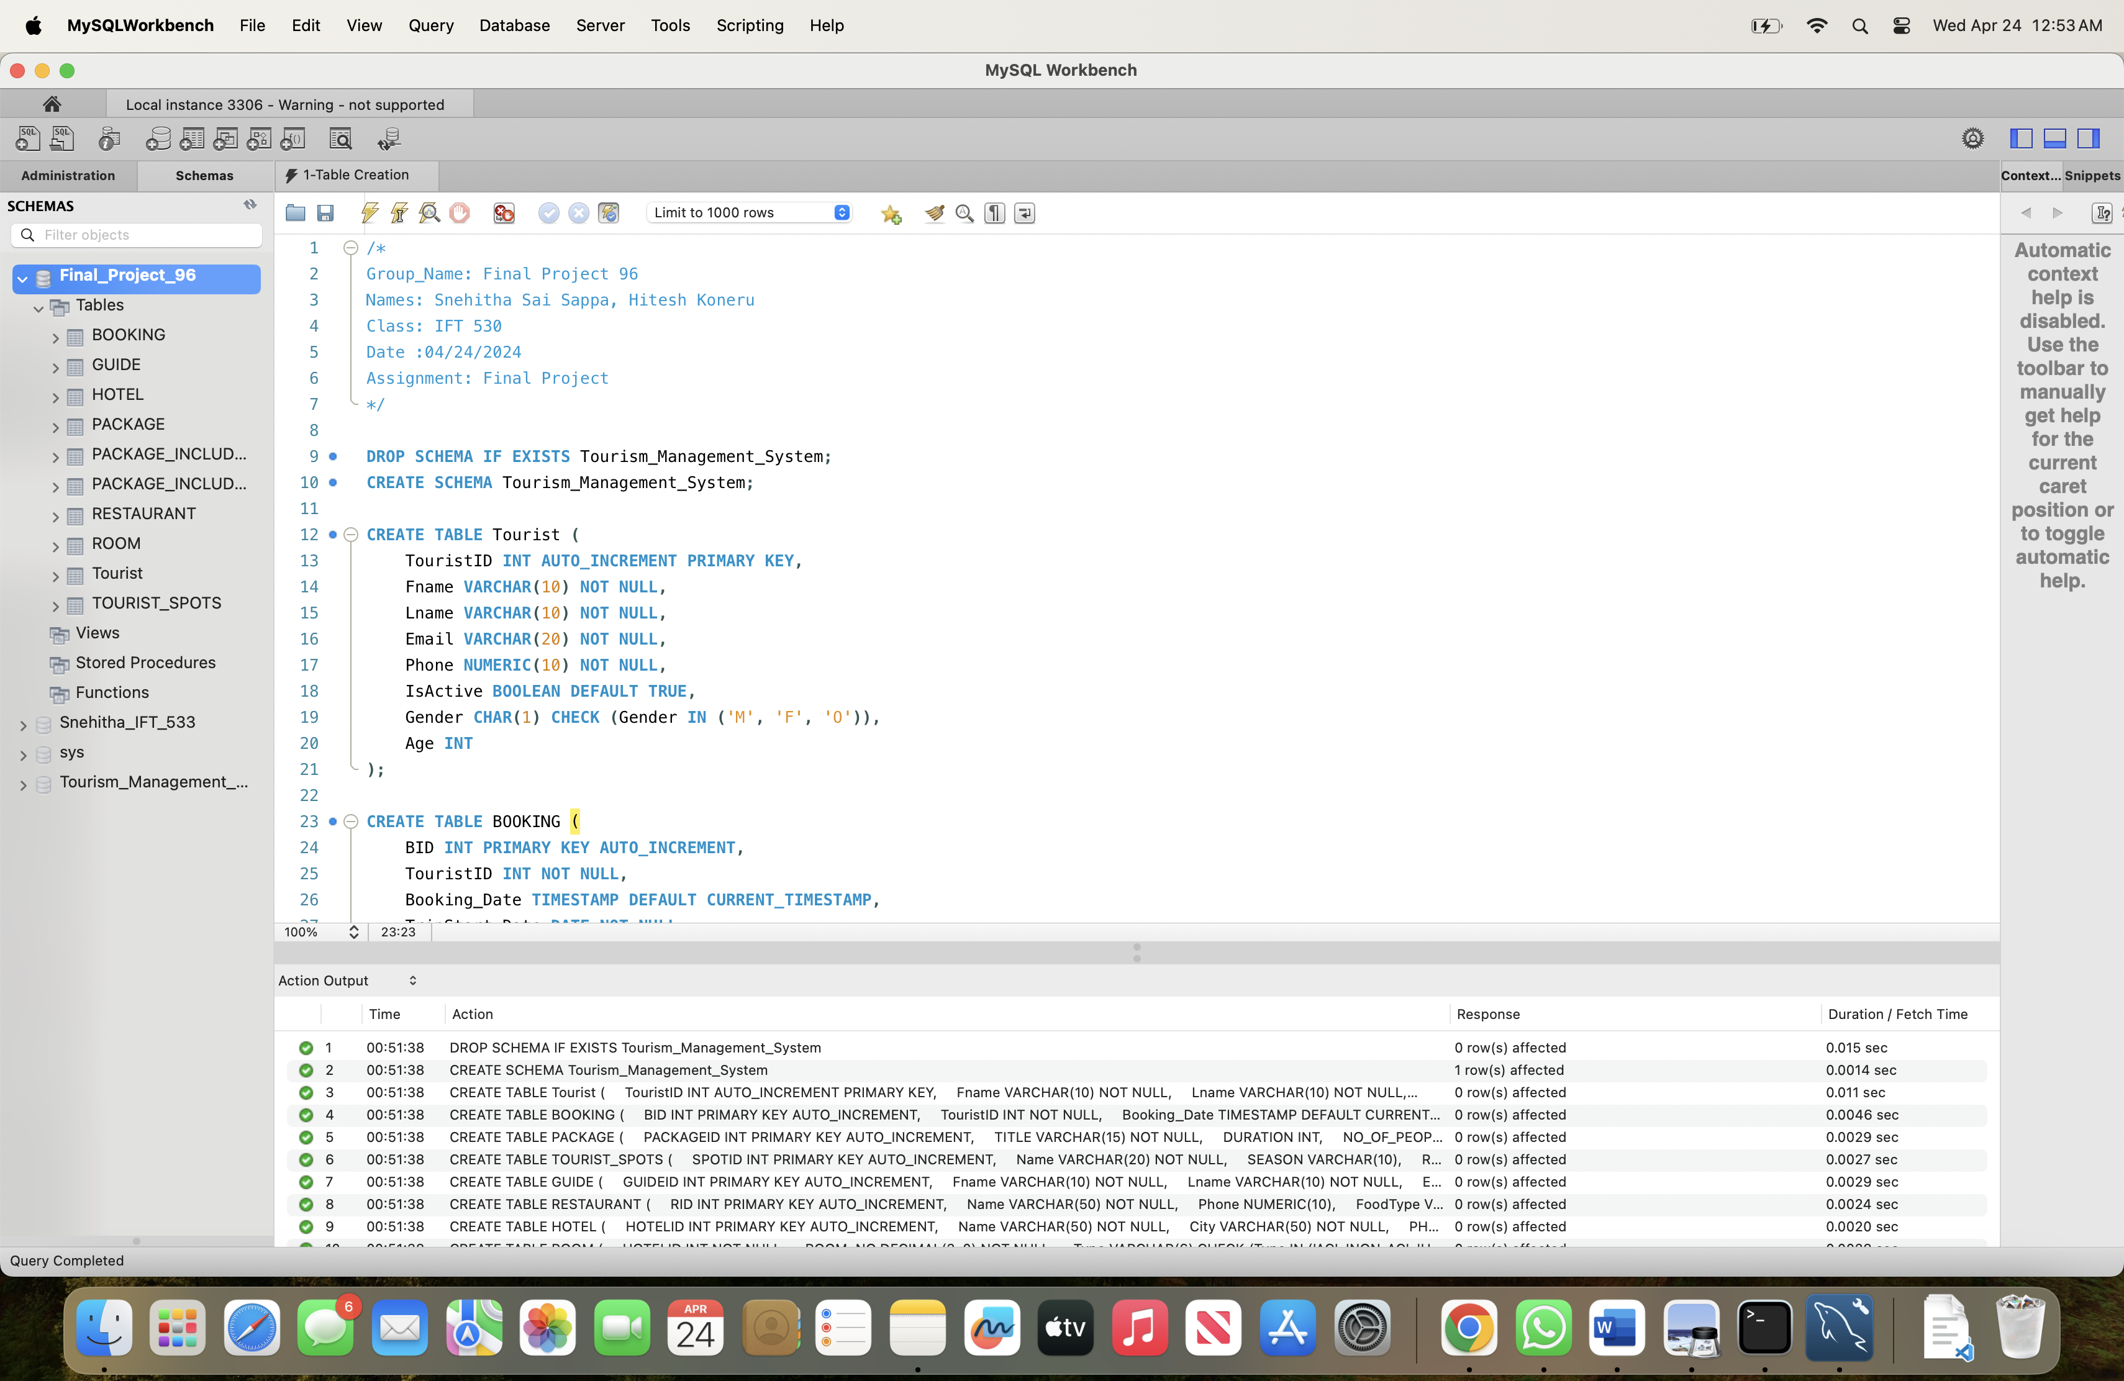

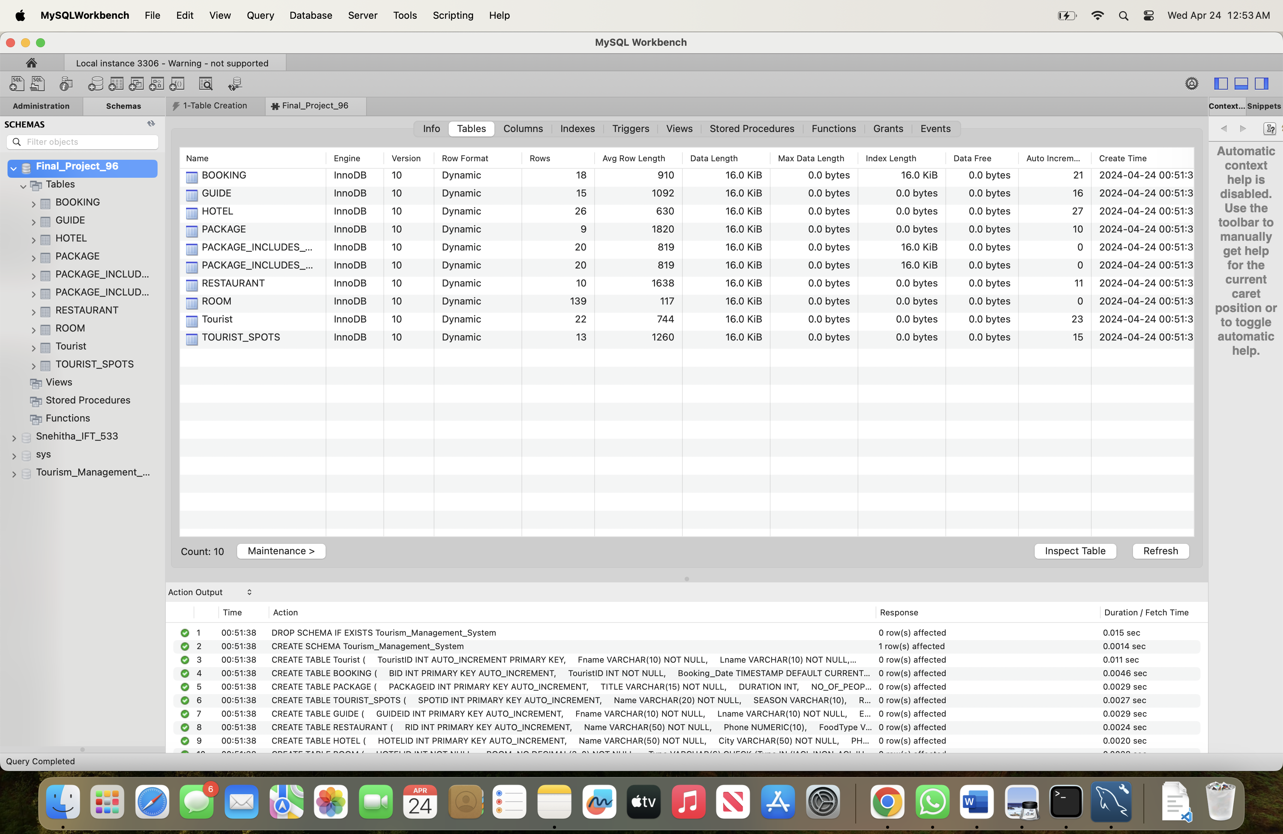



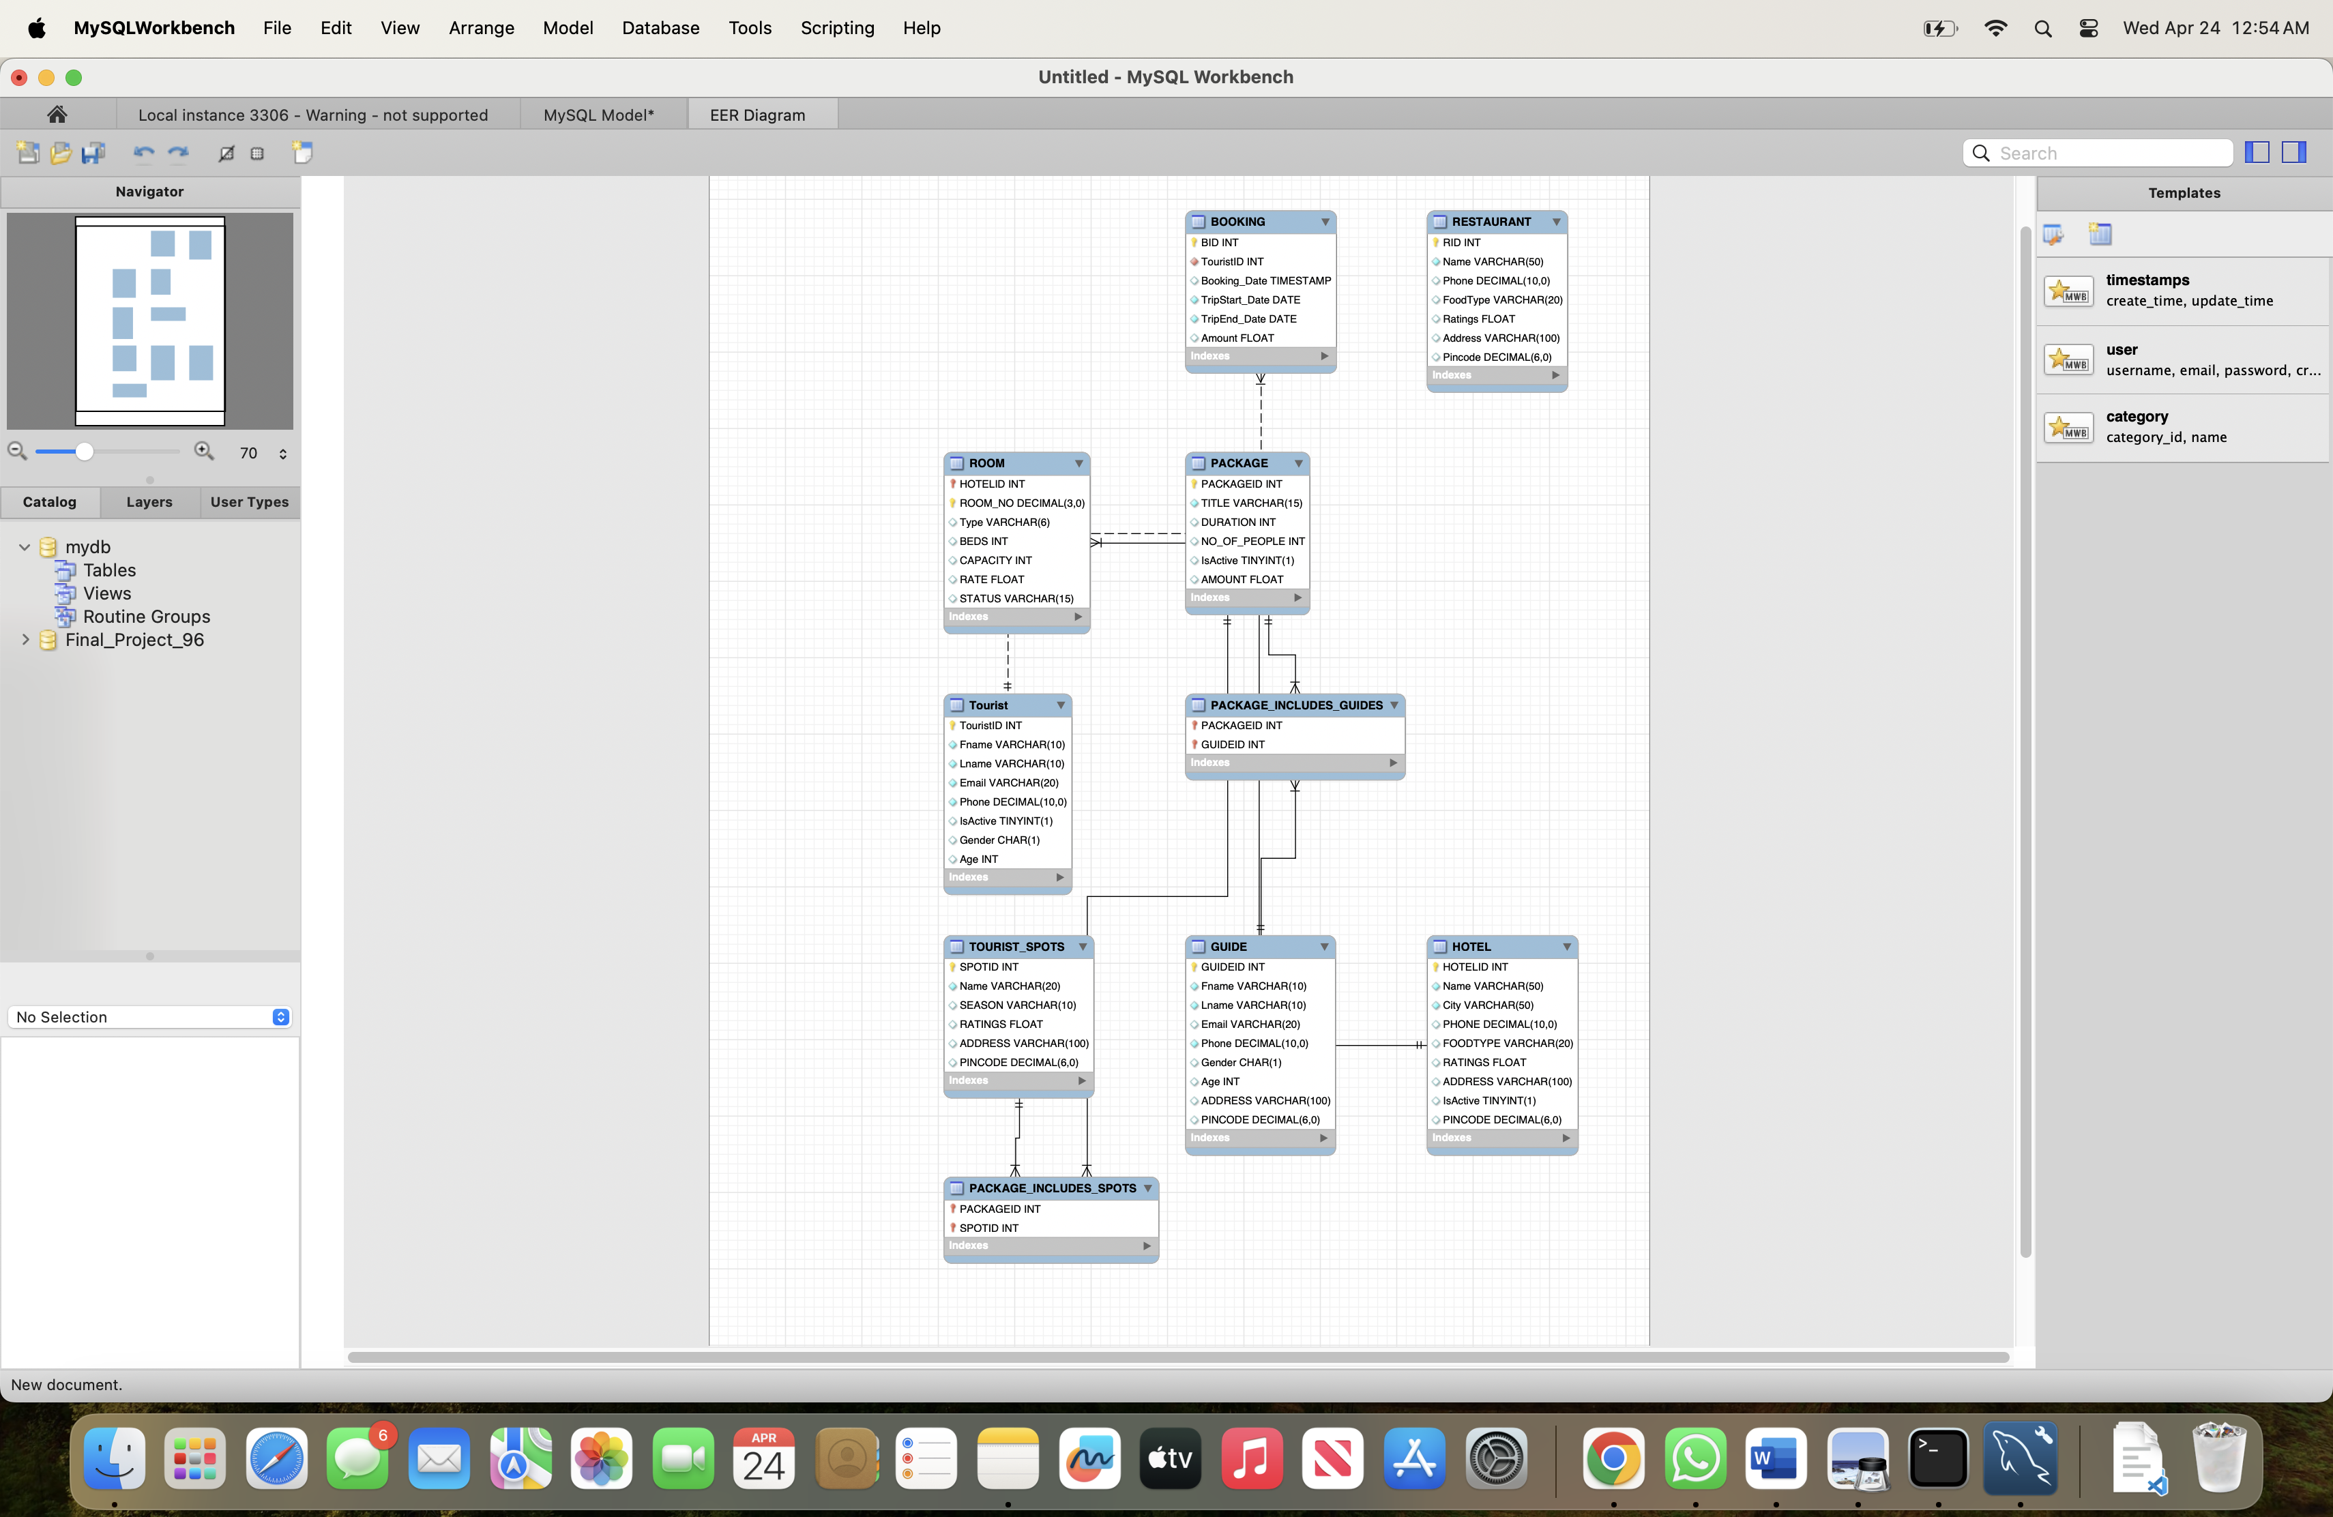



/*

Group_Name: Final Project 96

Names: Snehitha Sai Sappa, Hitesh Koneru

Class: IFT 530

Date :04/24/2024

Assignment: Final Project

*/

-- RESTAURANT

INSERT INTO RESTAURANT (Name, Phone, FoodType, Ratings, Address, Pincode)

VALUES

('Jahanpanah', 9898456721, 'VEG', 4.5, 'E 23, Shopping Arcade, Sadar Bazaar, Agra Cantt', 282001),

('Huber & Holly', 9889855455, 'VEG', 2.5, 'Shreekunj Mandapam, Beside Golden Tulip Bunglows & Tulip Citadel, Manekbaug, Ambavadi', 380027),

('Cryo Lab', 9876543210, 'VEG', 3, 'Ground Floor, Arjun Avenue, Opposite Samartheshwar Mahadev, Law Garden', 380027),

('Subway', 6826589432, 'VEG', 4.5, '207/53, Mahatma Gandhi Marg, Civil Lines', 212111),

('Tandoor Restaurant', 7954215885, 'NON-VEG', 4, '17/33, Mahatma Gandhi Marg, Civil Lines', 212111),

('Three Dots & A Dash', 7878252364, 'NON-VEG', 3.5, '840/1,100 Feet Road, Metro Pillar 56-57, Indiranagar', 560004),

('ECHOES Koramangala', 9465853246, 'BOTH', 3, '44, 4th B Cross, Koramangala 5th Block', 560004),

('The American Joint', 7985556233, 'NON-VEG', 2.5, 'The Ahcl Homes Tower, Chikuwadi New Link Road, Borivali West', 400012),

('Open Hand Cafe', 9898569825, 'VEG', 3, 'B1/128-3, Dumraun Bagh Colony, Assi Ghat', 221106),

('Cava Cafe', 9876543211, 'BOTH', 4, 'MG Road, Vijayawada', 521006);

-- Tourist

INSERT INTO Tourist(Fname,Lname,Email,Phone,IsActive,Gender,Age) VALUES ('Siddhant','Shah','sid123@gmail.com',9988776655,TRUE,'M',21);

INSERT INTO Tourist(Fname,Lname,Email,Phone,IsActive,Gender,Age) VALUES ('Anurag','Kakkan','anu123@gmail.com',9876543210,TRUE,'M',23);

INSERT INTO Tourist(Fname,Lname,Email,Phone,IsActive,Gender,Age) VALUES ('Nihar','Shah','nihu123@gmail.com',9764318520,TRUE,'M',22);

INSERT INTO Tourist(Fname,Lname,Email,Phone,IsActive,Gender,Age) VALUES ('Viral','Gandhi','viru123@gmail.com',9873216540,TRUE,'M',25);

INSERT INTO Tourist(Fname,Lname,Email,Phone,IsActive,Gender,Age) VALUES ('Riya','Soni','riya456@gmail.com',9876512340,TRUE,'F',25);

INSERT INTO Tourist(Fname,Lname,Email,Phone,IsActive,Gender,Age) VALUES ('Rutvi','Sukhadia','rutu456@gmail.com',9871245630,TRUE,'F',24);

INSERT INTO Tourist(Fname,Lname,Email,Phone,IsActive,Gender,Age) VALUES ('Nirmal','Kashyap','nir789@gmail.com',8877991440,TRUE,'M',29);

INSERT INTO Tourist(Fname,Lname,Email,Phone,IsActive,Gender,Age) VALUES ('Rahul','Patel','prahul1221@gmail.com',8798546521,TRUE,'M',30);

INSERT INTO Tourist(Fname,Lname,Email,Phone,IsActive,Gender,Age) VALUES ('Priya','Angel','angel111@gmail.com',8679451237,TRUE,'F',19);

INSERT INTO Tourist(Fname,Lname,Email,Phone,IsActive,Gender,Age) VALUES ('Nora','Fatehi','nora888@gmail.com',9999888801,TRUE,'F',28);

INSERT INTO Tourist(Fname,Lname,Email,Phone,IsActive,Gender,Age) VALUES ('Abhimaan','Kapoor','abhi99@gmail.com',9199999999,TRUE,'M',32);

-- GUIDE

INSERT INTO GUIDE (Fname,Lname,Email,Phone,Gender,Age,Address,Pincode) VALUES ('Pooran','Singh','theps4@gmail.com',9977884455,'M',40,'Dargah Homatpura, Fateh Singh Road, Bharariwal, Amritsar, Punjab',143006);

INSERT INTO GUIDE (Fname,Lname,Email,Phone,Gender,Age,Address,Pincode) VALUES ('Param','Singh','psingh@gmail.com',6645789155,'M',28,'Gill Medical Store, Fateh Singh Road, Mule Chak, Amritsar, Punjab',143006);

INSERT INTO GUIDE (Fname,Lname,Email,Phone,Gender,Age,Address,Pincode) VALUES ('Sachin','Bhide','sbhide457@gmail.com',8899745614,'M',30,'TLH Forest Way Cottage, Dhungri, Manali, Kullu, Himachal Pradesh',175131);

INSERT INTO GUIDE (Fname,Lname,Email,Phone,Gender,Age,Address,Pincode) VALUES ('Jay','Prajapati','jp57@gmail.com',8123445614,'M',34,'Near sunset point road , Srinagar, J & K',190001);

INSERT INTO GUIDE (Fname,Lname,Email,Phone,Gender,Age,Address,Pincode) VALUES ('Jiimy','Nisham','nishamji89@gmail.com',7548691265,'M',34,'Shree Ganesh Communication, Bhitari Industrial Area, Varanasi, Uttar Pradesh',221106);

INSERT INTO GUIDE (Fname,Lname,Email,Phone,Gender,Age,Address,Pincode) VALUES ('Suresh','Raina','sraina@gmail.com',667844785,'M',26,'Kedarnath, Ukhimath, Rudraprayag, Uttarakhand',246445);

INSERT INTO GUIDE (Fname,Lname,Email,Phone,Gender,Age,Address,Pincode) VALUES ('Virat','Kohli','vk123@gmail.com',8978456912,'M',32,'Taj Mahal-Beauty of India, Taj Mahal Road, Forest Area, Agra, Uttar Pradesh',282001);

INSERT INTO GUIDE (Fname,Lname,Email,Phone,Gender,Age,Address,Pincode) VALUES ('Ajay','Bishnoi','ajjub78@gmail.com',8795764101,'M',33,'Baba Ramdev Mandir, Tanot Road, Jaisalmer Sub-District, Jaisalmer, Rajasthan',345001);

INSERT INTO GUIDE (Fname,Lname,Email,Phone,Gender,Age,Address,Pincode) VALUES ('Abhi','Baluni','abhib111@gmail.com',7845152356,'M',41,'Janta Society Sim Shala, Somnath, Gir Somnath, Gujarat',362268);

INSERT INTO GUIDE (Fname,Lname,Email,Phone,Gender,Age,Address,Pincode) VALUES ('Karan','Thakker','kt14@gmail.com',9988451601,'M',30,'Abhay Ghat, Juna Vadaj, Ahmedabad, Gujarat',380027);

INSERT INTO GUIDE (Fname,Lname,Email,Phone,Gender,Age,Address,Pincode) VALUES ('Shanker','Desai','shivd88@gmail.com',7984561534,'M',56,'Shree Munivrat Swami Jain Derasar, Keshav Nagar Road, Sabarmati, Ahmedabad, Gujarat',380027);

INSERT INTO GUIDE (Fname,Lname,Email,Phone,Gender,Age,Address,Pincode) VALUES('Akshar','Patel','akpatel45@gmail.com',7845561255,'M',26,'Aarogya Van, Kevadiya, Nandod, Narmada, Gujarat',393151);

INSERT INTO GUIDE (Fname,Lname,Email,Phone,Gender,Age,Address,Pincode) VALUES ('Shikhar','Dhoni','sd88@gmail.com',7985561534,'M',46,'Near Bandra Station,Mumbai,Maharastra',400012);

INSERT INTO GUIDE (Fname,Lname,Email,Phone,Gender,Age,Address,Pincode) VALUES ('Ganesh','Gaitonde','gg0007@gmail.com',9988990007,'M',35,'128 ,pragati House, Budhwar Peth,Pune, Maharashtra',410401);

INSERT INTO GUIDE (Fname,Lname,Email,Phone,Gender,Age,Address,Pincode) VALUES ('Shakil','Narayan','koishak789@gmail.com',9874587648,'M',29,'Hotel Nityanand, Lokmanya Tilak Road, Bhangarwadi, Lonavala, Pune, Maharashtra',410401);

-- Tourist Spot

INSERT INTO TOURIST_SPOTS (Name,season,ratings,address,pincode) VALUES ('Golden Temple','All',4.9,'Golden Temple Rd, Atta Mandi, Katra Ahluwalia',143006);

INSERT INTO TOURIST_SPOTS (Name,season,ratings,address,pincode) VALUES ('Manali','Winter',4.7,'Rotang Pass Road, Manali',175131);

INSERT INTO TOURIST_SPOTS (Name,season,ratings,address,pincode) VALUES ('Srinagar','Winter',4.7,'Srinagar,J & K', 190001);

INSERT INTO TOURIST_SPOTS (Name,season,ratings,address,pincode) VALUES ('Allahabad','All',4.7,'Allahabad, Uttar Pradesh',212111);

INSERT INTO TOURIST_SPOTS (Name,season,ratings,address,pincode) VALUES ('Dashashwamedh Ghat','Winter',4.6,'Dashashwamedh Ghat Rd, Ghats of varanasi, Godowlia',221106);

INSERT INTO TOURIST_SPOTS (Name,season,ratings,address,pincode) VALUES ('Kedarnath Temple','Pre-winter',4.8,'Kedarnath, Rudra Prayag',246445);

INSERT INTO TOURIST_SPOTS (Name,season,ratings,address,pincode) VALUES ('Taj Mahal','All',4.9,'Dharmapuri, Forest Colony, Tajganj',282001);

INSERT INTO TOURIST_SPOTS (Name,season,ratings,address,pincode) VALUES ('Jaisalmer Fort','All',4.2,'Near Gopa CHOCK, Khejer Para, Manak Chowk, Amar Sagar Pol',345001);

INSERT INTO TOURIST_SPOTS (Name,season,ratings,address,pincode) VALUES ('Somnath Temple','Winter',4.3,'Somnath Mandir Rd',362268);

INSERT INTO TOURIST_SPOTS (Name,season,ratings,address,pincode) VALUES ('Sabarmati Aashram','All',4.5,'Gandhi Ashram, Gandhi Smarak Sangrahalaya',380027);

INSERT INTO TOURIST_SPOTS (Name,season,ratings,address,pincode) VALUES ('Statue Of Unity','All',4.7,'Sardar Sarovar Dam, Kevadiya Village',393151);

INSERT INTO TOURIST_SPOTS (Name,season,ratings,address,pincode) VALUES ('Gate Way Of India','All',4.3,'Mumbai, Maharashtra',400012);

INSERT INTO TOURIST_SPOTS (Name,season,ratings,address,pincode) VALUES ('Lonavla Hills','All',4.3,'Lonavla , Maharashtra',410401);

-- HOTELS

INSERT INTO HOTEL(HotelID, Name, City) VALUES (1, 'Hotel Taj', 'Delhi');

INSERT INTO HOTEL(HotelID, Name, City) VALUES (2, 'Hotel Grand', 'Mumbai');

INSERT INTO HOTEL(HotelID, Name, City) VALUES (3, 'Hotel Ritz', 'Kolkata');

INSERT INTO HOTEL(HotelID, Name, City) VALUES (4, 'Hotel Plaza', 'Chennai');

INSERT INTO HOTEL(HotelID, Name, City) VALUES (5, 'Hotel Marriott', 'Bangalore');

INSERT INTO HOTEL(HotelID, Name, City) VALUES (6, 'Hotel Hyatt', 'Hyderabad');

INSERT INTO HOTEL(HotelID, Name, City) VALUES (7, 'Hotel Leela', 'Gurgaon');

INSERT INTO HOTEL(HotelID, Name, City) VALUES (8, 'Hotel Oberoi', 'Pune');

INSERT INTO HOTEL(HotelID, Name, City) VALUES (9, 'Hotel Radisson', 'Ahmedabad');

INSERT INTO HOTEL(HotelID, Name, City) VALUES (10, 'Hotel Sheraton', 'Jaipur');

INSERT INTO HOTEL(HotelID, Name, City) VALUES (11, 'Hotel Hilton', 'Lucknow');

INSERT INTO HOTEL(HotelID, Name, City) VALUES (12, 'Hotel Holiday Inn', 'Surat');

INSERT INTO HOTEL(HotelID, Name, City) VALUES (13, 'Hotel Crown Plaza', 'Kanpur');

INSERT INTO HOTEL(HotelID, Name, City) VALUES (14, 'Hotel Novotel', 'Nagpur');

INSERT INTO HOTEL(HotelID, Name, City) VALUES (15, 'Hotel Ramada', 'Indore');

INSERT INTO HOTEL(HotelID, Name, City) VALUES (16, 'Hotel Westin', 'Bhopal');

INSERT INTO HOTEL(HotelID, Name, City) VALUES (17, 'Hotel Park Plaza', 'Coimbatore');

INSERT INTO HOTEL(HotelID, Name, City) VALUES (18, 'Hotel Sofitel', 'Kochi');

INSERT INTO HOTEL(HotelID, Name, City) VALUES (19, 'Hotel Courtyard', 'Thiruvananthapuram');

INSERT INTO HOTEL(HotelID, Name, City) VALUES (20, 'Hotel Renaissance', 'Kolhapur');

INSERT INTO HOTEL(HotelID, Name, City) VALUES (21, 'Hotel JW Marriott', 'Nashik');

INSERT INTO HOTEL(HotelID, Name, City) VALUES (22, 'Hotel Fairmont', 'Aurangabad');

INSERT INTO HOTEL(HotelID, Name, City) VALUES (23, 'Hotel Four Seasons', 'Goa');

INSERT INTO HOTEL(HotelID, Name, City) VALUES (24, 'Hotel Mandarin Oriental', 'Chandigarh');

INSERT INTO HOTEL(HotelID, Name, City) VALUES (25, 'Hotel Shangri-La', 'Ludhiana');

INSERT INTO HOTEL(HotelID, Name, City) VALUES (26, 'Hotel Park Hyatt', 'Visakhapatnam');

-- ROOMS

INSERT INTO ROOM(HotelID, Room_no, Type, Beds, Capacity, Rate, Status) VALUES (1, 002, 'AC', 3, 6, 6000, 'AVAILABLE');

INSERT INTO ROOM(HotelID, Room_no, Type, Beds, Capacity, Rate, Status) VALUES (1, 003, 'AC', 2, 4, 4000, 'AVAILABLE');

INSERT INTO ROOM(HotelID, Room_no, Type, Beds, Capacity, Rate, Status) VALUES (1, 004, 'AC', 2, 4, 4000, 'AVAILABLE');

INSERT INTO ROOM(HotelID, Room_no, Type, Beds, Capacity, Rate, Status) VALUES (1, 005, 'AC', 1, 2, 2500, 'AVAILABLE');

INSERT INTO ROOM(HotelID, Room_no, Type, Beds, Capacity, Rate, Status) VALUES (1, 006, 'NON-AC', 2, 2, 2000, 'AVAILABLE');

INSERT INTO ROOM(HotelID, Room_no, Type, Beds, Capacity, Rate, Status) VALUES (1, 007, 'NON-AC', 3, 6, 5000, 'AVAILABLE');

INSERT INTO ROOM(HotelID, Room_no, Type, Beds, Capacity, Rate, Status) VALUES (1, 008, 'NON-AC', 2, 4, 3000, 'AVAILABLE');

INSERT INTO ROOM(HotelID, Room_no, Type, Beds, Capacity, Rate, Status) VALUES (1, 009, 'NON-AC', 2, 4, 3000, 'AVAILABLE');

INSERT INTO ROOM(HotelID, Room_no, Type, Beds, Capacity, Rate, Status) VALUES (1, 010, 'NON-AC', 1, 2, 1500, 'AVAILABLE');

INSERT INTO ROOM(HotelID, Room_no, Type, Beds, Capacity, Rate, Status) VALUES (2, 001, 'AC', 2, 2, 4000, 'AVAILABLE');

INSERT INTO ROOM(HotelID, Room_no, Type, Beds, Capacity, Rate, Status) VALUES (2, 002, 'AC', 3, 6, 6500, 'AVAILABLE');

INSERT INTO ROOM(HotelID, Room_no, Type, Beds, Capacity, Rate, Status) VALUES (2, 003, 'AC', 2, 4, 5000, 'AVAILABLE');

INSERT INTO ROOM(HotelID, Room_no, Type, Beds, Capacity, Rate, Status) VALUES (2, 004, 'AC', 2, 4, 5000, 'AVAILABLE');

INSERT INTO ROOM(HotelID, Room_no, Type, Beds, Capacity, Rate, Status) VALUES (2, 005, 'AC', 1, 2, 2500, 'AVAILABLE');

INSERT INTO ROOM(HotelID, Room_no, Type, Beds, Capacity, Rate, Status) VALUES (2, 006, 'NON-AC', 2, 2, 3000, 'AVAILABLE');

INSERT INTO ROOM(HotelID, Room_no, Type, Beds, Capacity, Rate, Status) VALUES (2, 007, 'NON-AC', 3, 6, 5500, 'AVAILABLE');

INSERT INTO ROOM(HotelID, Room_no, Type, Beds, Capacity, Rate, Status) VALUES (2, 008, 'NON-AC', 2, 4, 4000, 'AVAILABLE');

INSERT INTO ROOM(HotelID, Room_no, Type, Beds, Capacity, Rate, Status) VALUES (2, 009, 'NON-AC', 2, 4, 5000, 'AVAILABLE');

INSERT INTO ROOM(HotelID, Room_no, Type, Beds, Capacity, Rate, Status) VALUES (2, 010, 'NON-AC', 1, 2, 1500, 'AVAILABLE');

INSERT INTO ROOM(HotelID, Room_no, Type, Beds, Capacity, Rate, Status) VALUES (3, 001, 'AC', 2, 2, 4000, 'AVAILABLE');

INSERT INTO ROOM(HotelID, Room_no, Type, Beds, Capacity, Rate, Status) VALUES (3, 002, 'AC', 1, 2, 1500, 'AVAILABLE');

INSERT INTO ROOM(HotelID, Room_no, Type, Beds, Capacity, Rate, Status) VALUES (3, 003, 'AC', 2, 4, 5000, 'AVAILABLE');

INSERT INTO ROOM(HotelID, Room_no, Type, Beds, Capacity, Rate, Status) VALUES (3, 004, 'AC', 2, 4, 5000, 'AVAILABLE');

INSERT INTO ROOM(HotelID, Room_no, Type, Beds, Capacity, Rate, Status) VALUES (3, 005, 'NON-AC', 1, 2, 2500, 'AVAILABLE');

INSERT INTO ROOM(HotelID, Room_no, Type, Beds, Capacity, Rate, Status) VALUES (4, 001, 'AC', 2, 2, 3000, 'AVAILABLE');

INSERT INTO ROOM(HotelID, Room_no, Type, Beds, Capacity, Rate, Status) VALUES (4, 002, 'AC', 2, 4, 5500, 'AVAILABLE');

INSERT INTO ROOM(HotelID, Room_no, Type, Beds, Capacity, Rate, Status) VALUES (4, 003, 'AC', 2, 4, 3000, 'AVAILABLE');

INSERT INTO ROOM(HotelID, Room_no, Type, Beds, Capacity, Rate, Status) VALUES (4, 004, 'NON-AC', 2, 4, 3000, 'AVAILABLE');

INSERT INTO ROOM(HotelID, Room_no, Type, Beds, Capacity, Rate, Status) VALUES (4, 005, 'NON-AC', 1, 2, 1500, 'AVAILABLE');

INSERT INTO ROOM(HotelID, Room_no, Type, Beds, Capacity, Rate, Status) VALUES (5, 001, 'AC', 2, 2, 3000, 'AVAILABLE');

INSERT INTO ROOM(HotelID, Room_no, Type, Beds, Capacity, Rate, Status) VALUES (5, 002, 'AC', 3, 6, 5500, 'AVAILABLE');

INSERT INTO ROOM(HotelID, Room_no, Type, Beds, Capacity, Rate, Status) VALUES (5, 003, 'AC', 2, 4, 4000, 'AVAILABLE');

INSERT INTO ROOM(HotelID, Room_no, Type, Beds, Capacity, Rate, Status) VALUES (5, 004, 'NON-AC', 2, 4, 3000, 'AVAILABLE');

INSERT INTO ROOM(HotelID, Room_no, Type, Beds, Capacity, Rate, Status) VALUES (5, 005, 'NON-AC', 1, 2, 1500, 'AVAILABLE');

INSERT INTO ROOM(HotelID, Room_no, Type, Beds, Capacity, Rate, Status) VALUES (6, 001, 'AC', 2, 2, 4000, 'AVAILABLE');

INSERT INTO ROOM(HotelID, Room_no, Type, Beds, Capacity, Rate, Status) VALUES (6, 002, 'AC', 1, 2, 1500, 'AVAILABLE');

INSERT INTO ROOM(HotelID, Room_no, Type, Beds, Capacity, Rate, Status) VALUES (6, 003, 'AC', 2, 4, 5000, 'AVAILABLE');

INSERT INTO ROOM(HotelID, Room_no, Type, Beds, Capacity, Rate, Status) VALUES (6, 004, 'AC', 2, 4, 5000, 'AVAILABLE');

INSERT INTO ROOM(HotelID, Room_no, Type, Beds, Capacity, Rate, Status) VALUES (6, 005, 'NON-AC', 1, 2, 2500, 'AVAILABLE');

INSERT INTO ROOM(HotelID, Room_no, Type, Beds, Capacity, Rate, Status) VALUES (7, 001, 'AC', 2, 2, 3000, 'AVAILABLE');

INSERT INTO ROOM(HotelID, Room_no, Type, Beds, Capacity, Rate, Status) VALUES (7, 002, 'AC', 2, 4, 5500, 'AVAILABLE');

INSERT INTO ROOM(HotelID, Room_no, Type, Beds, Capacity, Rate, Status) VALUES (7, 003, 'NON-AC', 2, 4, 3000, 'AVAILABLE');

INSERT INTO ROOM(HotelID, Room_no, Type, Beds, Capacity, Rate, Status) VALUES (7, 004, 'NON-AC', 2, 4, 3000, 'AVAILABLE');

INSERT INTO ROOM(HotelID, Room_no, Type, Beds, Capacity, Rate, Status) VALUES (7, 005, 'NON-AC', 1, 2, 1500, 'AVAILABLE');

INSERT INTO ROOM(HotelID, Room_no, Type, Beds, Capacity, Rate, Status) VALUES (8, 001, 'AC', 2, 2, 3000, 'AVAILABLE');

INSERT INTO ROOM(HotelID, Room_no, Type, Beds, Capacity, Rate, Status) VALUES (8, 002, 'AC', 3, 6, 5500, 'AVAILABLE');

INSERT INTO ROOM(HotelID, Room_no, Type, Beds, Capacity, Rate, Status) VALUES (8, 003, 'AC', 2, 4, 4000, 'AVAILABLE');

INSERT INTO ROOM(HotelID, Room_no, Type, Beds, Capacity, Rate, Status) VALUES (8, 004, 'NON-AC', 2, 4, 3000, 'AVAILABLE');

INSERT INTO ROOM(HotelID, Room_no, Type, Beds, Capacity, Rate, Status) VALUES (8, 005, 'NON-AC', 1, 2, 1500, 'AVAILABLE');

INSERT INTO ROOM(HotelID, Room_no, Type, Beds, Capacity, Rate, Status) VALUES (9, 001, 'AC', 2, 2, 4000, 'AVAILABLE');

INSERT INTO ROOM(HotelID, Room_no, Type, Beds, Capacity, Rate, Status) VALUES (9, 002, 'AC', 1, 2, 1500, 'AVAILABLE');

INSERT INTO ROOM(HotelID, Room_no, Type, Beds, Capacity, Rate, Status) VALUES (9, 003, 'AC', 2, 4, 5000, 'AVAILABLE');

INSERT INTO ROOM(HotelID, Room_no, Type, Beds, Capacity, Rate, Status) VALUES (9, 004, 'AC', 2, 4, 5000, 'AVAILABLE');

INSERT INTO ROOM(HotelID, Room_no, Type, Beds, Capacity, Rate, Status) VALUES (9, 005, 'NON-AC', 1, 2, 2500, 'AVAILABLE');

INSERT INTO ROOM(HotelID, Room_no, Type, Beds, Capacity, Rate, Status) VALUES (10, 001, 'AC', 2, 2, 4000, 'AVAILABLE');

INSERT INTO ROOM(HotelID, Room_no, Type, Beds, Capacity, Rate, Status) VALUES (10, 002, 'AC', 3, 6, 6500, 'AVAILABLE');

INSERT INTO ROOM(HotelID, Room_no, Type, Beds, Capacity, Rate, Status) VALUES (10, 003, 'AC', 2, 4, 5000, 'AVAILABLE');

INSERT INTO ROOM(HotelID, Room_no, Type, Beds, Capacity, Rate, Status) VALUES (10, 004, 'AC', 2, 4, 5000, 'AVAILABLE');

INSERT INTO ROOM(HotelID, Room_no, Type, Beds, Capacity, Rate, Status) VALUES (10, 005, 'AC', 1, 2, 2500, 'AVAILABLE');

INSERT INTO ROOM(HotelID, Room_no, Type, Beds, Capacity, Rate, Status) VALUES (11, 001, 'AC', 2, 2, 4000, 'AVAILABLE');

INSERT INTO ROOM(HotelID, Room_no, Type, Beds, Capacity, Rate, Status) VALUES (11, 002, 'AC', 1, 2, 1500, 'AVAILABLE');

INSERT INTO ROOM(HotelID, Room_no, Type, Beds, Capacity, Rate, Status) VALUES (11, 003, 'AC', 2, 4, 5000, 'AVAILABLE');

INSERT INTO ROOM(HotelID, Room_no, Type, Beds, Capacity, Rate, Status) VALUES (11, 004, 'AC', 2, 4, 5000, 'AVAILABLE');

INSERT INTO ROOM(HotelID, Room_no, Type, Beds, Capacity, Rate, Status) VALUES (11, 005, 'NON-AC', 1, 2, 2500, 'AVAILABLE');

INSERT INTO ROOM(HotelID, Room_no, Type, Beds, Capacity, Rate, Status) VALUES (12, 001, 'AC', 2, 2, 3000, 'AVAILABLE');

INSERT INTO ROOM(HotelID, Room_no, Type, Beds, Capacity, Rate, Status) VALUES (12, 002, 'AC', 2, 4, 5500, 'AVAILABLE');

INSERT INTO ROOM(HotelID, Room_no, Type, Beds, Capacity, Rate, Status) VALUES (12, 003, 'NON-AC', 2, 4, 3000, 'AVAILABLE');

INSERT INTO ROOM(HotelID, Room_no, Type, Beds, Capacity, Rate, Status) VALUES (12, 004, 'NON-AC', 2, 4, 3000, 'AVAILABLE');

INSERT INTO ROOM(HotelID, Room_no, Type, Beds, Capacity, Rate, Status) VALUES (12, 005, 'NON-AC', 1, 2, 1500, 'AVAILABLE');

INSERT INTO ROOM(HotelID, Room_no, Type, Beds, Capacity, Rate, Status) VALUES (13, 001, 'AC', 2, 2, 3000, 'AVAILABLE');

INSERT INTO ROOM(HotelID, Room_no, Type, Beds, Capacity, Rate, Status) VALUES (13, 002, 'AC', 3, 6, 5500, 'AVAILABLE');

INSERT INTO ROOM(HotelID, Room_no, Type, Beds, Capacity, Rate, Status) VALUES (13, 003, 'AC', 2, 4, 4000, 'AVAILABLE');

INSERT INTO ROOM(HotelID, Room_no, Type, Beds, Capacity, Rate, Status) VALUES (13, 004, 'NON-AC', 2, 4, 3000, 'AVAILABLE');

INSERT INTO ROOM(HotelID, Room_no, Type, Beds, Capacity, Rate, Status) VALUES (13, 005, 'NON-AC', 1, 2, 1500, 'AVAILABLE');

INSERT INTO ROOM(HotelID, Room_no, Type, Beds, Capacity, Rate, Status) VALUES (14, 001, 'AC', 2, 2, 4000, 'AVAILABLE');

INSERT INTO ROOM(HotelID, Room_no, Type, Beds, Capacity, Rate, Status) VALUES (14, 002, 'AC', 1, 2, 1500, 'AVAILABLE');

INSERT INTO ROOM(HotelID, Room_no, Type, Beds, Capacity, Rate, Status) VALUES (14, 003, 'AC', 2, 4, 5000, 'AVAILABLE');

INSERT INTO ROOM(HotelID, Room_no, Type, Beds, Capacity, Rate, Status) VALUES (14, 004, 'AC', 2, 4, 5000, 'AVAILABLE');

INSERT INTO ROOM(HotelID, Room_no, Type, Beds, Capacity, Rate, Status) VALUES (14, 005, 'NON-AC', 1, 2, 2500, 'AVAILABLE');

INSERT INTO ROOM(HotelID, Room_no, Type, Beds, Capacity, Rate, Status) VALUES (15, 001, 'AC', 2, 2, 3000, 'AVAILABLE');

INSERT INTO ROOM(HotelID, Room_no, Type, Beds, Capacity, Rate, Status) VALUES (15, 002, 'AC', 2, 4, 5500, 'AVAILABLE');

INSERT INTO ROOM(HotelID, Room_no, Type, Beds, Capacity, Rate, Status) VALUES (15, 003, 'NON-AC', 2, 4, 3000, 'AVAILABLE');

INSERT INTO ROOM(HotelID, Room_no, Type, Beds, Capacity, Rate, Status) VALUES (15, 004, 'NON-AC', 2, 4, 3000, 'AVAILABLE');

INSERT INTO ROOM(HotelID, Room_no, Type, Beds, Capacity, Rate, Status) VALUES (15, 005, 'NON-AC', 1, 2, 1500, 'AVAILABLE');

INSERT INTO ROOM(HotelID, Room_no, Type, Beds, Capacity, Rate, Status) VALUES (16, 001, 'AC', 2, 2, 3000, 'AVAILABLE');

INSERT INTO ROOM(HotelID, Room_no, Type, Beds, Capacity, Rate, Status) VALUES (16, 002, 'AC', 3, 6, 5500, 'AVAILABLE');

INSERT INTO ROOM(HotelID, Room_no, Type, Beds, Capacity, Rate, Status) VALUES (16, 003, 'AC', 2, 4, 4000, 'AVAILABLE');

INSERT INTO ROOM(HotelID, Room_no, Type, Beds, Capacity, Rate, Status) VALUES (16, 004, 'NON-AC', 2, 4, 3000, 'AVAILABLE');

INSERT INTO ROOM(HotelID, Room_no, Type, Beds, Capacity, Rate, Status) VALUES (16, 005, 'NON-AC', 1, 2, 1500, 'AVAILABLE');

INSERT INTO ROOM(HotelID, Room_no, Type, Beds, Capacity, Rate, Status) VALUES (17, 001, 'AC', 2, 2, 4000, 'AVAILABLE');

INSERT INTO ROOM(HotelID, Room_no, Type, Beds, Capacity, Rate, Status) VALUES (17, 002, 'AC', 1, 2, 1500, 'AVAILABLE');

INSERT INTO ROOM(HotelID, Room_no, Type, Beds, Capacity, Rate, Status) VALUES (17, 003, 'AC', 2, 4, 5000, 'AVAILABLE');

INSERT INTO ROOM(HotelID, Room_no, Type, Beds, Capacity, Rate, Status) VALUES (17, 004, 'AC', 2, 4, 5000, 'AVAILABLE');

INSERT INTO ROOM(HotelID, Room_no, Type, Beds, Capacity, Rate, Status) VALUES (17, 005, 'NON-AC', 1, 2, 2500, 'AVAILABLE');

INSERT INTO ROOM(HotelID, Room_no, Type, Beds, Capacity, Rate, Status) VALUES (18, 001, 'AC', 2, 2, 4000, 'AVAILABLE');

INSERT INTO ROOM(HotelID, Room_no, Type, Beds, Capacity, Rate, Status) VALUES (18, 002, 'AC', 3, 6, 6500, 'AVAILABLE');

INSERT INTO ROOM(HotelID, Room_no, Type, Beds, Capacity, Rate, Status) VALUES (18, 003, 'AC', 2, 4, 5000, 'AVAILABLE');

INSERT INTO ROOM(HotelID, Room_no, Type, Beds, Capacity, Rate, Status) VALUES (18, 004, 'AC', 2, 4, 5000, 'AVAILABLE');

INSERT INTO ROOM(HotelID, Room_no, Type, Beds, Capacity, Rate, Status) VALUES (18, 005, 'AC', 1, 2, 2500, 'AVAILABLE');

INSERT INTO ROOM(HotelID, Room_no, Type, Beds, Capacity, Rate, Status) VALUES (19, 001, 'AC', 2, 2, 4000, 'AVAILABLE');

INSERT INTO ROOM(HotelID, Room_no, Type, Beds, Capacity, Rate, Status) VALUES (19, 002, 'AC', 1, 2, 1500, 'AVAILABLE');

INSERT INTO ROOM(HotelID, Room_no, Type, Beds, Capacity, Rate, Status) VALUES (19, 003, 'AC', 2, 4, 5000, 'AVAILABLE');

INSERT INTO ROOM(HotelID, Room_no, Type, Beds, Capacity, Rate, Status) VALUES (19, 004, 'AC', 2, 4, 5000, 'AVAILABLE');

INSERT INTO ROOM(HotelID, Room_no, Type, Beds, Capacity, Rate, Status) VALUES (19, 005, 'NON-AC', 1, 2, 2500, 'AVAILABLE');

INSERT INTO ROOM(HotelID, Room_no, Type, Beds, Capacity, Rate, Status) VALUES (20, 001, 'AC', 2, 2, 4000, 'AVAILABLE');

INSERT INTO ROOM(HotelID, Room_no, Type, Beds, Capacity, Rate, Status) VALUES (20, 002, 'AC', 3, 6, 6500, 'AVAILABLE');

INSERT INTO ROOM(HotelID, Room_no, Type, Beds, Capacity, Rate, Status) VALUES (20, 003, 'AC', 2, 4, 5000, 'AVAILABLE');

INSERT INTO ROOM(HotelID, Room_no, Type, Beds, Capacity, Rate, Status) VALUES (20, 004, 'AC', 2, 4, 5000, 'AVAILABLE');

INSERT INTO ROOM(HotelID, Room_no, Type, Beds, Capacity, Rate, Status) VALUES (20, 005, 'AC', 1, 2, 2500, 'AVAILABLE');

INSERT INTO ROOM(HotelID, Room_no, Type, Beds, Capacity, Rate, Status) VALUES (21, 001, 'AC', 2, 2, 4000, 'AVAILABLE');

INSERT INTO ROOM(HotelID, Room_no, Type, Beds, Capacity, Rate, Status) VALUES (21, 002, 'AC', 1, 2, 1500, 'AVAILABLE');

INSERT INTO ROOM(HotelID, Room_no, Type, Beds, Capacity, Rate, Status) VALUES (21, 003, 'AC', 2, 4, 5000, 'AVAILABLE');

INSERT INTO ROOM(HotelID, Room_no, Type, Beds, Capacity, Rate, Status) VALUES (21, 004, 'AC', 2, 4, 5000, 'AVAILABLE');

INSERT INTO ROOM(HotelID, Room_no, Type, Beds, Capacity, Rate, Status) VALUES (21, 005, 'NON-AC', 1, 2, 2500, 'AVAILABLE');

INSERT INTO ROOM(HotelID, Room_no, Type, Beds, Capacity, Rate, Status) VALUES (22, 001, 'AC', 2, 2, 3000, 'AVAILABLE');

INSERT INTO ROOM(HotelID, Room_no, Type, Beds, Capacity, Rate, Status) VALUES (22, 002, 'AC', 2, 4, 5500, 'AVAILABLE');

INSERT INTO ROOM(HotelID, Room_no, Type, Beds, Capacity, Rate, Status) VALUES (22, 003, 'NON-AC', 2, 4, 3000, 'AVAILABLE');

INSERT INTO ROOM(HotelID, Room_no, Type, Beds, Capacity, Rate, Status) VALUES (22, 004, 'NON-AC', 2, 4, 3000, 'AVAILABLE');

INSERT INTO ROOM(HotelID, Room_no, Type, Beds, Capacity, Rate, Status) VALUES (22, 005, 'NON-AC', 1, 2, 1500, 'AVAILABLE');

INSERT INTO ROOM(HotelID, Room_no, Type, Beds, Capacity, Rate, Status) VALUES (23, 001, 'AC', 2, 2, 3000, 'AVAILABLE');

INSERT INTO ROOM(HotelID, Room_no, Type, Beds, Capacity, Rate, Status) VALUES (23, 002, 'AC', 3, 6, 5500, 'AVAILABLE');

INSERT INTO ROOM(HotelID, Room_no, Type, Beds, Capacity, Rate, Status) VALUES (23, 003, 'AC', 2, 4, 4000, 'AVAILABLE');

INSERT INTO ROOM(HotelID, Room_no, Type, Beds, Capacity, Rate, Status) VALUES (23, 004, 'NON-AC', 2, 4, 3000, 'AVAILABLE');

INSERT INTO ROOM(HotelID, Room_no, Type, Beds, Capacity, Rate, Status) VALUES (23, 005, 'NON-AC', 1, 2, 1500, 'AVAILABLE');

INSERT INTO ROOM(HotelID, Room_no, Type, Beds, Capacity, Rate, Status) VALUES (24, 001, 'AC', 2, 2, 4000, 'AVAILABLE');

INSERT INTO ROOM(HotelID, Room_no, Type, Beds, Capacity, Rate, Status) VALUES (24, 002, 'AC', 1, 2, 1500, 'AVAILABLE');

INSERT INTO ROOM(HotelID, Room_no, Type, Beds, Capacity, Rate, Status) VALUES (24, 003, 'AC', 2, 4, 5000, 'AVAILABLE');

INSERT INTO ROOM(HotelID, Room_no, Type, Beds, Capacity, Rate, Status) VALUES (24, 004, 'AC', 2, 4, 5000, 'AVAILABLE');

INSERT INTO ROOM(HotelID, Room_no, Type, Beds, Capacity, Rate, Status) VALUES (24, 005, 'NON-AC', 1, 2, 2500, 'AVAILABLE');

INSERT INTO ROOM(HotelID, Room_no, Type, Beds, Capacity, Rate, Status) VALUES (25, 001, 'AC', 2, 2, 3000, 'AVAILABLE');

INSERT INTO ROOM(HotelID, Room_no, Type, Beds, Capacity, Rate, Status) VALUES (25, 002, 'AC', 2, 4, 5500, 'AVAILABLE');

INSERT INTO ROOM(HotelID, Room_no, Type, Beds, Capacity, Rate, Status) VALUES (25, 003, 'NON-AC', 2, 4, 3000, 'AVAILABLE');

INSERT INTO ROOM(HotelID, Room_no, Type, Beds, Capacity, Rate, Status) VALUES (25, 004, 'NON-AC', 2, 4, 3000, 'AVAILABLE');

INSERT INTO ROOM(HotelID, Room_no, Type, Beds, Capacity, Rate, Status) VALUES (25, 005, 'NON-AC', 1, 2, 1500, 'AVAILABLE');

INSERT INTO ROOM(HotelID, Room_no, Type, Beds, Capacity, Rate, Status) VALUES (26, 001, 'AC', 2, 2, 3000, 'AVAILABLE');

INSERT INTO ROOM(HotelID, Room_no, Type, Beds, Capacity, Rate, Status) VALUES (26, 002, 'AC', 3, 6, 5500, 'AVAILABLE');

INSERT INTO ROOM(HotelID, Room_no, Type, Beds, Capacity, Rate, Status) VALUES (26, 003, 'AC', 2, 4, 4000, 'AVAILABLE');

INSERT INTO ROOM(HotelID, Room_no, Type, Beds, Capacity, Rate, Status) VALUES (26, 004, 'NON-AC', 2, 4, 3000, 'AVAILABLE');

INSERT INTO ROOM(HotelID, Room_no, Type, Beds, Capacity, Rate, Status) VALUES (26, 005, 'NON-AC', 1, 2, 1500, 'AVAILABLE');

-- PACKAGE

INSERT INTO Package(Title, Duration, No_of_people, isActive, Amount) VALUES ('Manali Tour', 9,8, TRUE,64000);

INSERT INTO Package(Title, Duration, No_of_people, isActive, Amount) VALUES ('Srinagar Tour',4,2,TRUE,19500);

INSERT INTO Package(Title, Duration, No_of_people, isActive, Amount) VALUES ('Varansi Tour',4,4,TRUE,15000);

INSERT INTO Package(Title, Duration, No_of_people, isActive, Amount) VALUES ('Kedarnath Tour',6,2,TRUE,20000);

INSERT INTO Package(Title, Duration, No_of_people, isActive, Amount) VALUES ('Taj Mahal Tour',2,4,TRUE,12000);

INSERT INTO Package(Title, Duration, No_of_people, isActive, Amount) VALUES ('Jaisalmer Tour',2,6,TRUE,12500);

INSERT INTO Package(Title, Duration, No_of_people, isActive, Amount) VALUES ('Somnath Tour',2,4,TRUE,6000);

INSERT INTO Package(Title, Duration, No_of_people, isActive, Amount) VALUES ('Mumbai Tour',2,4,TRUE,10000);

INSERT INTO Package(Title, Duration, No_of_people, isActive, Amount) VALUES ('Lonavla Tour',2,6,TRUE,12000);

-- Package Tourist Spots

INSERT INTO Package_Includes_Spots(PackageId, SpotID) VALUES (1, 2);

INSERT INTO Package_Includes_Spots(PackageId, SpotID) VALUES (2, 3);

INSERT INTO Package_Includes_Spots(PackageId, SpotID) VALUES (3, 5);

INSERT INTO Package_Includes_Spots(PackageId, SpotID) VALUES (4, 6);

INSERT INTO Package_Includes_Spots(PackageId, SpotID) VALUES (5, 7);

INSERT INTO Package_Includes_Spots(PackageId, SpotID) VALUES (6, 8);

INSERT INTO Package_Includes_Spots(PackageId, SpotID) VALUES (7, 9);

INSERT INTO Package_Includes_Spots(PackageId, SpotID) VALUES (8, 12);

INSERT INTO Package_Includes_Spots(PackageId, SpotID) VALUES (9, 13);

INSERT INTO Package_Includes_Spots(PackageId, SpotID) VALUES (1, 3);

INSERT INTO Package_Includes_Spots(PackageId, SpotID) VALUES (2, 5);

INSERT INTO Package_Includes_Spots(PackageId, SpotID) VALUES (3, 6);

INSERT INTO Package_Includes_Spots(PackageId, SpotID) VALUES (4, 7);

INSERT INTO Package_Includes_Spots(PackageId, SpotID) VALUES (5, 8);

INSERT INTO Package_Includes_Spots(PackageId, SpotID) VALUES (6, 9);

INSERT INTO Package_Includes_Spots(PackageId, SpotID) VALUES (7, 12);

INSERT INTO Package_Includes_Spots(PackageId, SpotID) VALUES (8, 13);

INSERT INTO Package_Includes_Spots(PackageId, SpotID) VALUES (9, 2);

INSERT INTO Package_Includes_Spots(PackageId, SpotID) VALUES (1, 5);

INSERT INTO Package_Includes_Spots(PackageId, SpotID) VALUES (2, 6);

-- Package GUIDE

INSERT INTO Package_Includes_Guides(PackageId, GUIDEID) VALUES (1, 3);

INSERT INTO Package_Includes_Guides(PackageId, GUIDEID) VALUES (2, 4);

INSERT INTO Package_Includes_Guides(PackageId, GUIDEID) VALUES (3, 5);

INSERT INTO Package_Includes_Guides(PackageId, GUIDEID) VALUES (4, 6);

INSERT INTO Package_Includes_Guides(PackageId, GUIDEID) VALUES (5, 7);

INSERT INTO Package_Includes_Guides(PackageId, GUIDEID) VALUES (6, 8);

INSERT INTO Package_Includes_Guides(PackageId, GUIDEID) VALUES (7, 9);

INSERT INTO Package_Includes_Guides(PackageId, GUIDEID) VALUES (8, 13);

INSERT INTO Package_Includes_Guides(PackageId, GUIDEID) VALUES (9, 15);

INSERT INTO Package_Includes_Guides(PackageId, GUIDEID) VALUES (1, 1);

INSERT INTO Package_Includes_Guides(PackageId, GUIDEID) VALUES (2, 2);

INSERT INTO Package_Includes_Guides(PackageId, GUIDEID) VALUES (3, 3);

INSERT INTO Package_Includes_Guides(PackageId, GUIDEID) VALUES (4, 4);

INSERT INTO Package_Includes_Guides(PackageId, GUIDEID) VALUES (5, 5);

INSERT INTO Package_Includes_Guides(PackageId, GUIDEID) VALUES (6, 6);

INSERT INTO Package_Includes_Guides(PackageId, GUIDEID) VALUES (7, 7);

INSERT INTO Package_Includes_Guides(PackageId, GUIDEID) VALUES (8, 8);

INSERT INTO Package_Includes_Guides(PackageId, GUIDEID) VALUES (9, 9);

INSERT INTO Package_Includes_Guides(PackageId, GUIDEID) VALUES (1, 10);

INSERT INTO Package_Includes_Guides(PackageId, GUIDEID) VALUES (2, 11);

-- Booking

INSERT INTO Booking(TouristID, TripStart_Date, TripEnd_Date, Amount) VALUES (1, '2020-12-08', '2020-12-08', 64000);

INSERT INTO Booking(TouristID, TripStart_Date, TripEnd_Date, Amount) VALUES (2, '2020-10-11', '2020-12-08', 1500);

INSERT INTO Booking(TouristID, TripStart_Date, TripEnd_Date, Amount) VALUES (3, '2020-11-20', '2020-11-22', 12000);

INSERT INTO Booking(TouristID, TripStart_Date, TripEnd_Date, Amount) VALUES (4, '2020-12-08', '2020-12-08', 64000);

INSERT INTO Booking(TouristID, TripStart_Date, TripEnd_Date, Amount) VALUES (5, '2020-12-30', '2021-01-01', 12000);

INSERT INTO Booking(TouristID, TripStart_Date, TripEnd_Date, Amount) VALUES (6, '2020-10-22', '2020-10-24', 10000);

INSERT INTO Booking(TouristID, TripStart_Date, TripEnd_Date, Amount) VALUES (7, '2020-09-15', '2020-09-17', 20000);

INSERT INTO Booking(TouristID, TripStart_Date, TripEnd_Date, Amount) VALUES (8, '2020-11-05', '2020-11-08', 18000);

INSERT INTO Booking(TouristID, TripStart_Date, TripEnd_Date, Amount) VALUES (9, '2020-11-28', '2020-11-30', 25000);

INSERT INTO Booking(TouristID, TripStart_Date, TripEnd_Date, Amount) VALUES (10, '2020-10-15', '2020-10-18', 22000);

INSERT INTO Booking(TouristID, TripStart_Date, TripEnd_Date, Amount) VALUES (11, '2020-12-05', '2020-12-07', 18000);

INSERT INTO Booking(TouristID, TripStart_Date, TripEnd_Date, Amount) VALUES (1, '2020-09-20', '2020-09-22', 30000);

INSERT INTO Booking(TouristID, TripStart_Date, TripEnd_Date, Amount) VALUES (2, '2020-10-01', '2020-10-03', 4000);

INSERT INTO Booking(TouristID, TripStart_Date, TripEnd_Date, Amount) VALUES (3, '2020-11-12', '2020-11-14', 28000);

INSERT INTO Booking(TouristID, TripStart_Date, TripEnd_Date, Amount) VALUES (4, '2020-12-18', '2020-12-20', 35000);

INSERT INTO Booking(TouristID, TripStart_Date, TripEnd_Date, Amount) VALUES (5, '2020-09-25', '2020-09-27', 18000);

INSERT INTO Booking(TouristID, TripStart_Date, TripEnd_Date, Amount) VALUES (6, '2020-10-05', '2020-10-07', 22000);

INSERT INTO Booking(TouristID, TripStart_Date, TripEnd_Date, Amount) VALUES (7, '2020-11-08', '2020-11-10', 28000);

INSERT INTO Booking(TouristID, TripStart_Date, TripEnd_Date, Amount) VALUES (8, '2020-11-30', '2020-12-02', 15000);

INSERT INTO Booking(TouristID, TripStart_Date, TripEnd_Date, Amount) VALUES (9, '2020-12-10', '2020-12-12', 20000);

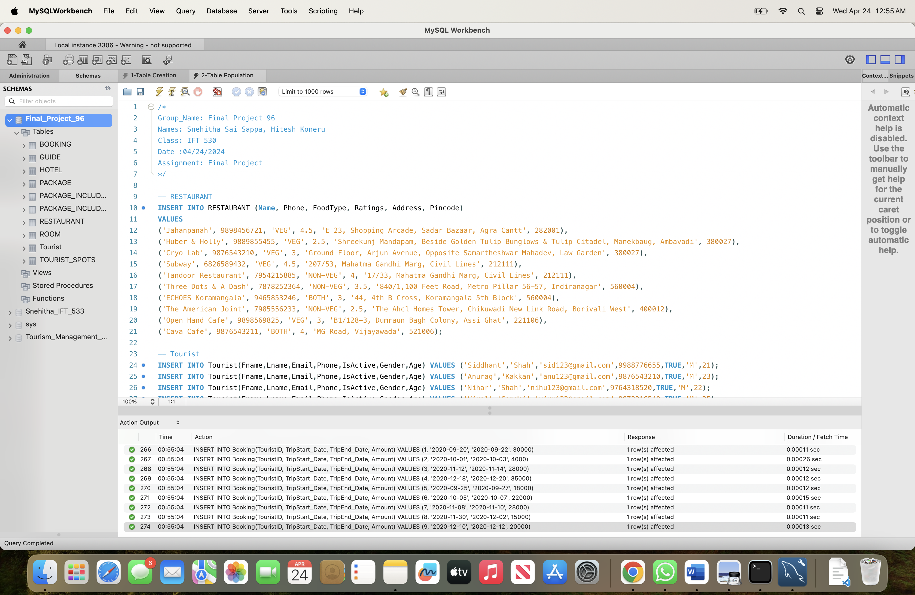

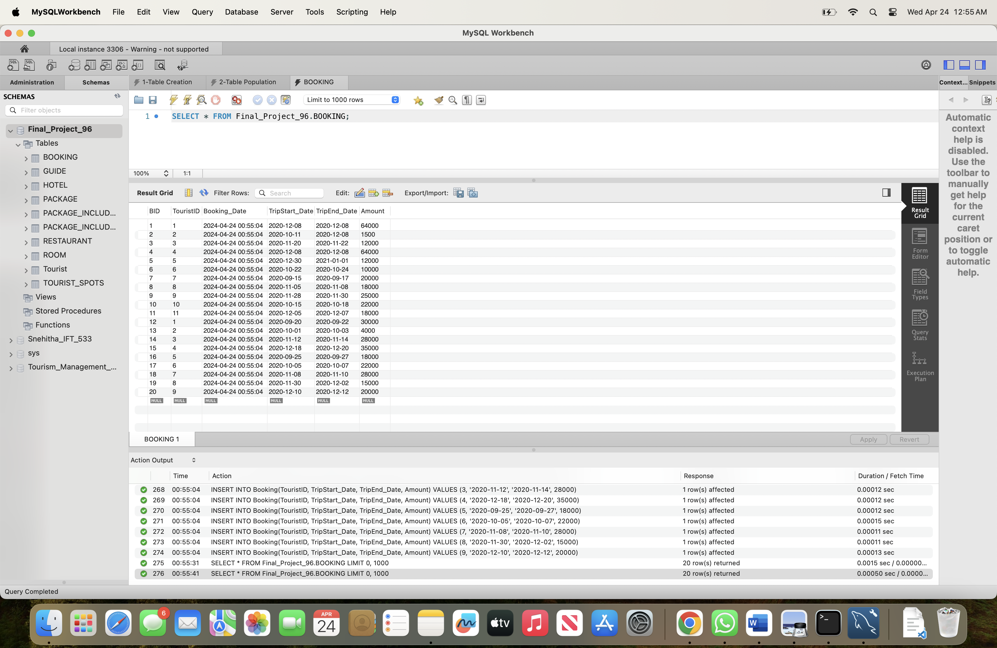

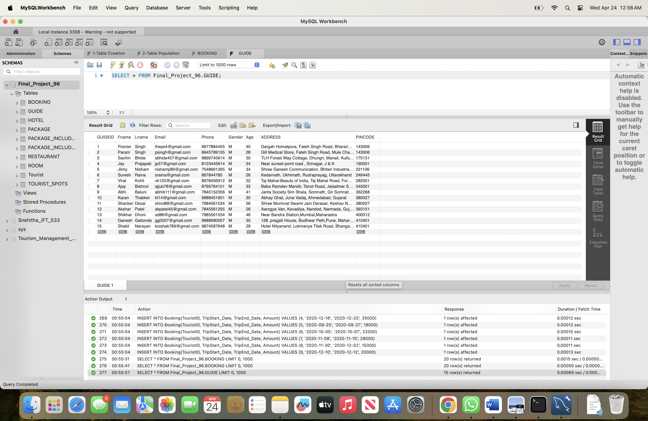

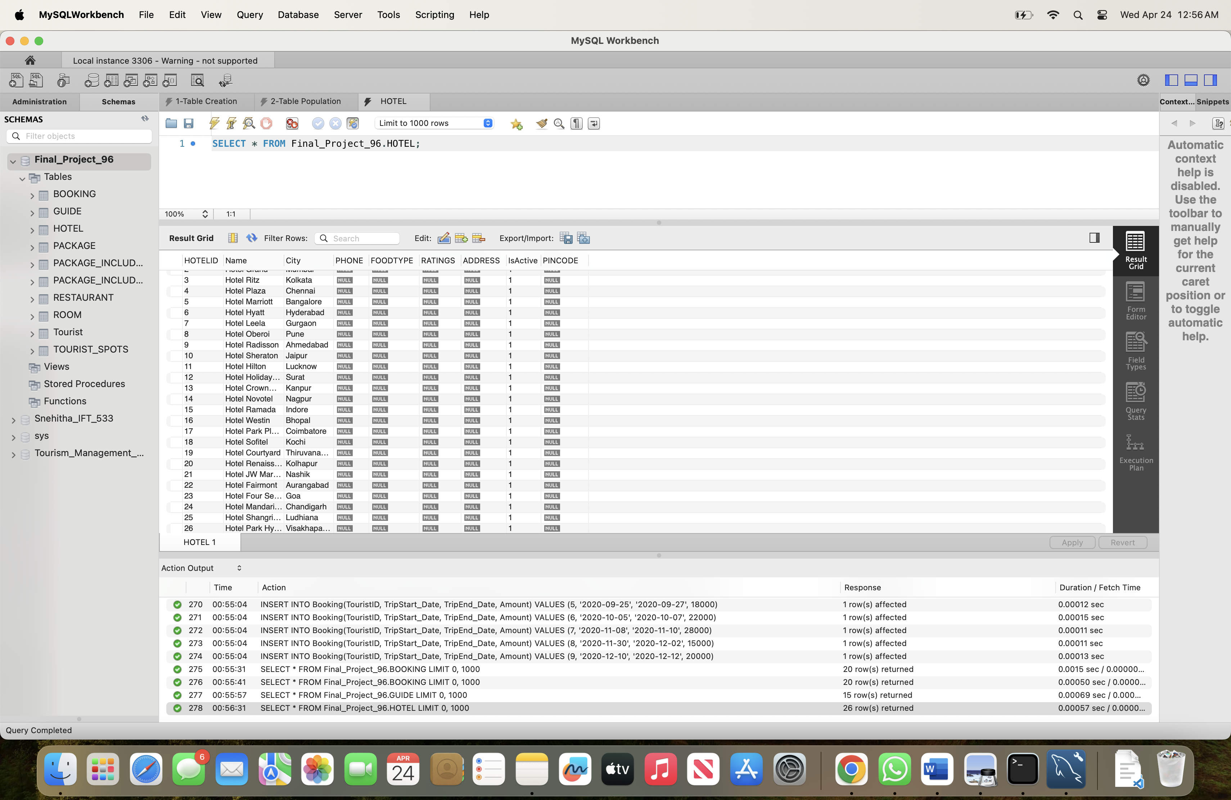

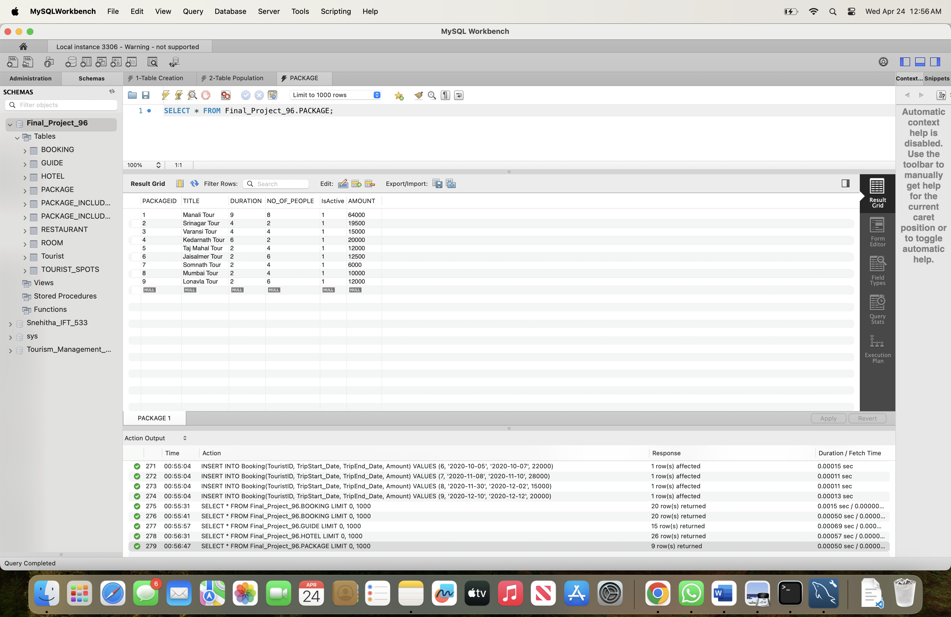

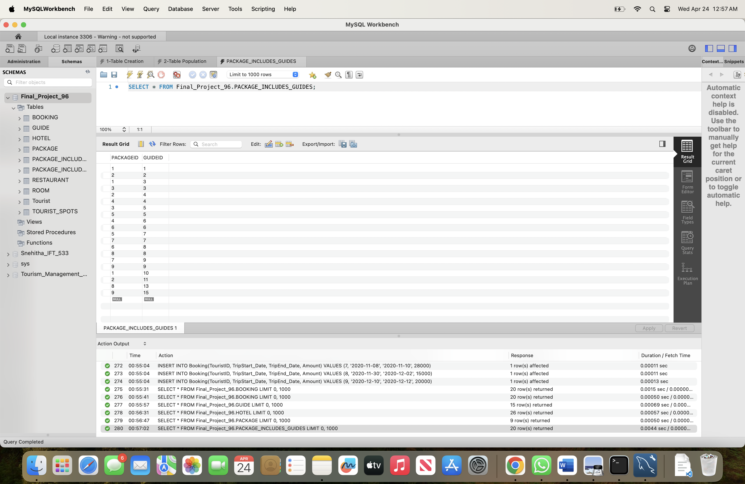

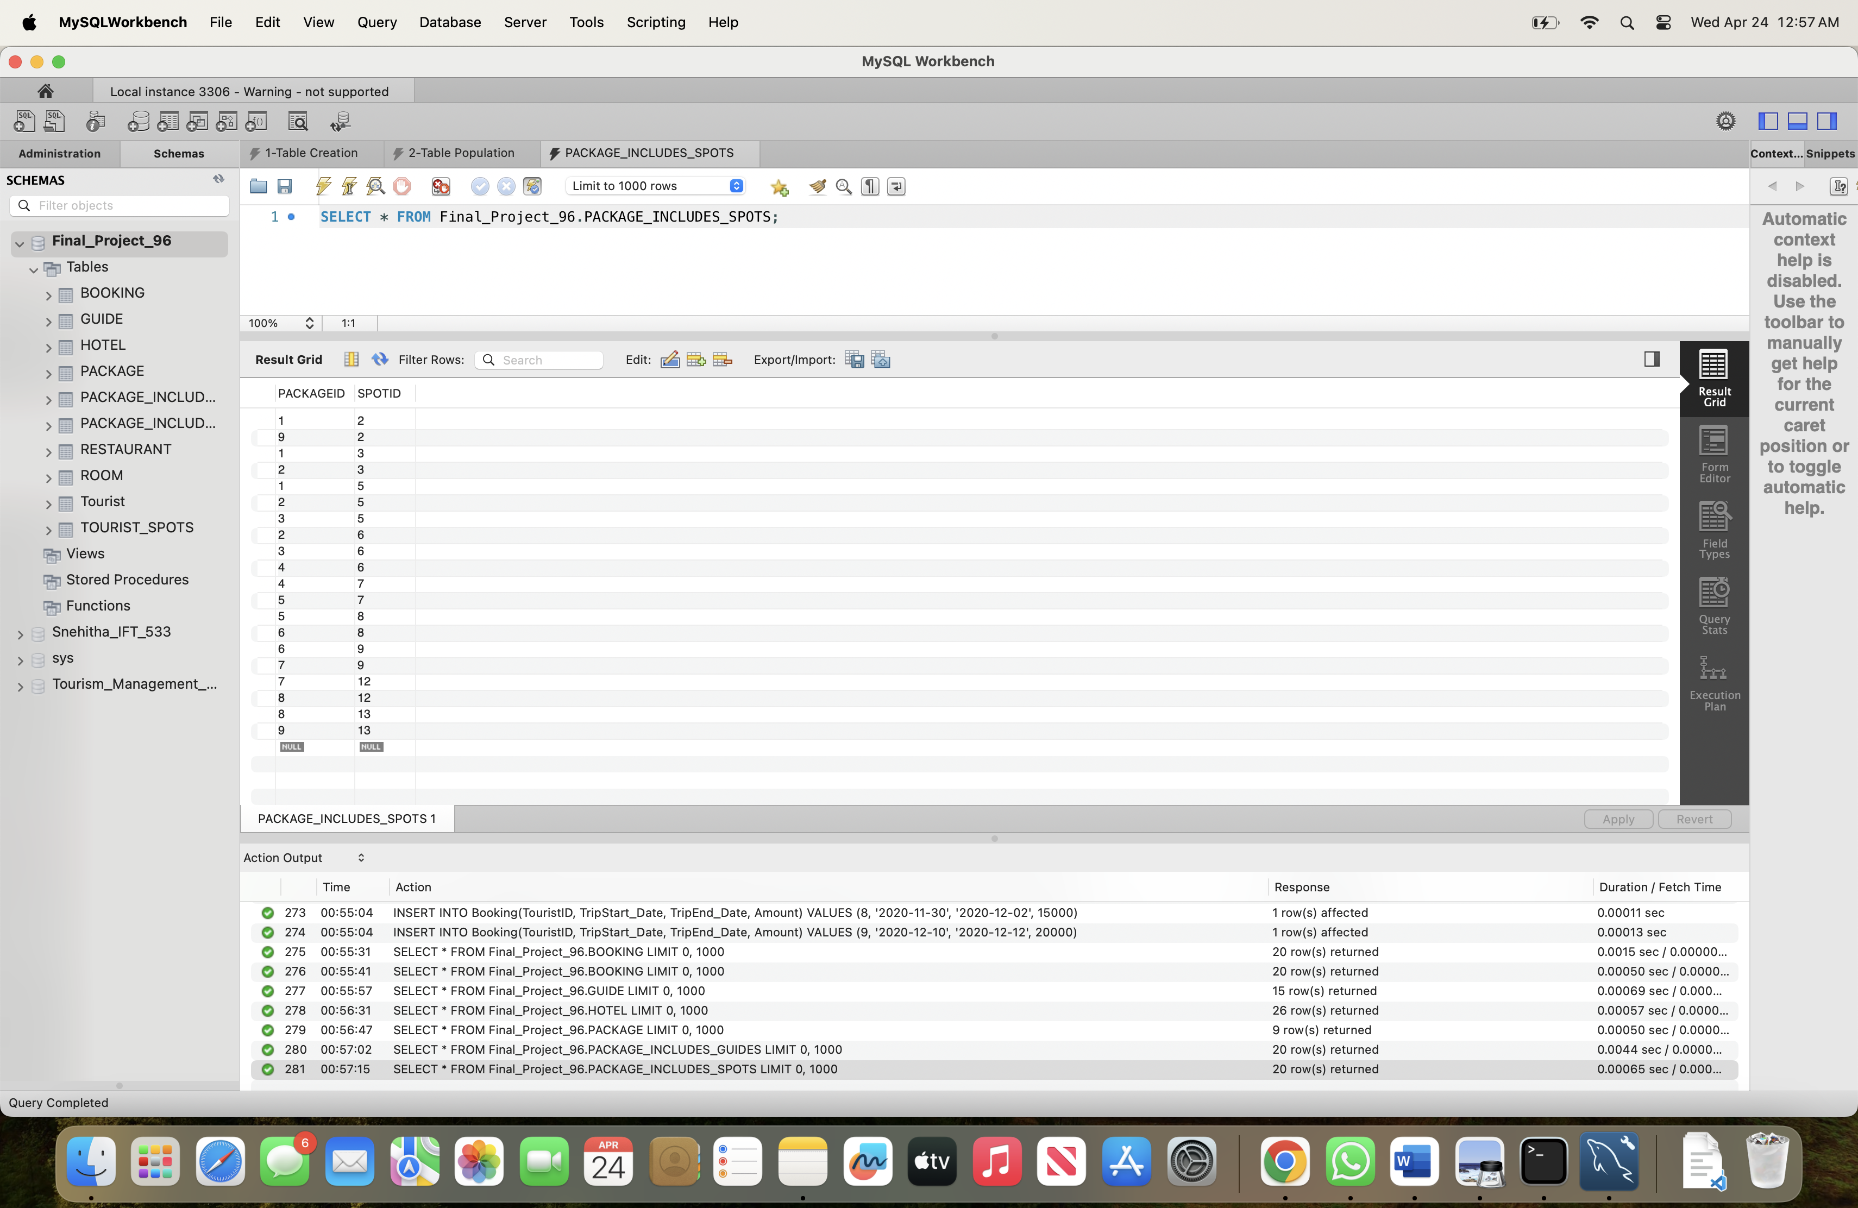

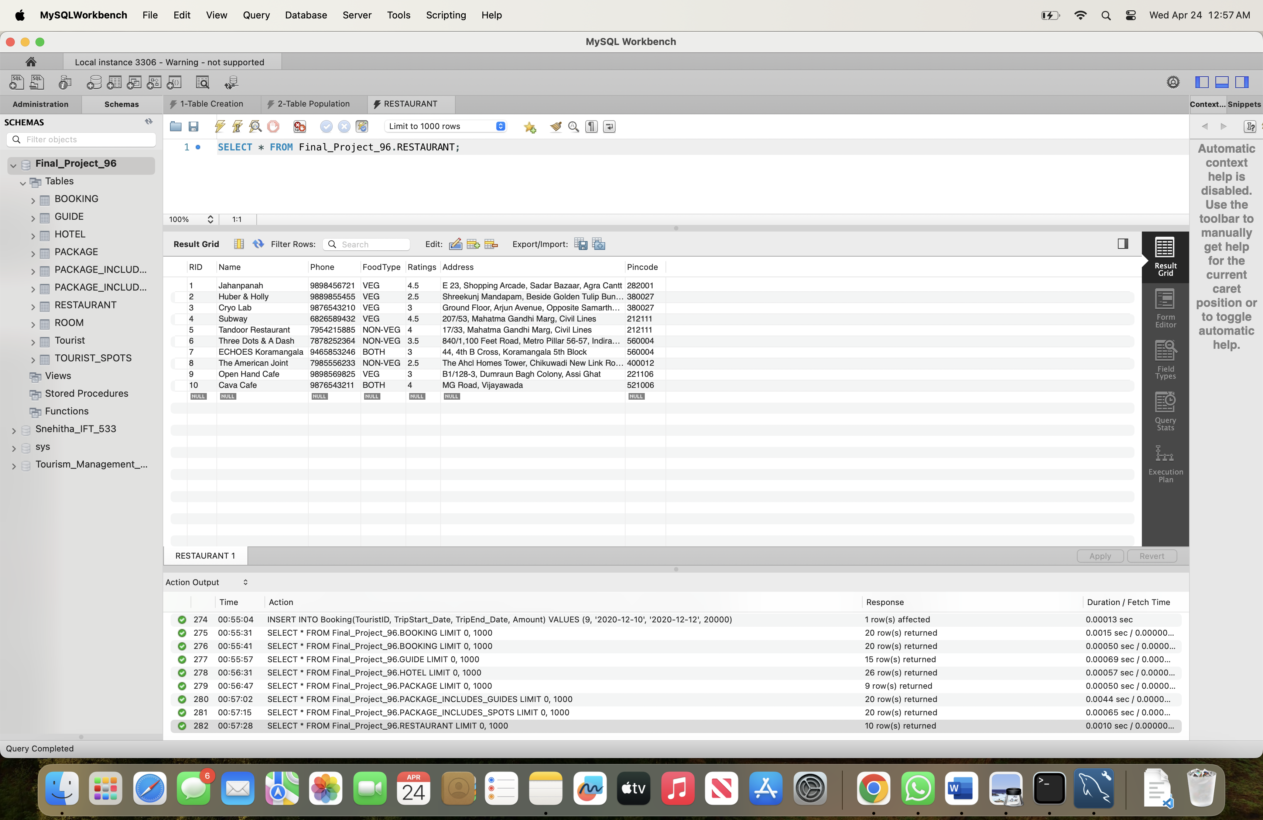

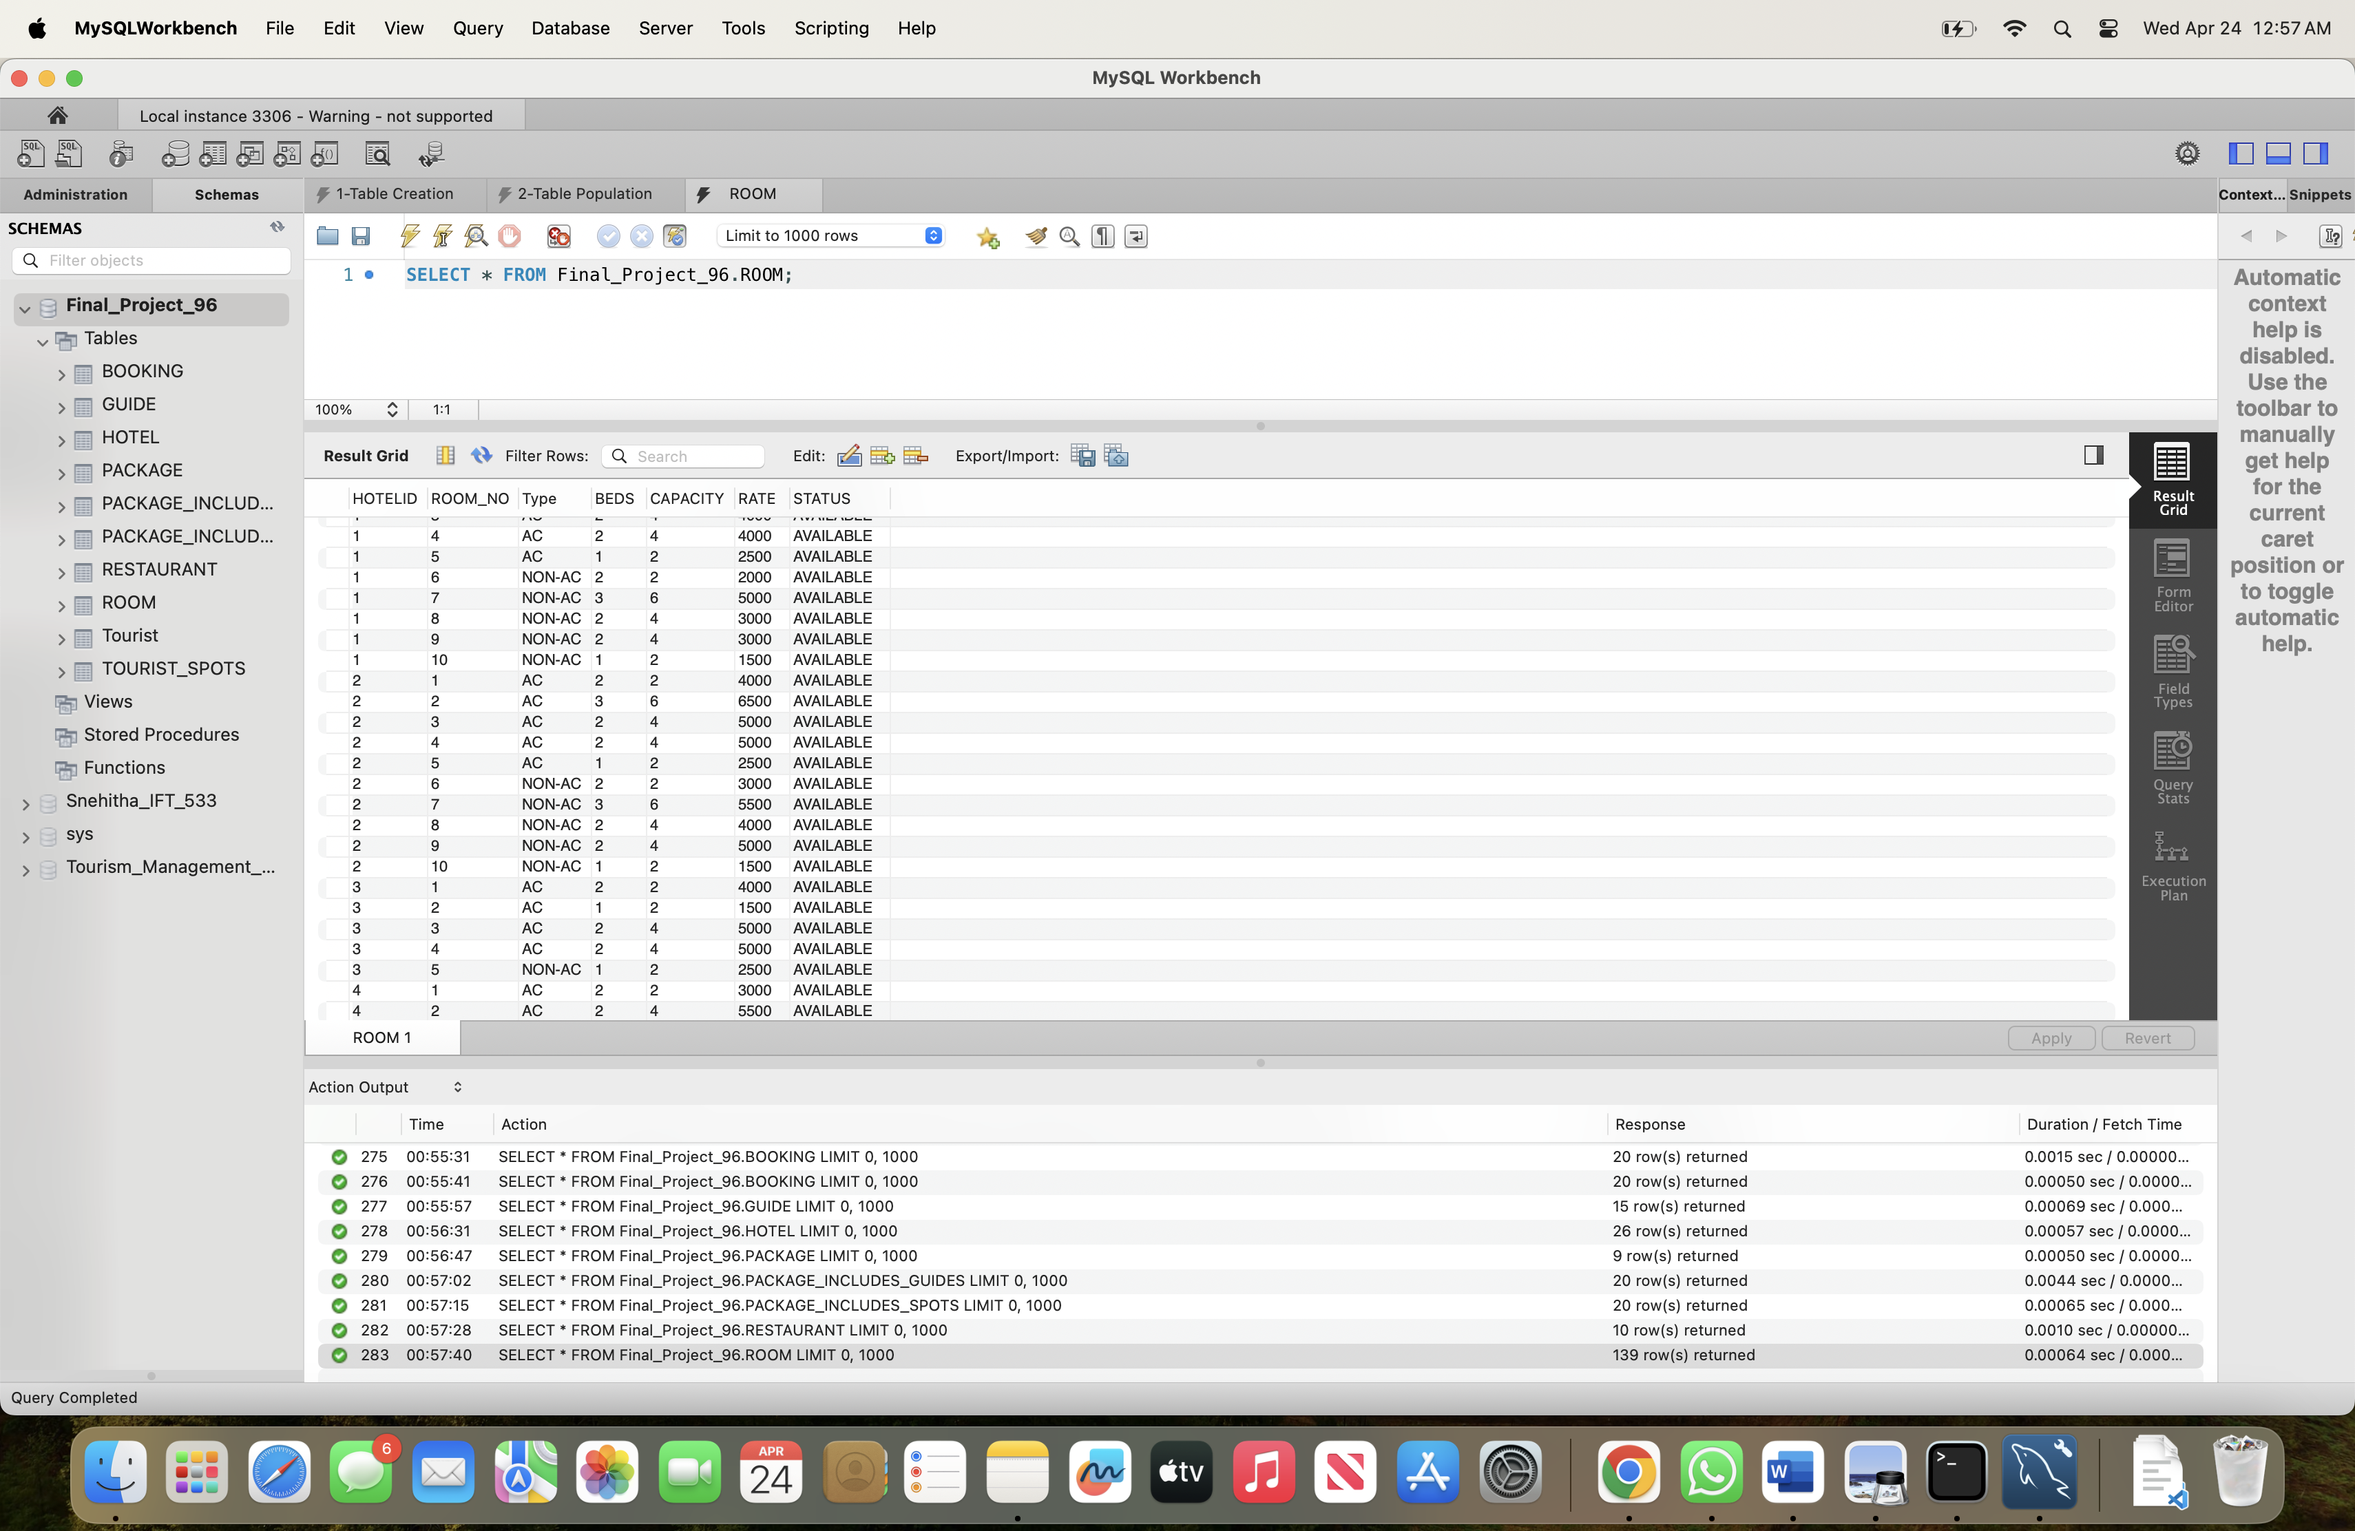

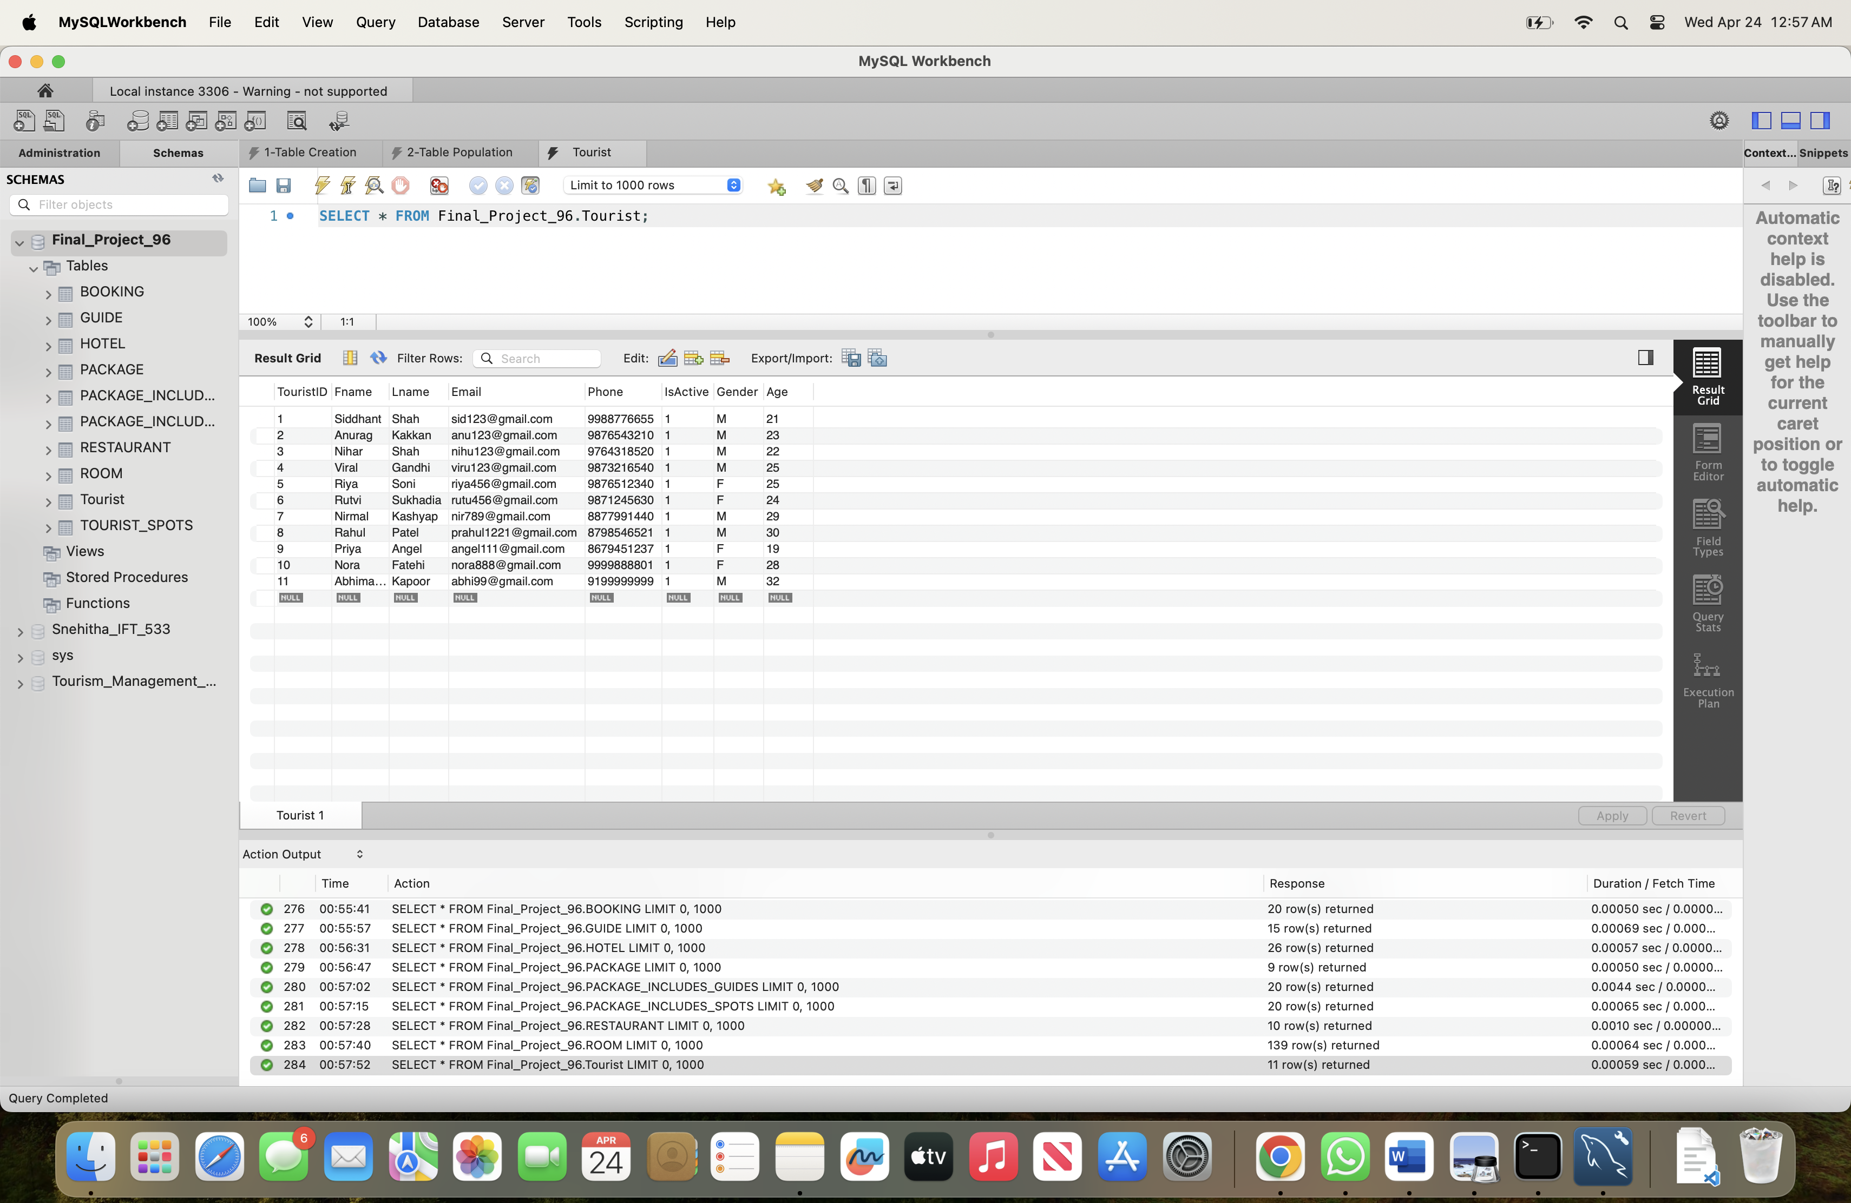

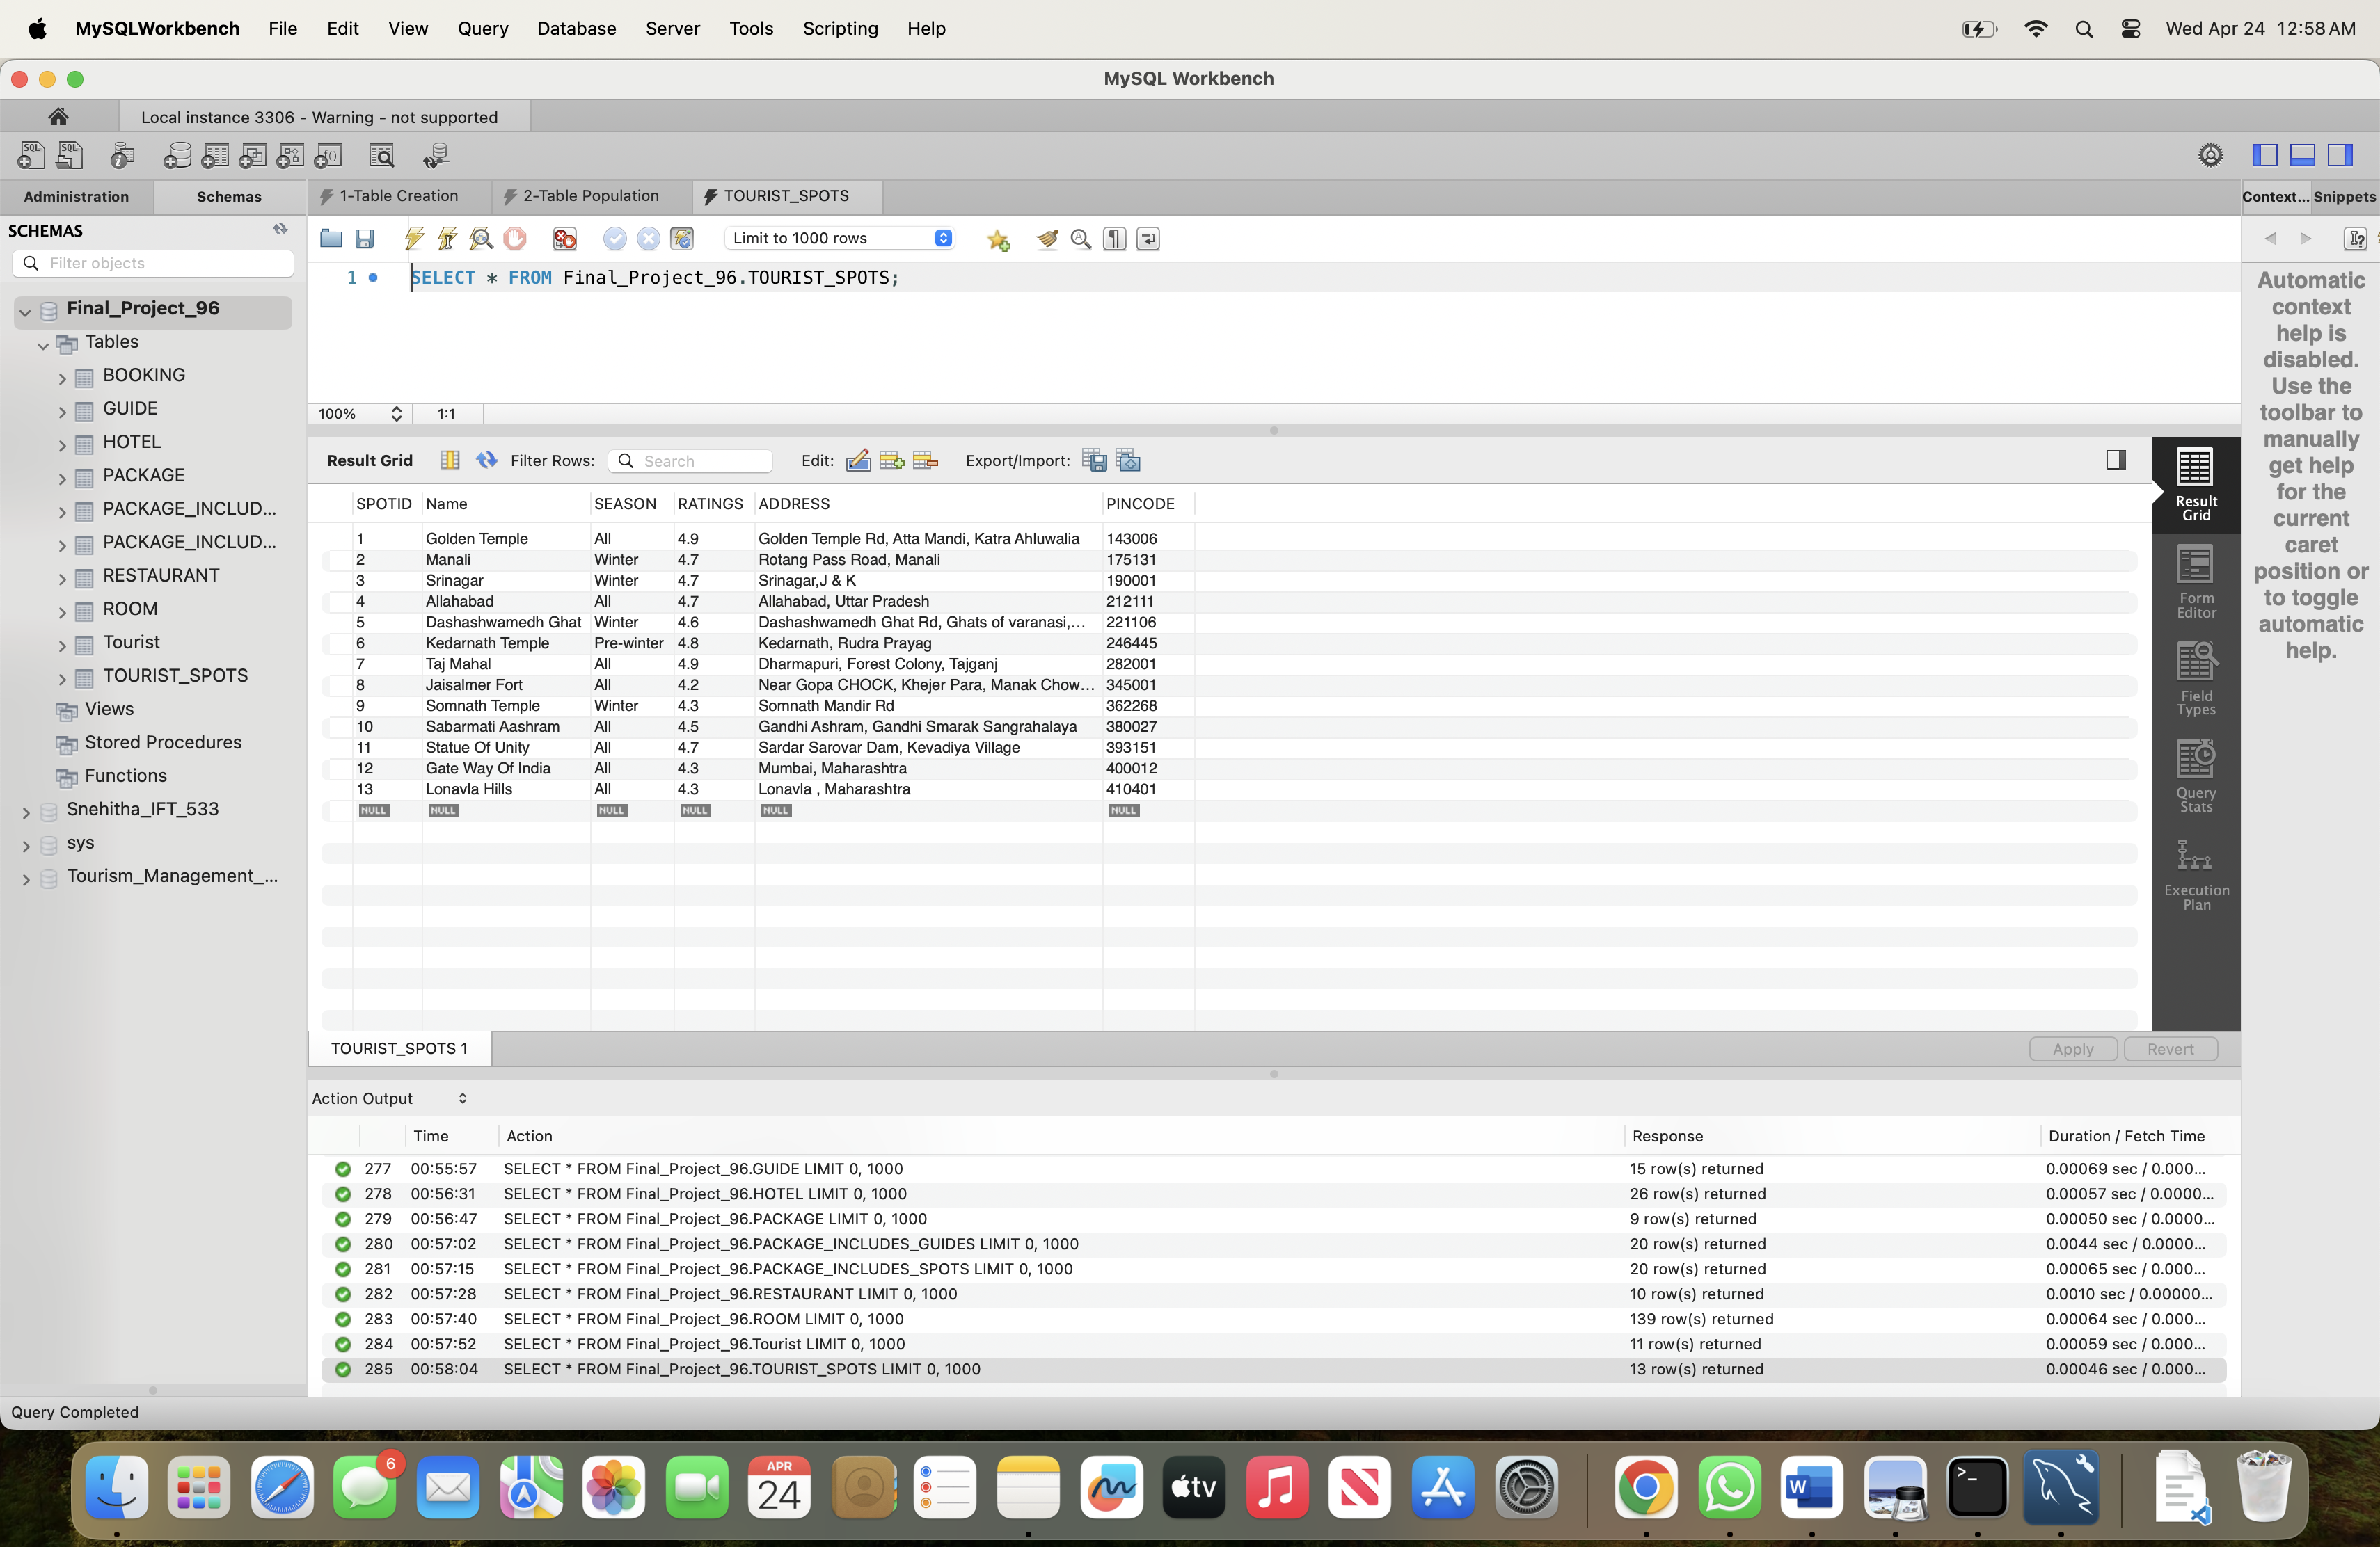



**View 1:** Active Tourists with their Bookings This view will display the active tourists along with their bookings, showing the trips they have booked. This can be useful for the hotel/travel agency staff to quickly view the customers and their travel plans.

/*

Group_Name: Final Project 96

Names: Snehitha Sai Sappa, Hitesh Koneru

Class: IFT 530

Date :04/24/2024

Assignment: Final Project

*/

CREATE VIEW ActiveTouristsWithBookings AS

SELECT T.Fname, T.Lname, T.Email, T.Phone, T.IsActive, B.TripStart_Date, B.TripEnd_Date, B.Amount

FROM Tourist T

JOIN Booking B ON T.TouristID = B.TouristID

WHERE T.IsActive = TRUE;

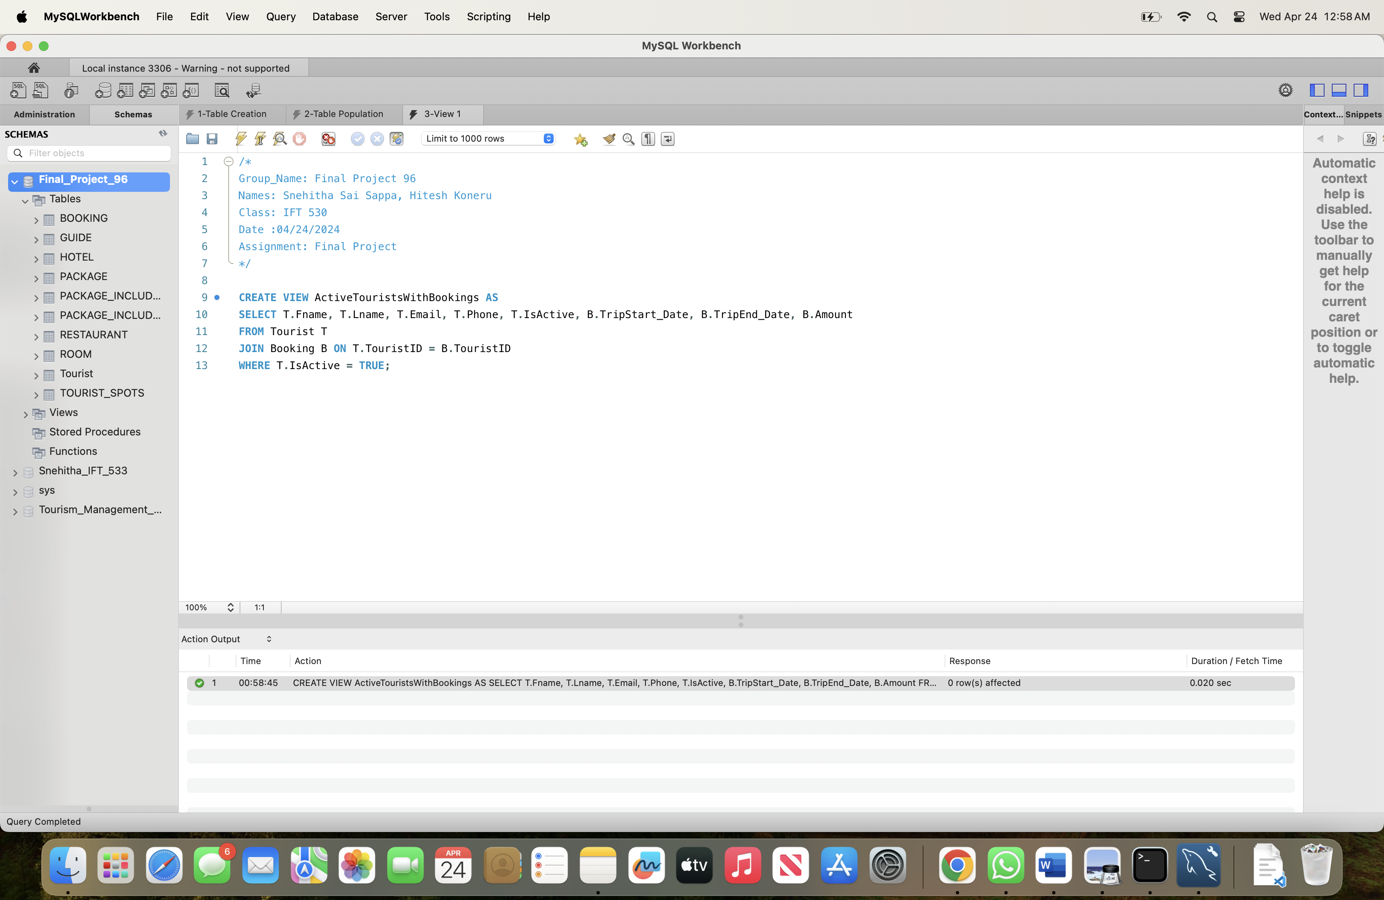

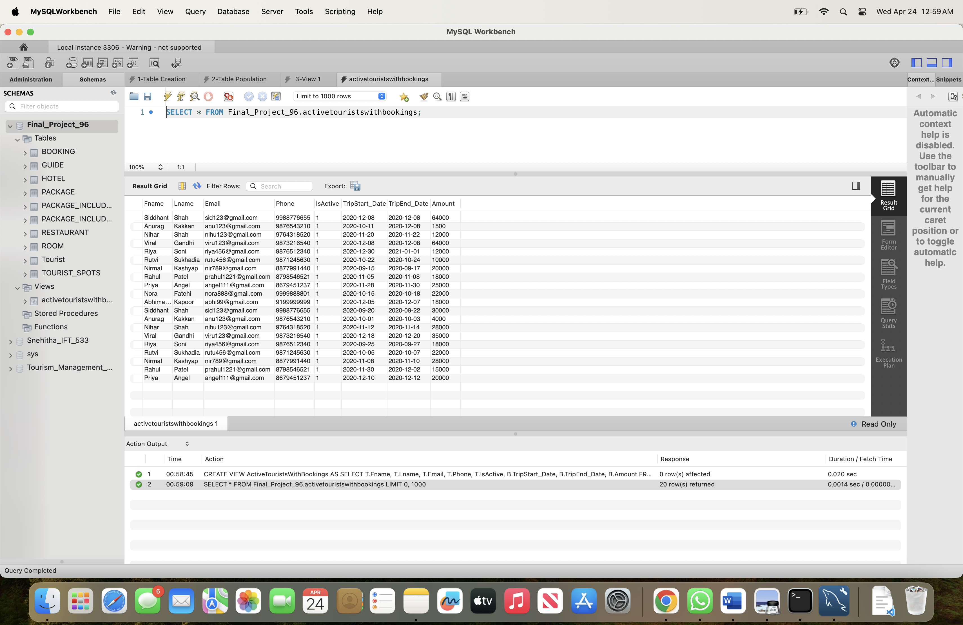

**View 2:** Guides Assigned to Active Packages This view will display the guides who are assigned to active packages, which can be useful for the hotel/travel agency staff to manage guide assignments and availability.

/*

Group_Name: Final Project 96

Names: Snehitha Sai Sappa, Hitesh Koneru

Class: IFT 530

Date :04/24/2024

Assignment: Final Project

*/

CREATE VIEW GuidesAssignedToActivePackages AS

SELECT G.Fname, G.Lname, G.Email, G.Phone, G.Gender, G.Age, G.Address, G.Pincode, P.Title, P.isActive

FROM GUIDE G

JOIN Package_Includes_Guides PIG ON G.GUIDEID = PIG.GUIDEID

JOIN Package P ON PIG.PackageId = P.PackageId

WHERE P.isActive = TRUE;

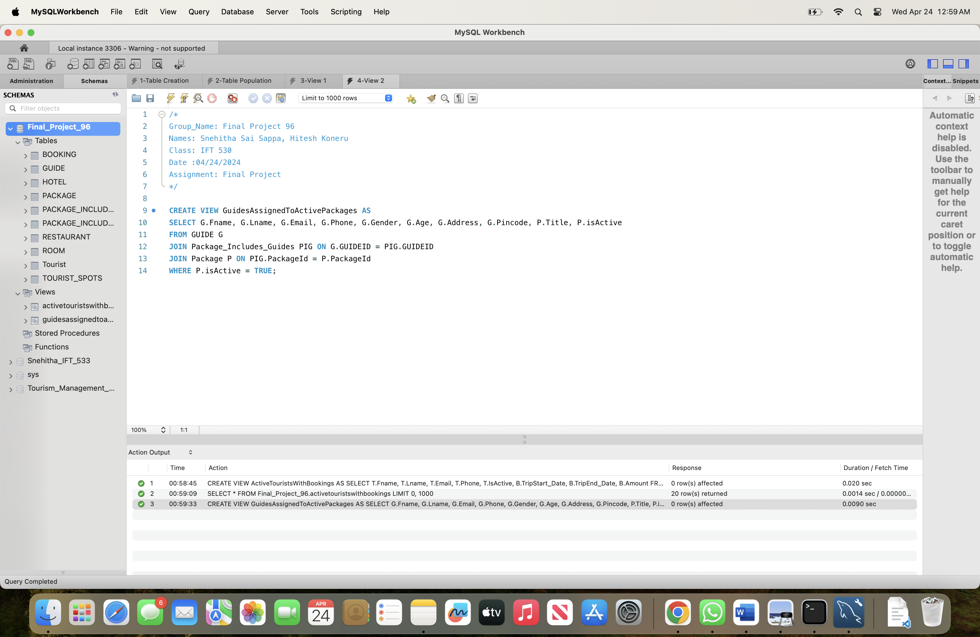

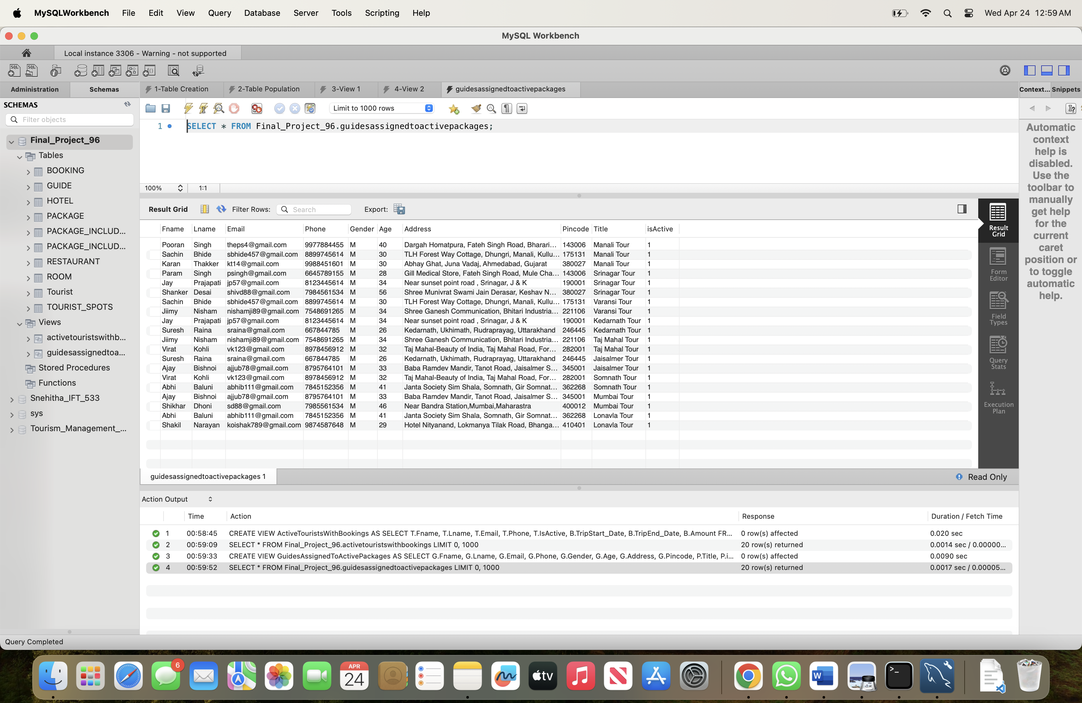

**View 3:** Restaurants Near Tourist Spots This view will display the restaurants near the tourist spots, which can be useful for tourists to find nearby dining options.

/*

Group_Name: Final Project 96

Names: Snehitha Sai Sappa, Hitesh Koneru

Class: IFT 530

Date :04/24/2024

Assignment: Final Project

*/

CREATE VIEW RestaurantsNearTouristSpots AS

SELECT R.Name, R.Phone, R.FoodType, R.Ratings, R.Address, R.Pincode, TS.Name AS TouristSpotName, TS.Address AS TouristSpotAddress, TS.Pincode AS TouristSpotPincode

FROM Restaurant R

JOIN TOURIST_SPOTS TS ON

(6911.8 * acos(cos(radians(R.Address)) * cos(radians(TS.Address)) * cos(radians(TS.Address) - radians(R.Address)) + sin(radians(R.Address)) * sin(radians(TS.Address)))) < 5

WHERE TS.season = 'All';

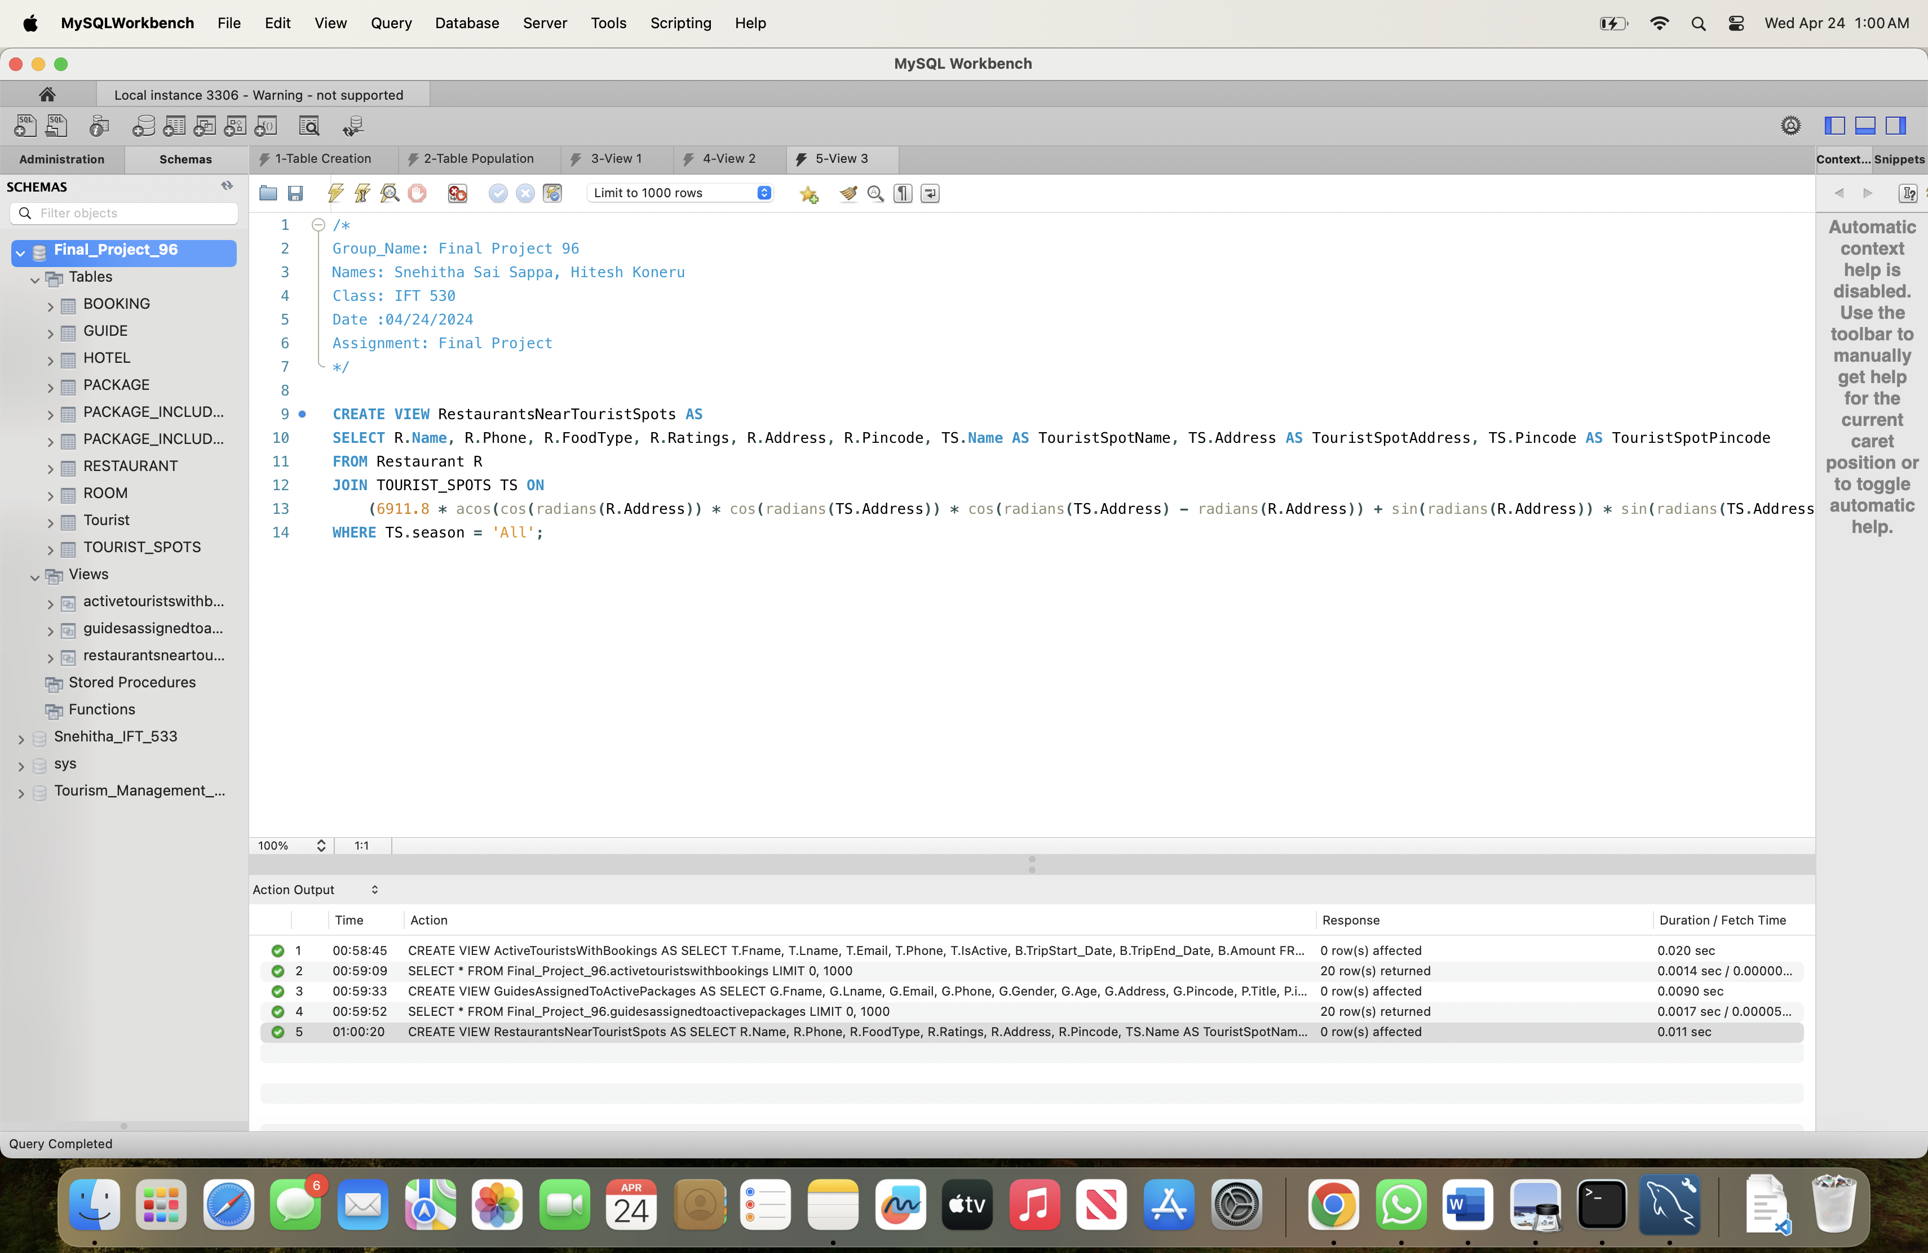

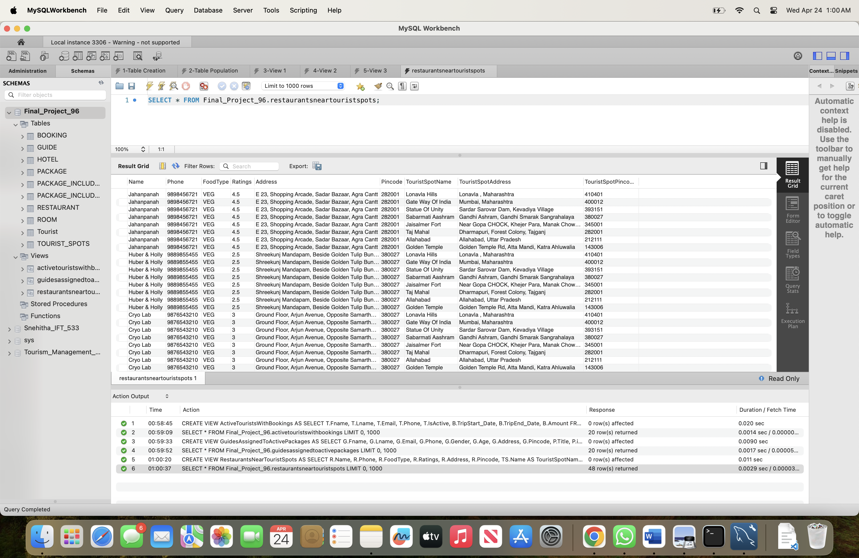

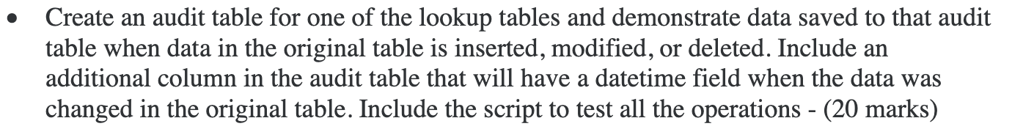

**Creating Audit Table:**

/*

Group_Name: Final Project 96

Names: Snehitha Sai Sappa, Hitesh Koneru

Class: IFT 530

Date :04/24/2024

Assignment: Final Project

*/

CREATE TABLE TOURIST_SPOTS_AUDIT (

AUDIT_ID INT AUTO_INCREMENT PRIMARY KEY,

SPOTID INT,

Name VARCHAR(20),

SEASON VARCHAR(10),

RATINGS FLOAT,

ADDRESS VARCHAR(100),

PINCODE NUMERIC(6),

ACTION VARCHAR(10), -- Insert, Update, or Delete

CHANGE_DATE TIMESTAMP DEFAULT CURRENT_TIMESTAMP

);

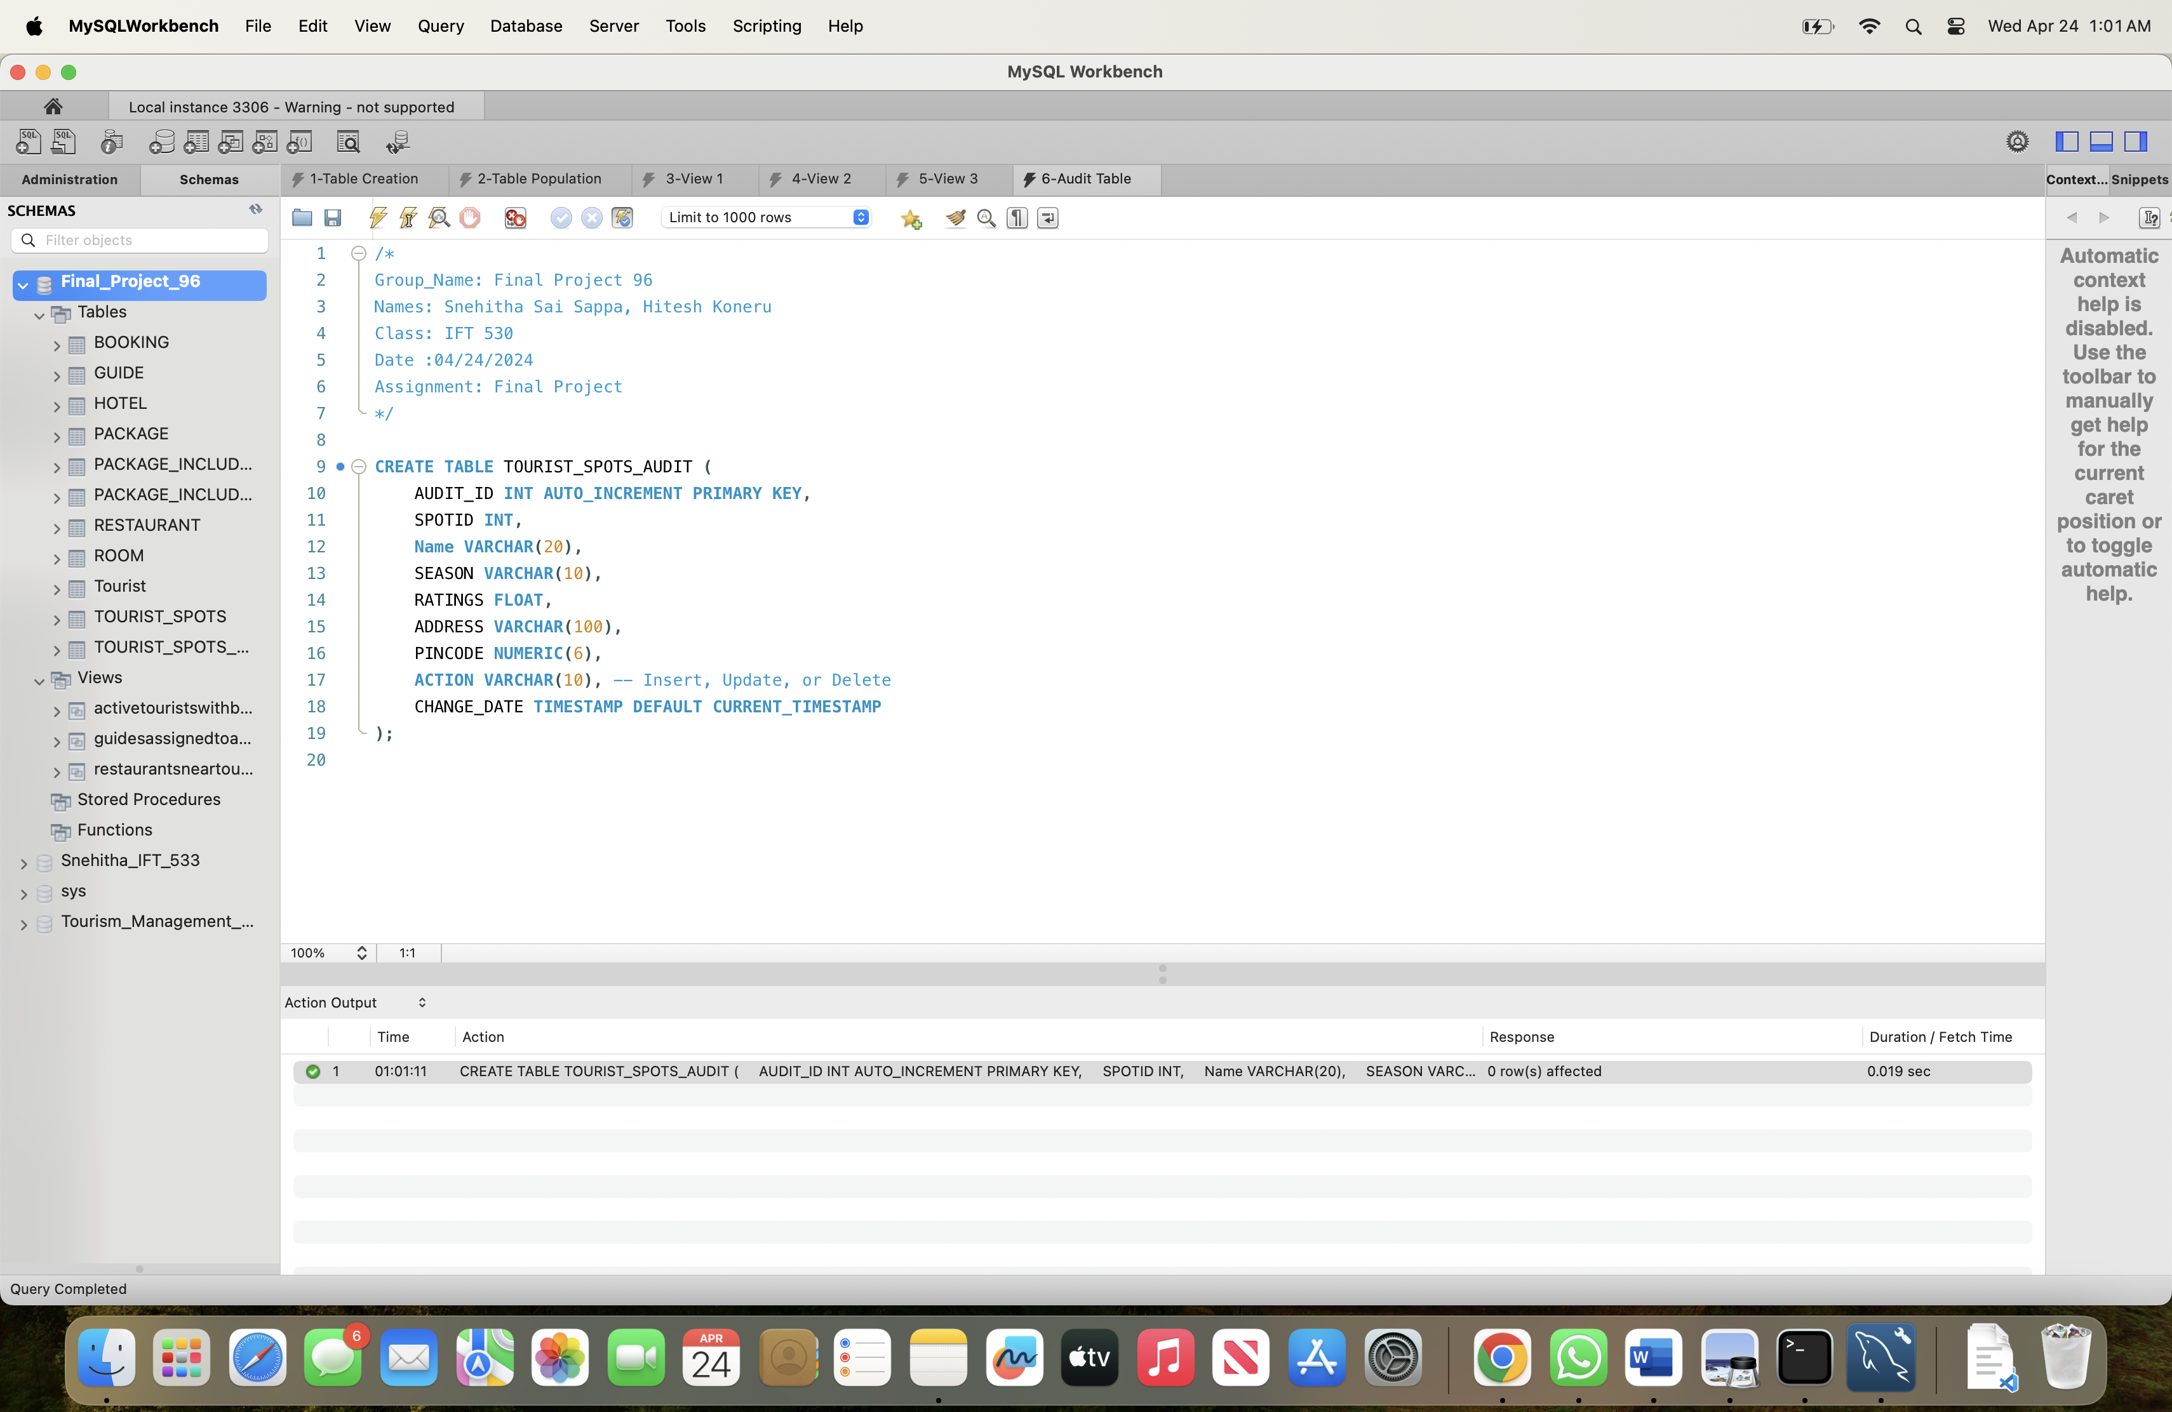

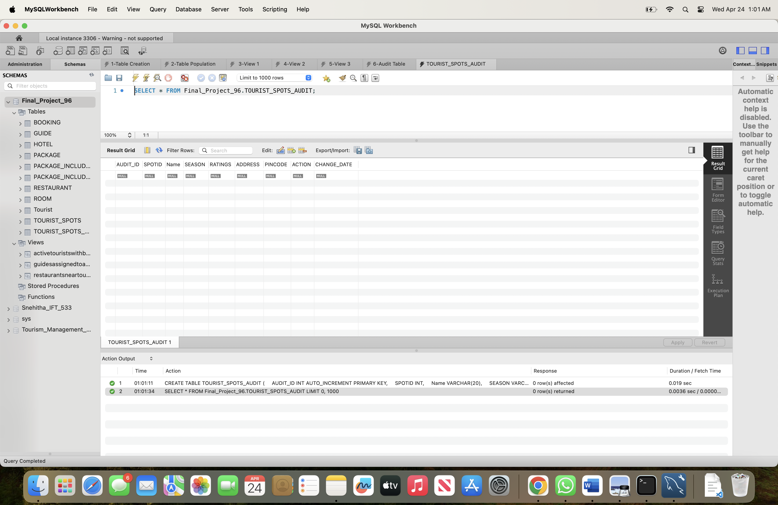

**Trigger for Audit Table:**

/*

Group_Name: Final Project 96

Names: Snehitha Sai Sappa, Hitesh Koneru

Class: IFT 530

Date :04/24/2024

Assignment: Final Project

*/

DELIMITER $$

CREATE TRIGGER tourist_spots_insert_trigger

AFTER INSERT ON TOURIST_SPOTS

FOR EACH ROW

BEGIN

INSERT INTO TOURIST_SPOTS_AUDIT (SPOTID, Name, SEASON, RATINGS, ADDRESS, PINCODE, ACTION)

VALUES (NEW.SPOTID, NEW.Name, NEW.SEASON, NEW.RATINGS, NEW.ADDRESS, NEW.PINCODE, 'Insert');

END$$

CREATE TRIGGER tourist_spots_update_trigger

AFTER UPDATE ON TOURIST_SPOTS

FOR EACH ROW

BEGIN

INSERT INTO TOURIST_SPOTS_AUDIT (SPOTID, Name, SEASON, RATINGS, ADDRESS, PINCODE, ACTION)

VALUES (NEW.SPOTID, NEW.Name, NEW.SEASON, NEW.RATINGS, NEW.ADDRESS, NEW.PINCODE, 'Update');

END$$

CREATE TRIGGER tourist_spots_delete_trigger

AFTER DELETE ON TOURIST_SPOTS

FOR EACH ROW

BEGIN

INSERT INTO TOURIST_SPOTS_AUDIT (SPOTID, Name, SEASON, RATINGS, ADDRESS, PINCODE, ACTION)

VALUES (OLD.SPOTID, OLD.Name, OLD.SEASON, OLD.RATINGS, OLD.ADDRESS, OLD.PINCODE, 'Delete');

END$$

DELIMITER ;

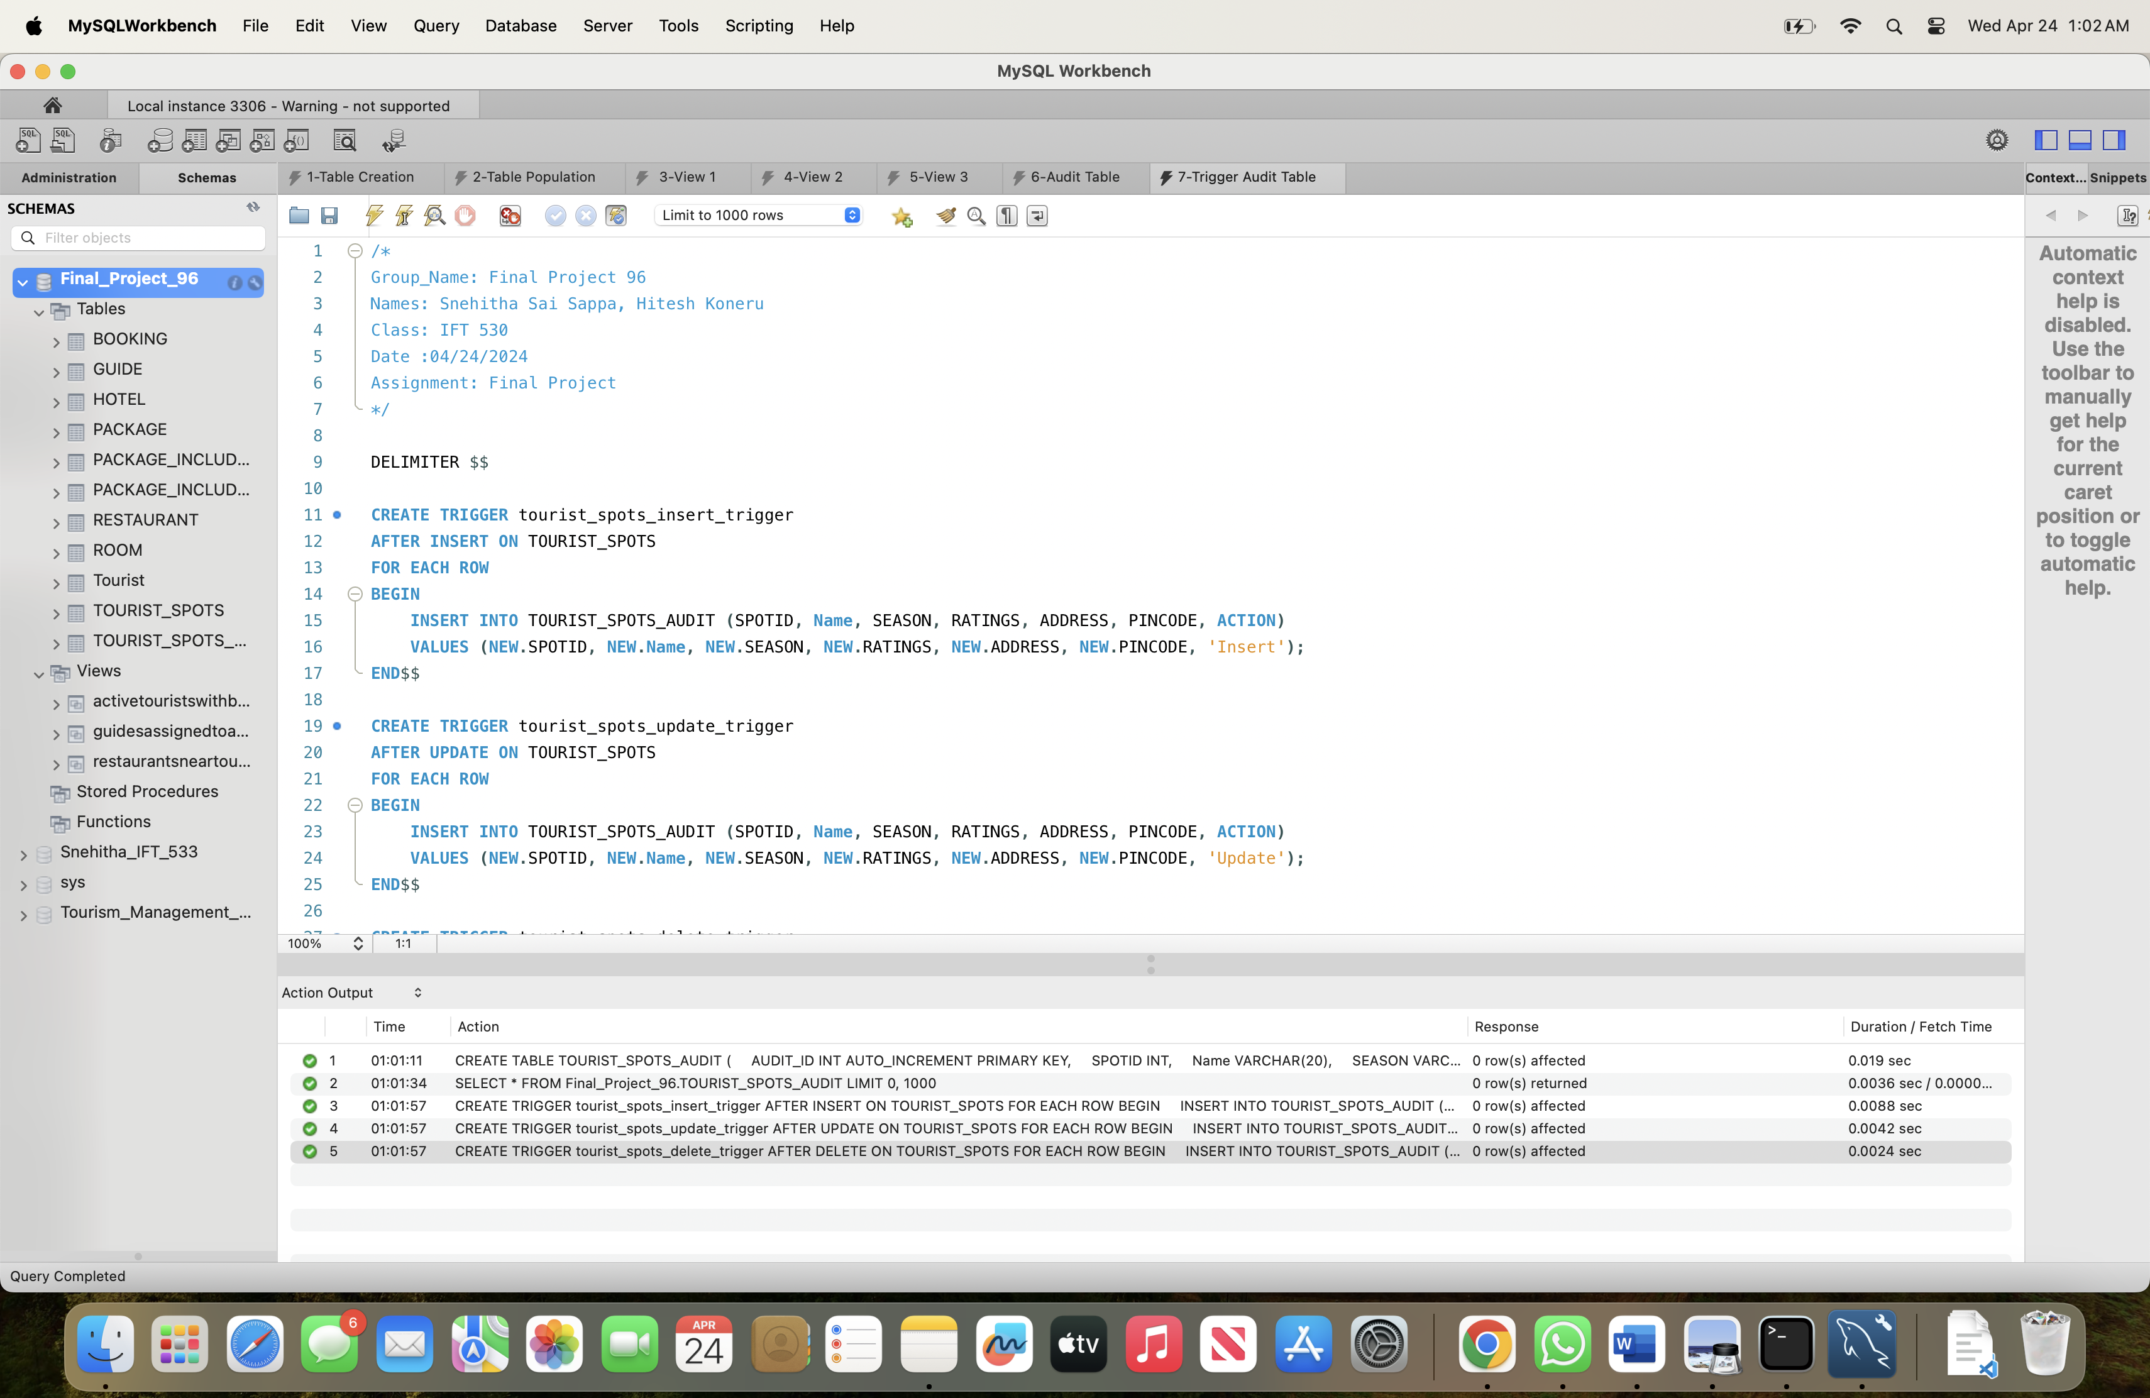

**Testing the Audit Table:**

/*

Group_Name: Final Project 96

Names: Snehitha Sai Sappa, Hitesh Koneru

Class: IFT 530

Date :04/24/2024

Assignment: Final Project

*/

-- Insert a new tourist spot

INSERT INTO TOURIST_SPOTS (Name, SEASON, RATINGS, ADDRESS, PINCODE)

VALUES ('Example Spot', 'Summer', 4.5, '123 Main St', 123456);

-- Update an existing tourist spot

UPDATE TOURIST_SPOTS

SET SEASON = 'Spring'

WHERE SPOTID = 1;

-- Delete a tourist spot

DELETE FROM TOURIST_SPOTS

WHERE SPOTID = 1;

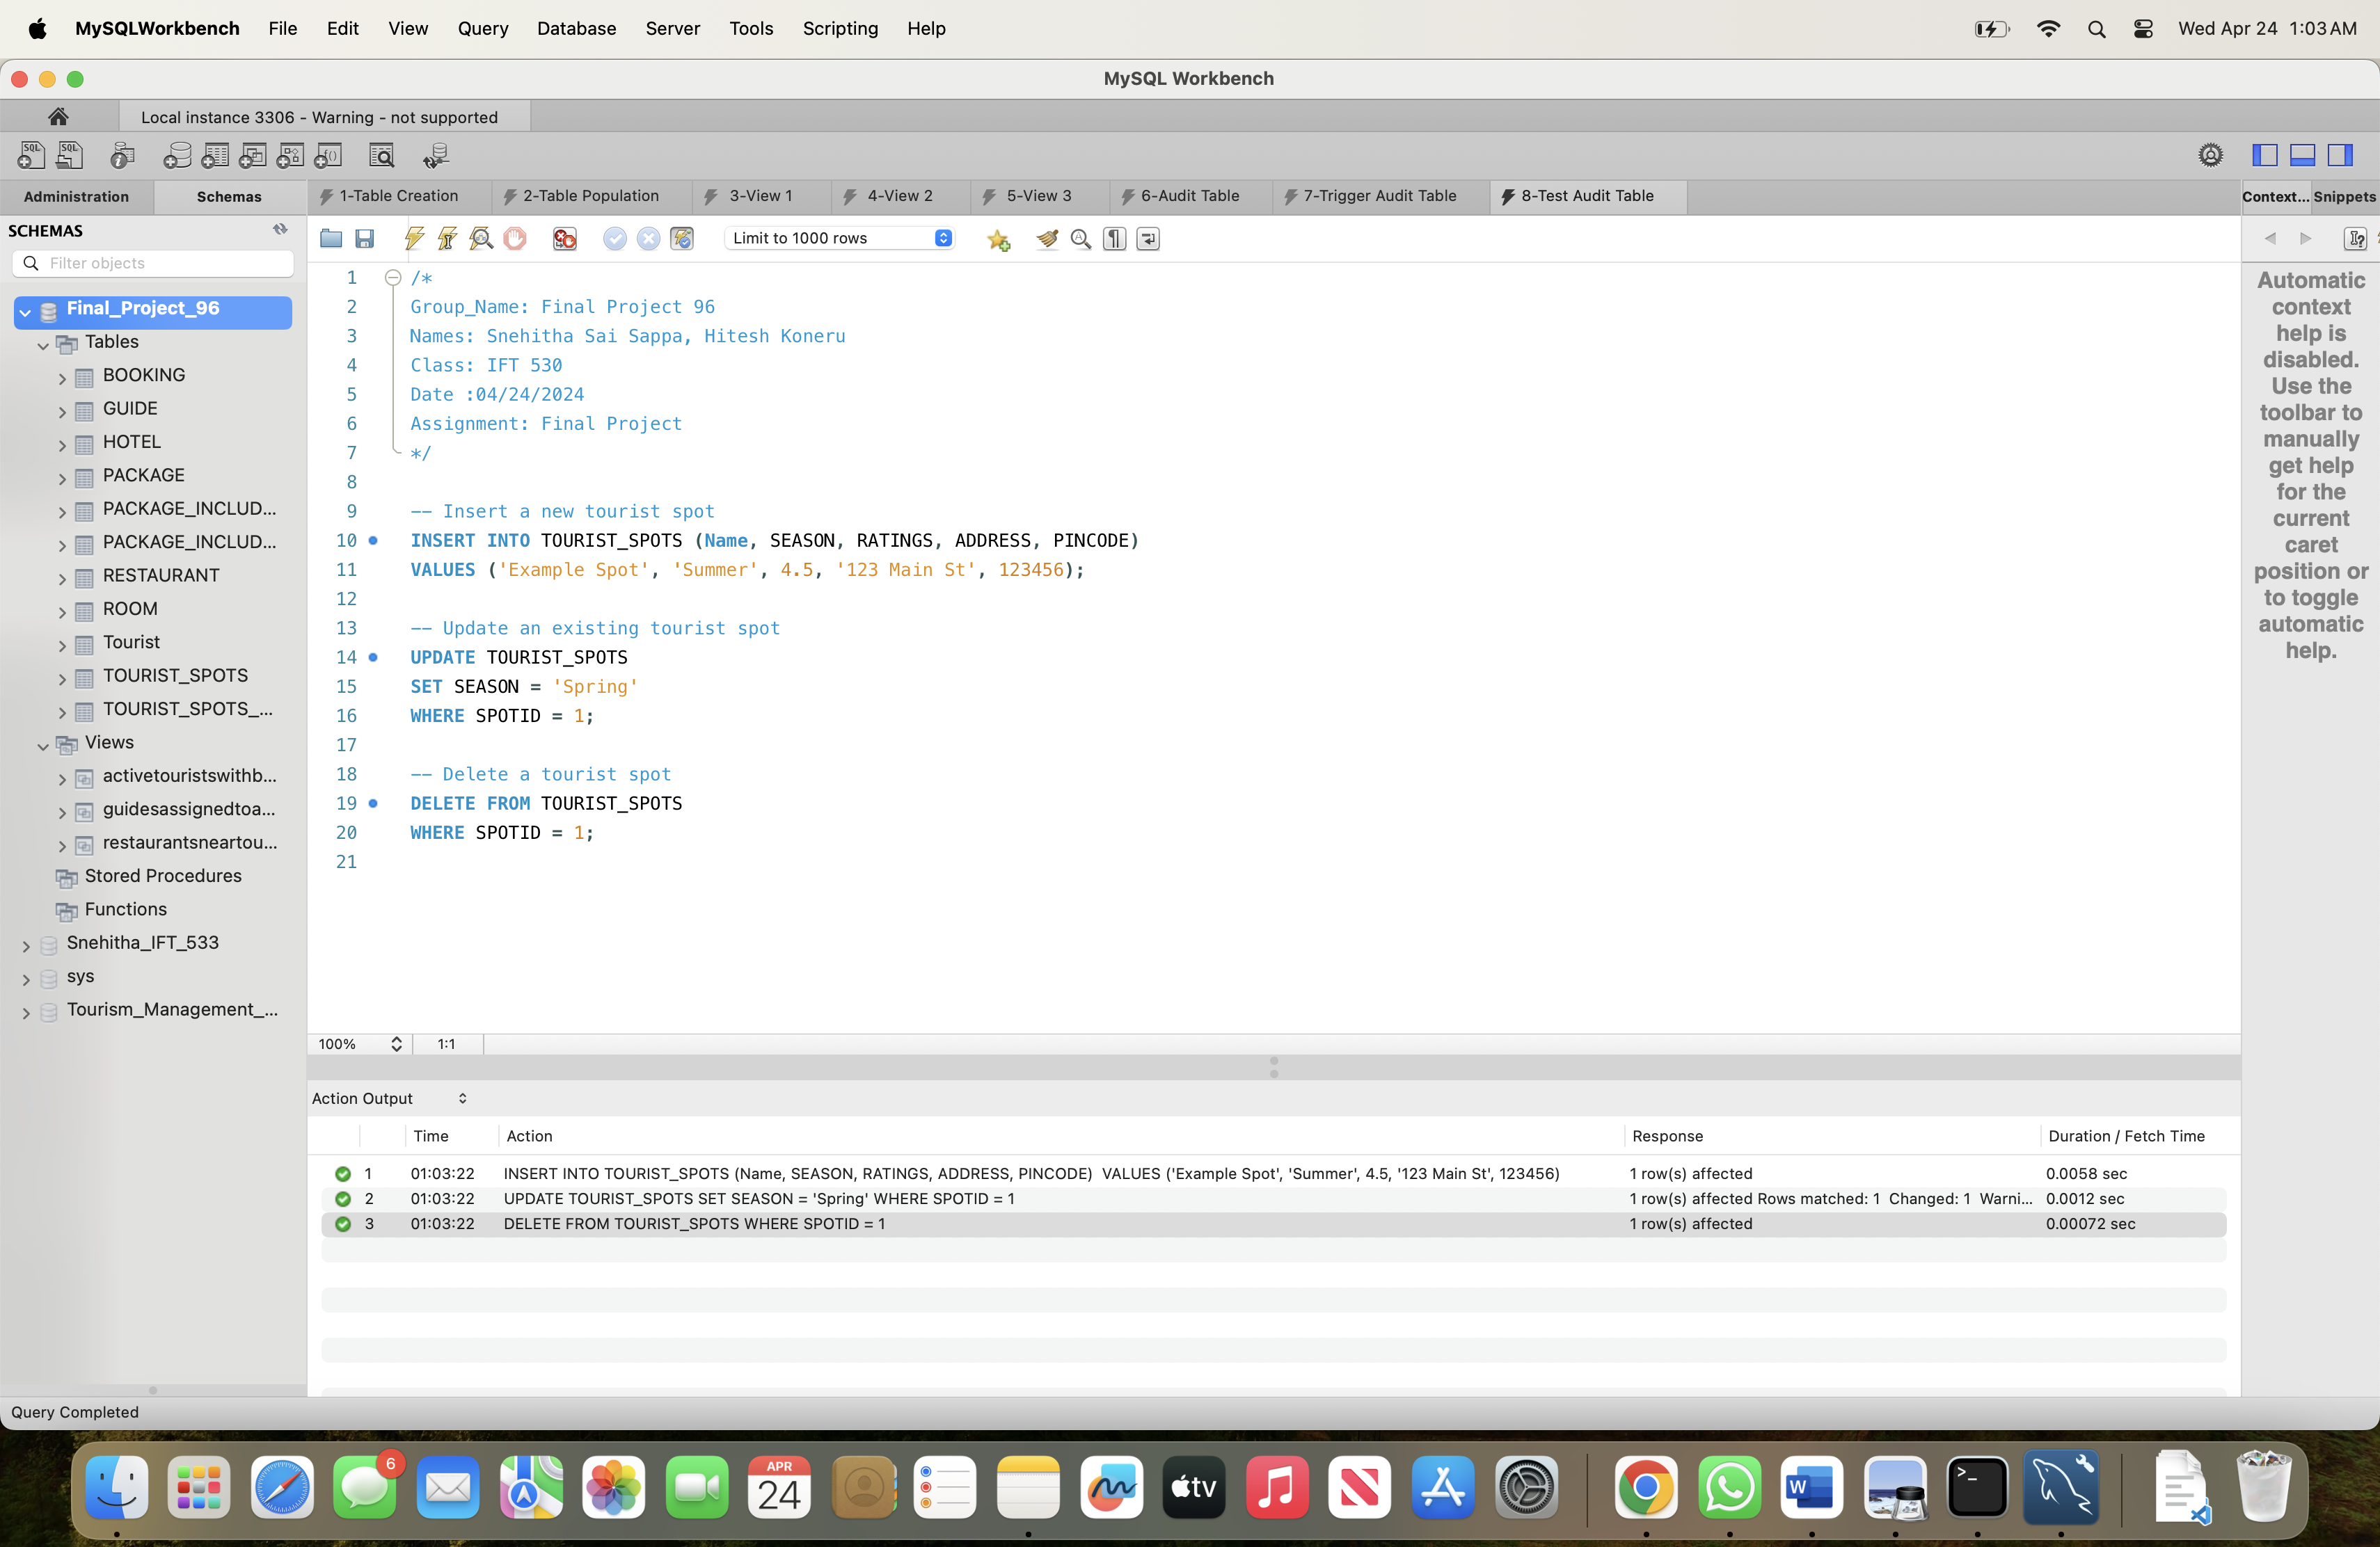

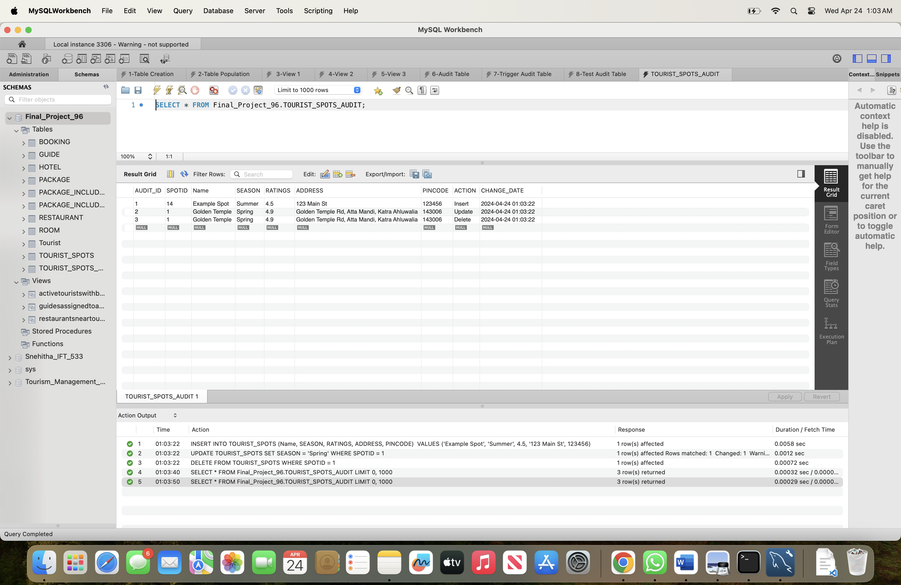



1. **GetBookingInfo Stored Procedure:**

* The `GetBookingInfo` stored procedure is designed to retrieve booking information for a specific tourist from the `BOOKING` table in the database.
* It takes one input parameter: the tourist ID (`tourist_id`).
* When called with a tourist ID, the procedure selects all booking details from the `BOOKING` table where the `TouristID` matches the provided ID.
* This procedure encapsulates the logic for retrieving booking information, making it convenient to use and maintain. Users can simply call the procedure with a tourist ID to get their booking details without needing to write the SQL query themselves.

1. **CalculateAge User-Defined Function (UDF):**
   * The `CalculateAge` UDF is designed to calculate the age of a person based on their date of birth.
   * It takes one input parameter: the person's date of birth (`BirthDate`).
   * The function determines the age by subtracting the birth year from the current year, and then adjusts the age if the person's birthday hasn't occurred yet in the current year.
   * This UDF encapsulates the age calculation logic, allowing users to calculate ages easily by providing a date of birth as input.
   * Users can use this function in SELECT queries to calculate the age of individuals stored in the database or with hardcoded dates to determine the age of someone based on their birthdate.

**Creating Stored Procedure:**

/*

Group_Name: Final Project 96

Names: Snehitha Sai Sappa, Hitesh Koneru

Class: IFT 530

Date :04/24/2024

Assignment: Final Project

*/

DELIMITER $$

CREATE PROCEDURE GetBookingInfo (IN tourist_id INT)

BEGIN

SELECT *

FROM BOOKING

WHERE TouristID = tourist_id;

END$$

DELIMITER ;

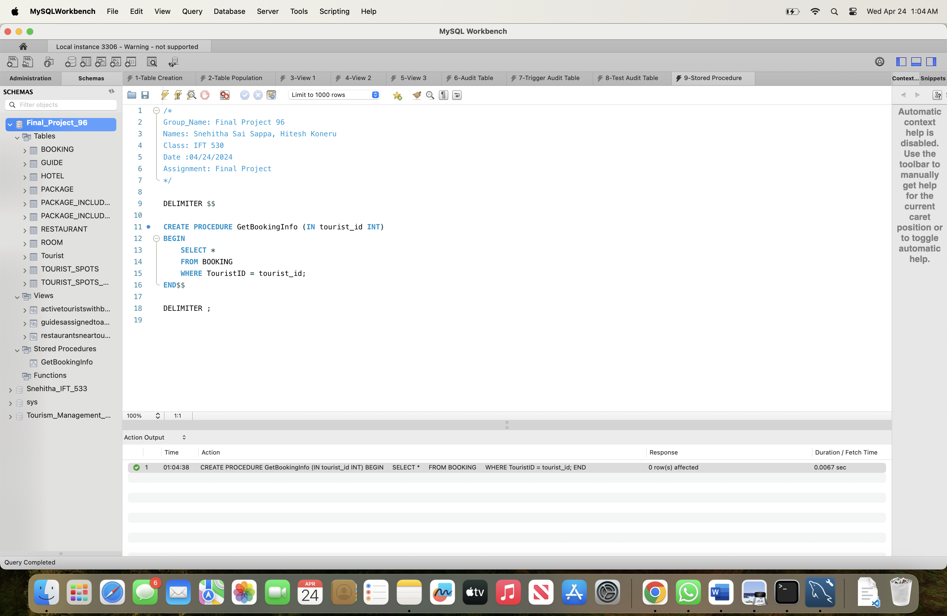

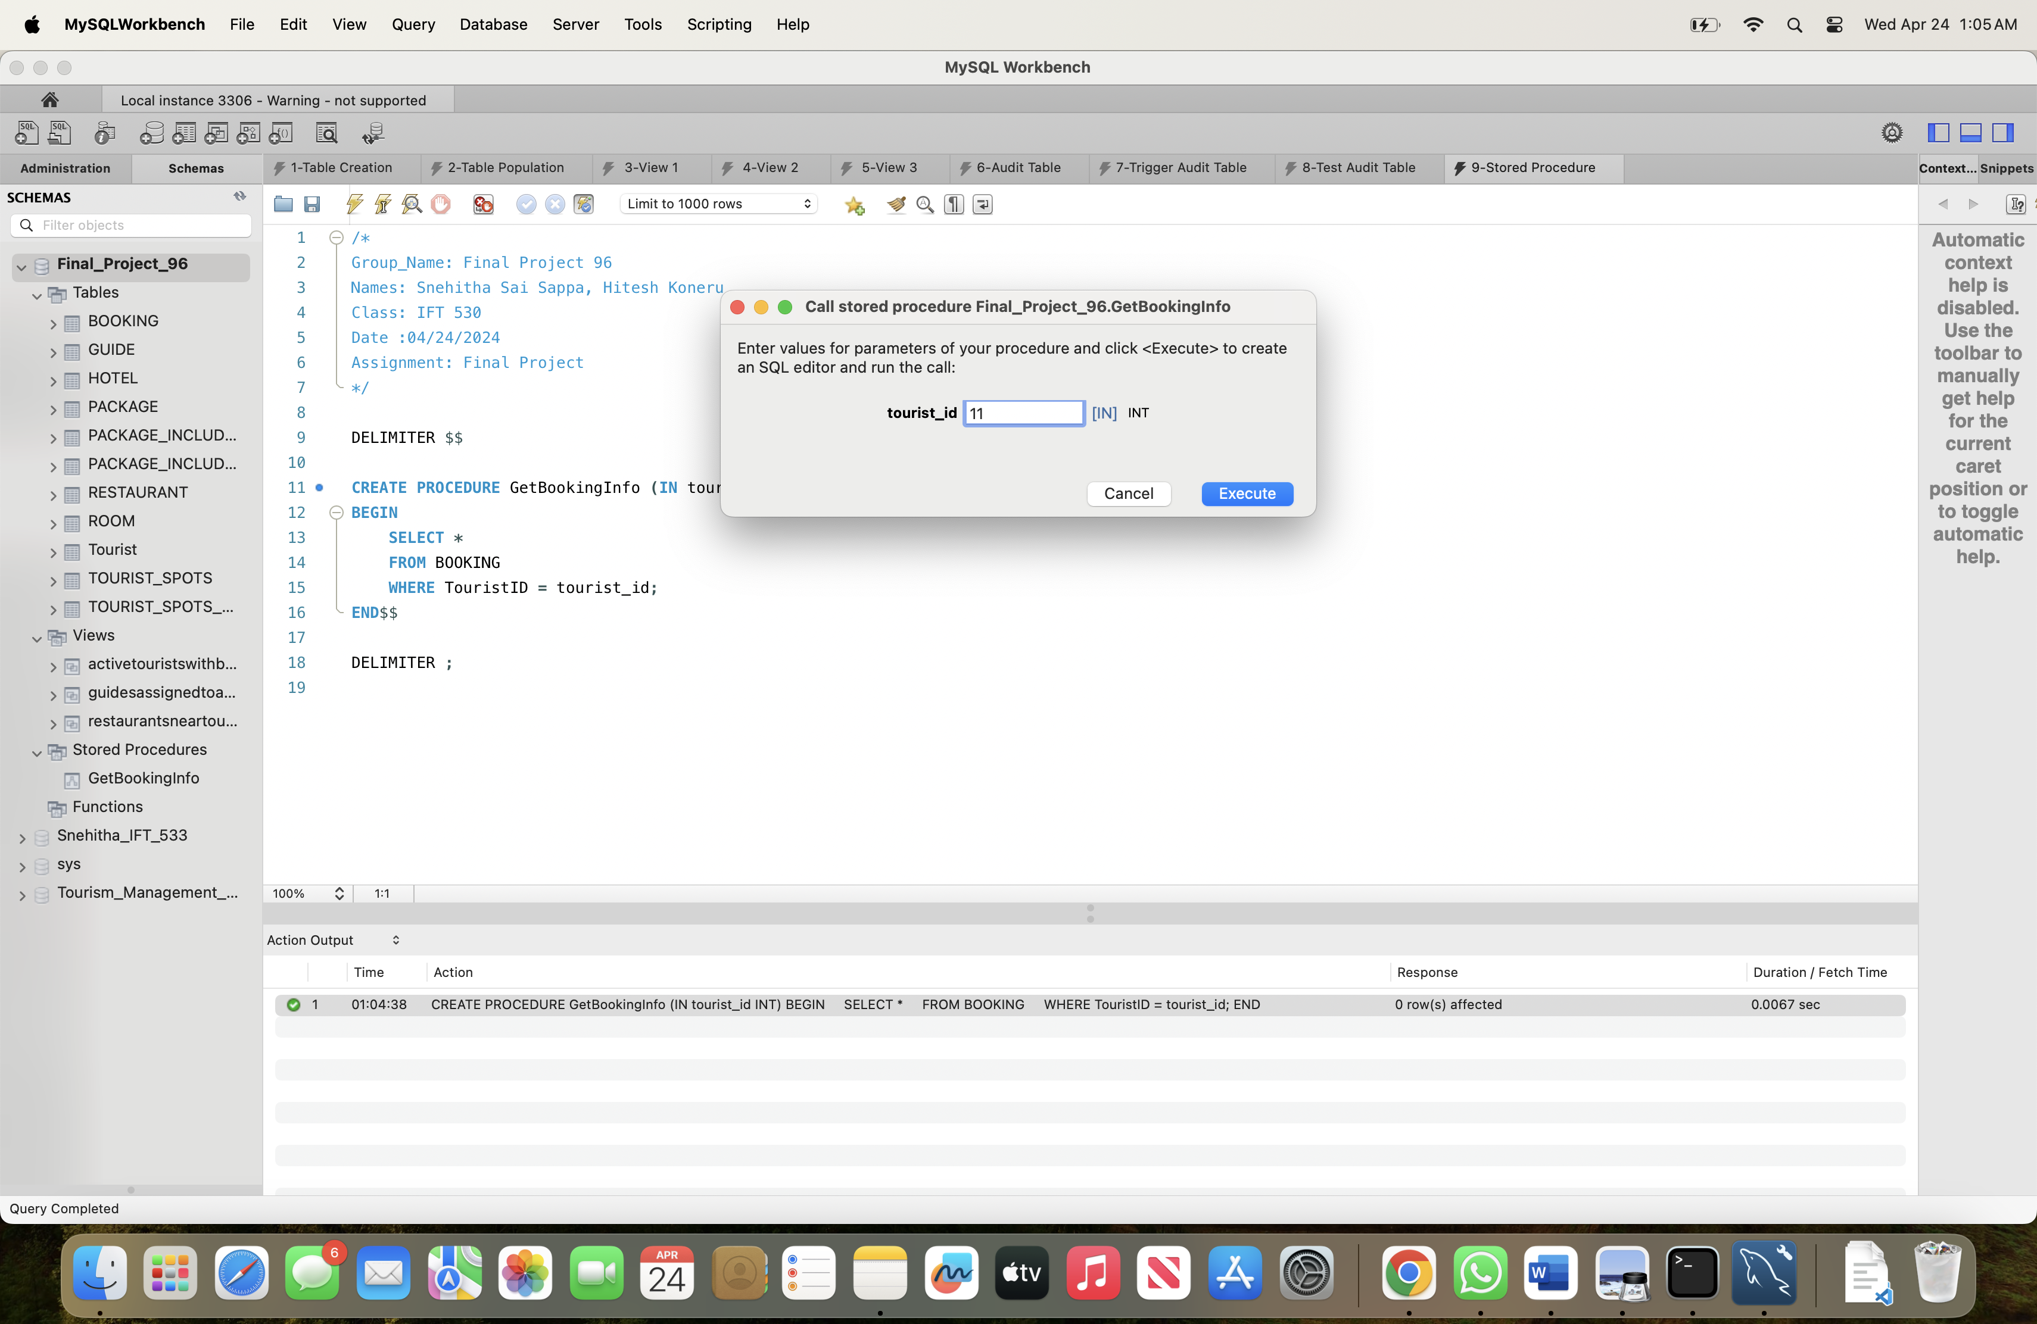

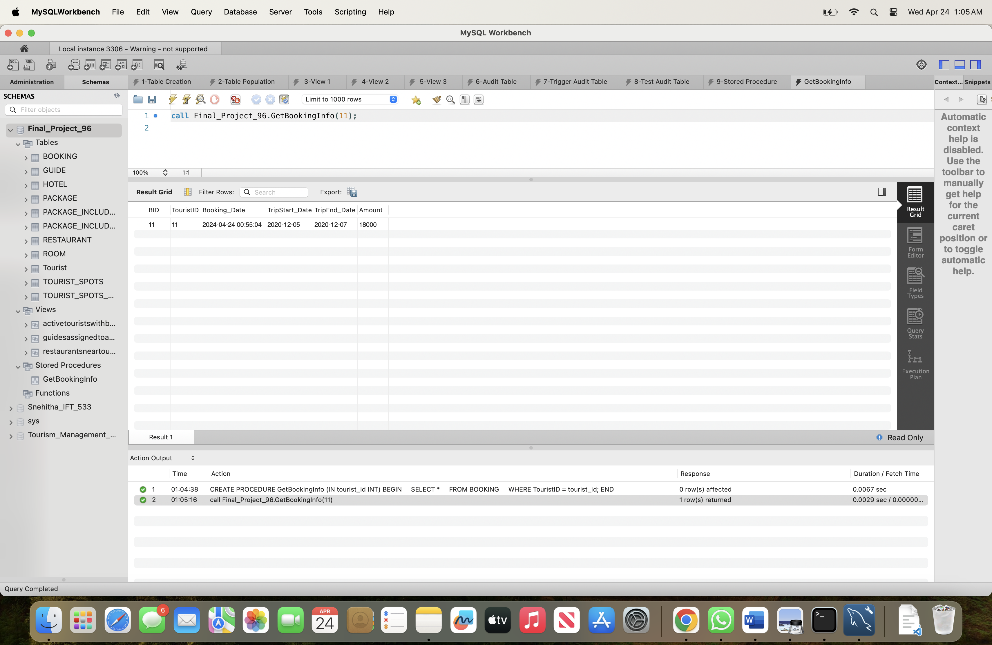

**Creating User Defined Function (UDF):**

/*

Group_Name: Final Project 96

Names: Snehitha Sai Sappa, Hitesh Koneru

Class: IFT 530

Date :04/24/2024

Assignment: Final Project

*/

DELIMITER //

CREATE FUNCTION CalculateAge (BirthDate DATE)

RETURNS INT

DETERMINISTIC

BEGIN

DECLARE Age INT;

SET Age = YEAR(CURRENT_DATE()) - YEAR(BirthDate);

IF MONTH(BirthDate) > MONTH(CURRENT_DATE()) OR (MONTH(BirthDate) = MONTH(CURRENT_DATE()) AND DAY(BirthDate) > DAY(CURRENT_DATE())) THEN

SET Age = Age - 1;

END IF;

RETURN Age;

END//

DELIMITER ;

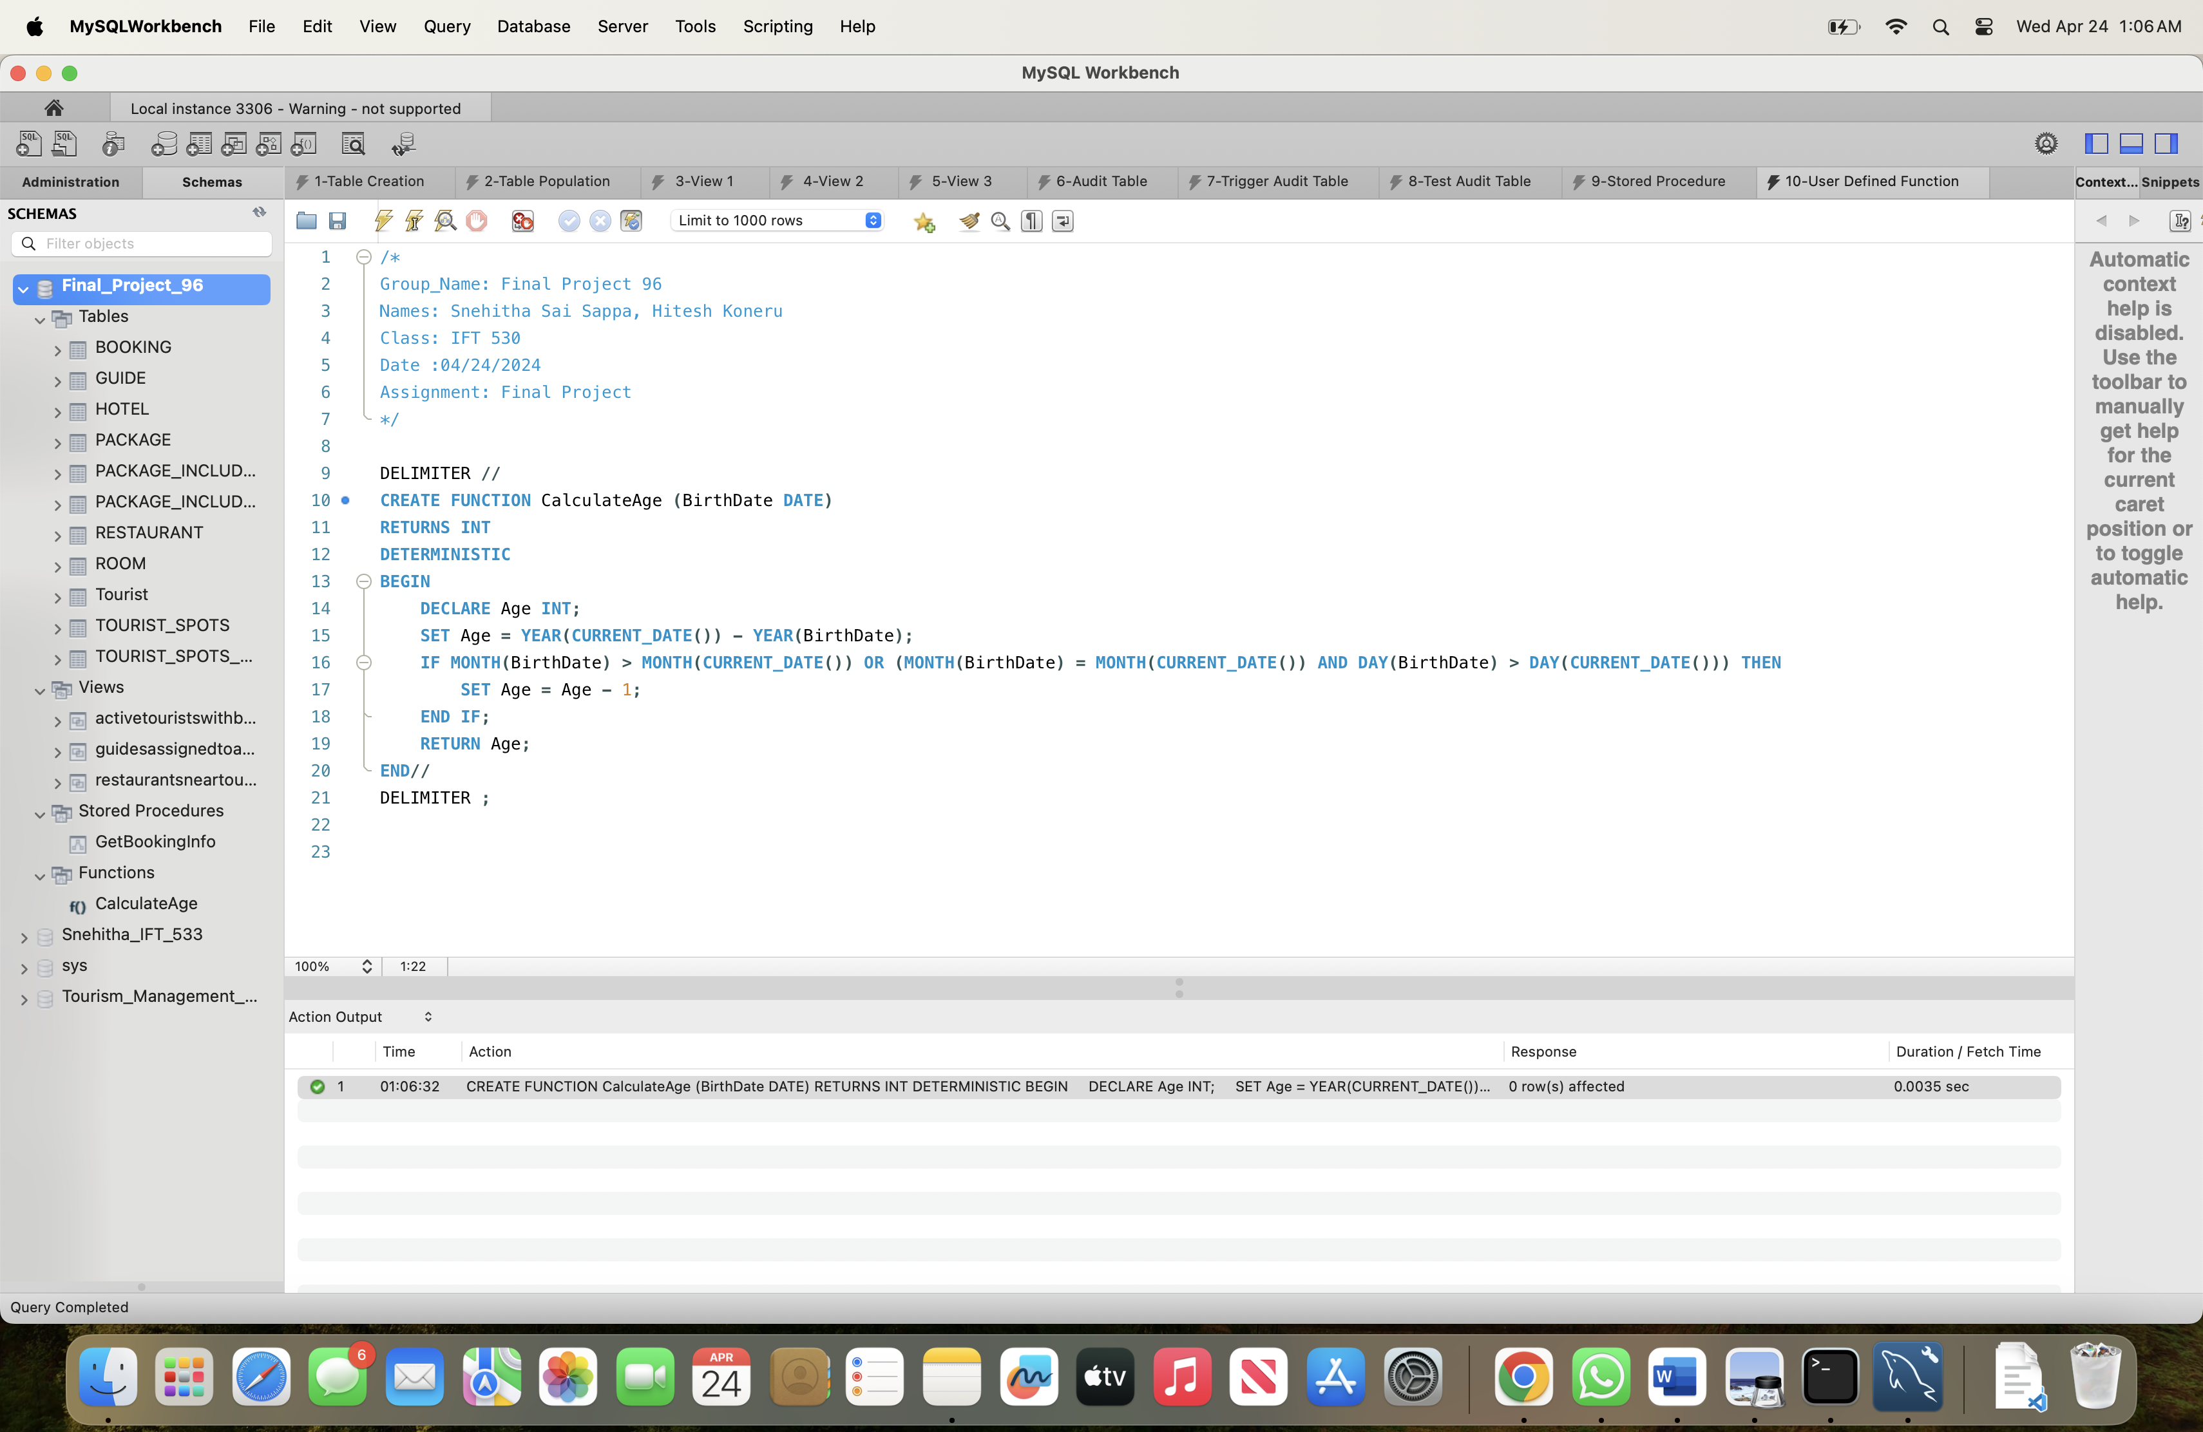

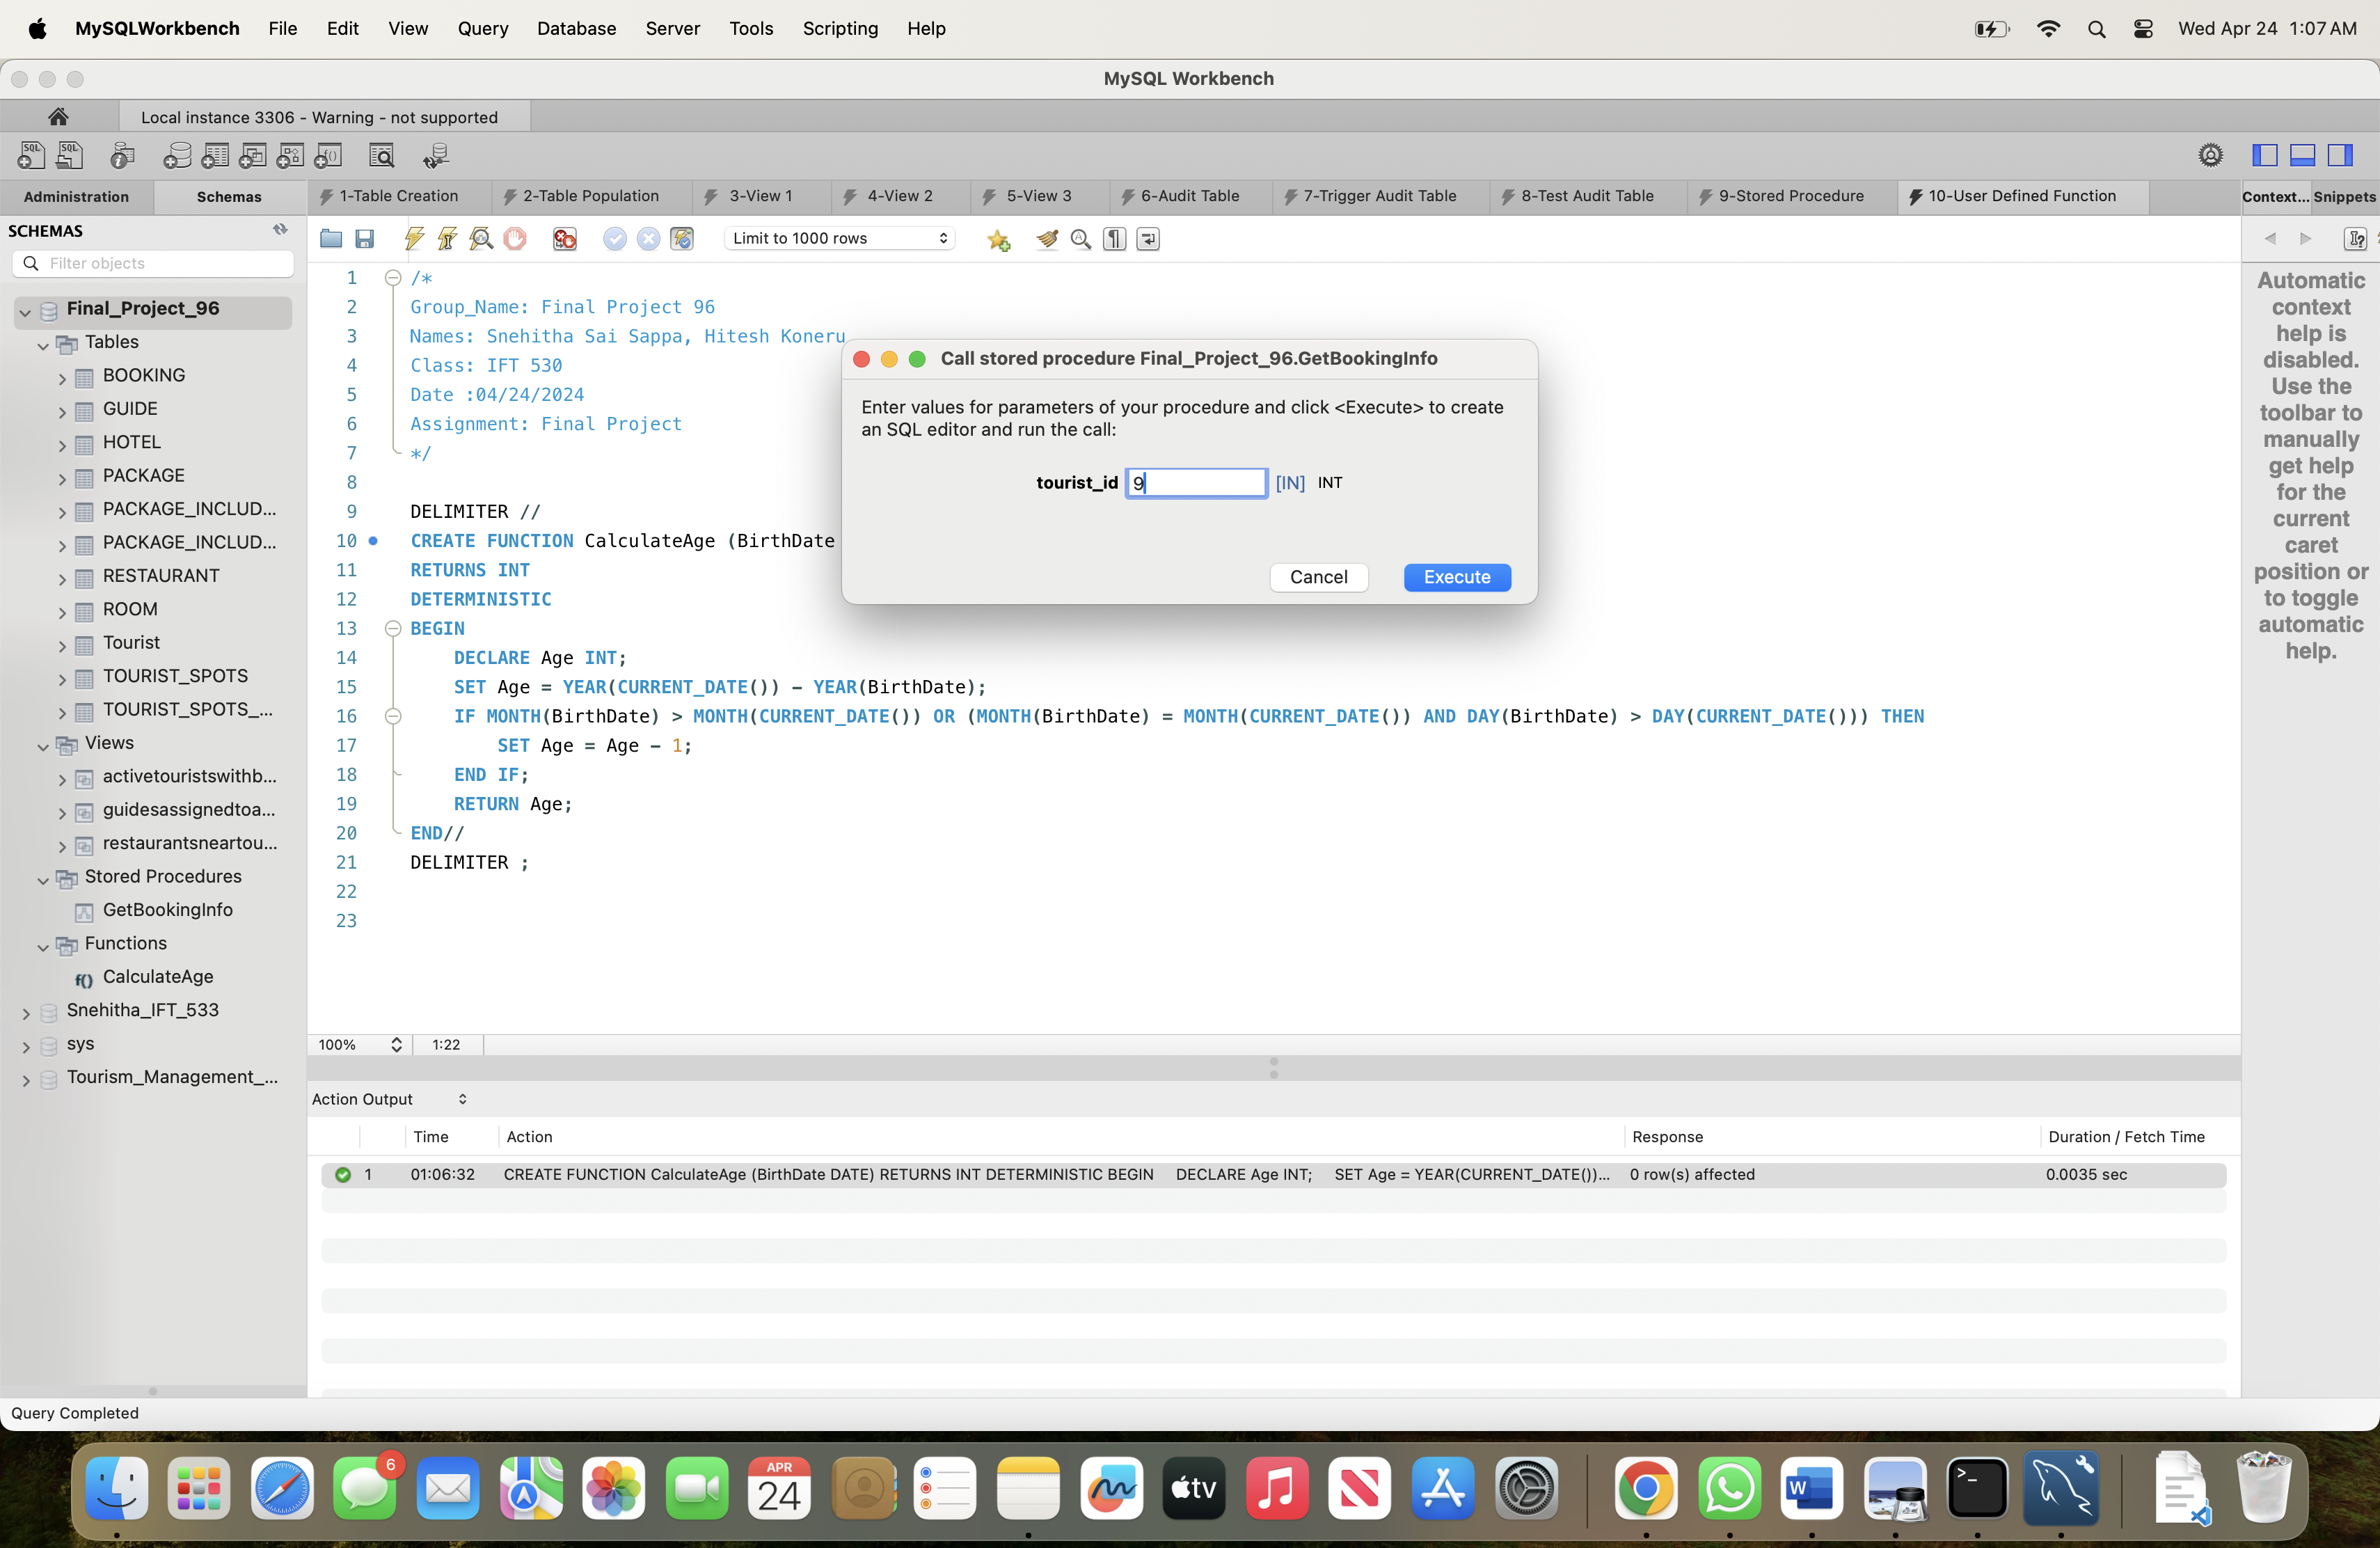

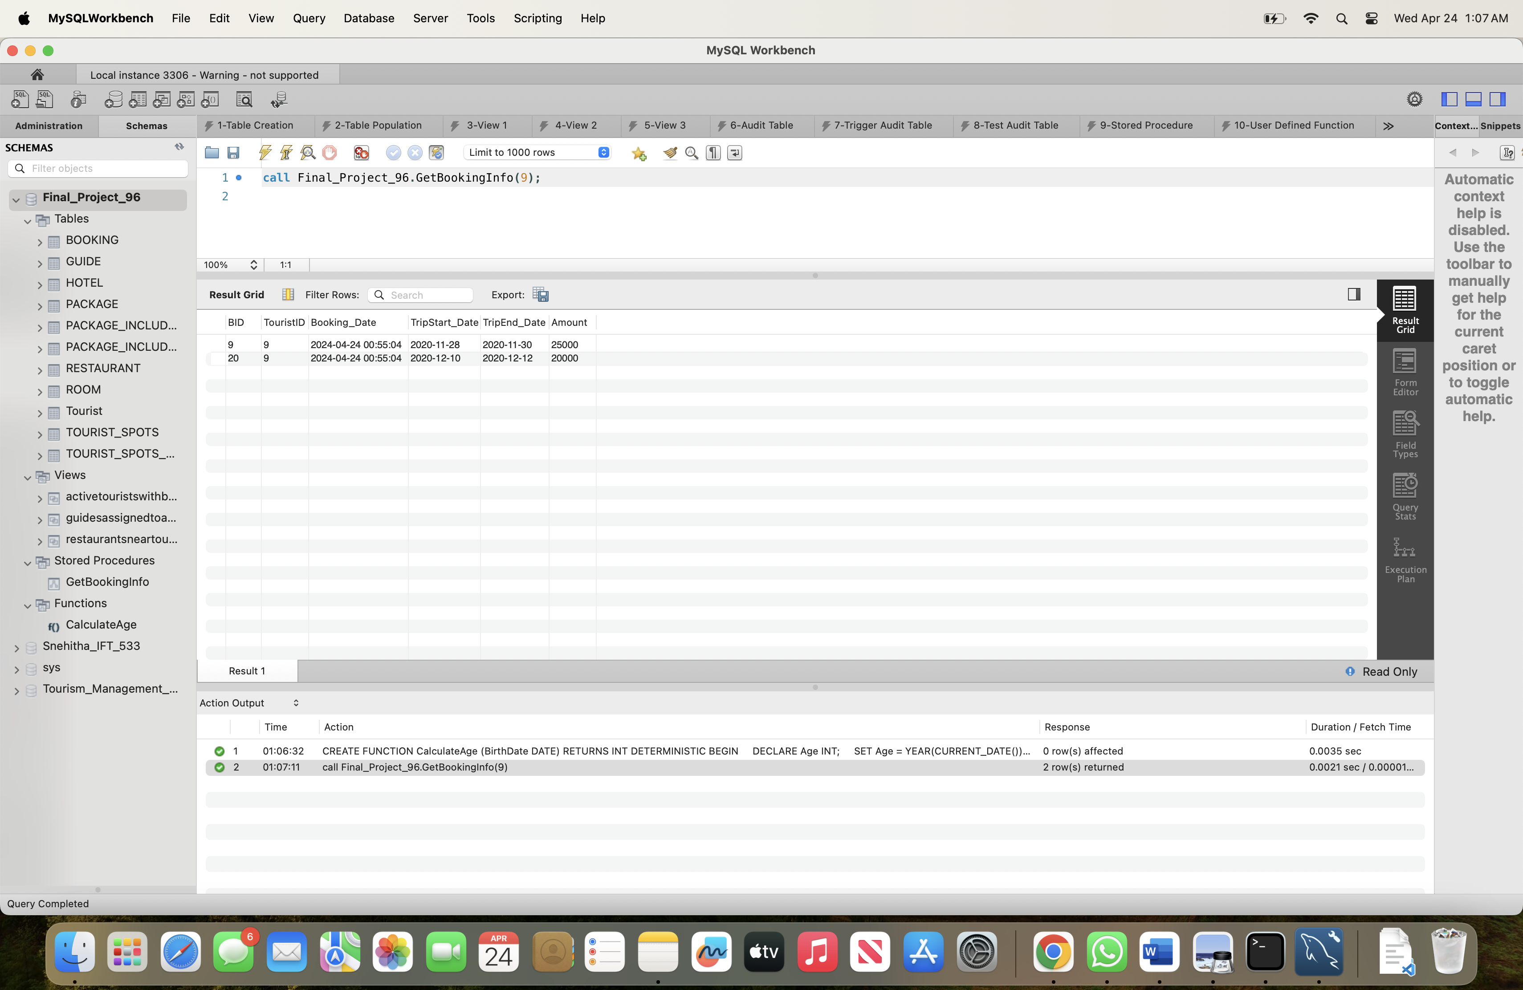

**Dropping the Stored Procedure and User Defined Function:**

/*

Group_Name: Final Project 96

Names: Snehitha Sai Sappa, Hitesh Koneru

Class: IFT 530

Date :04/24/2024

Assignment: Final Project

*/

-- Dropping Stored Procedure: GetBookingInfo

DROP PROCEDURE IF EXISTS GetBookingInfo;

-- Dropping User Defined Function (UDF): CalculateAge

DROP FUNCTION IF EXISTS CalculateAge;

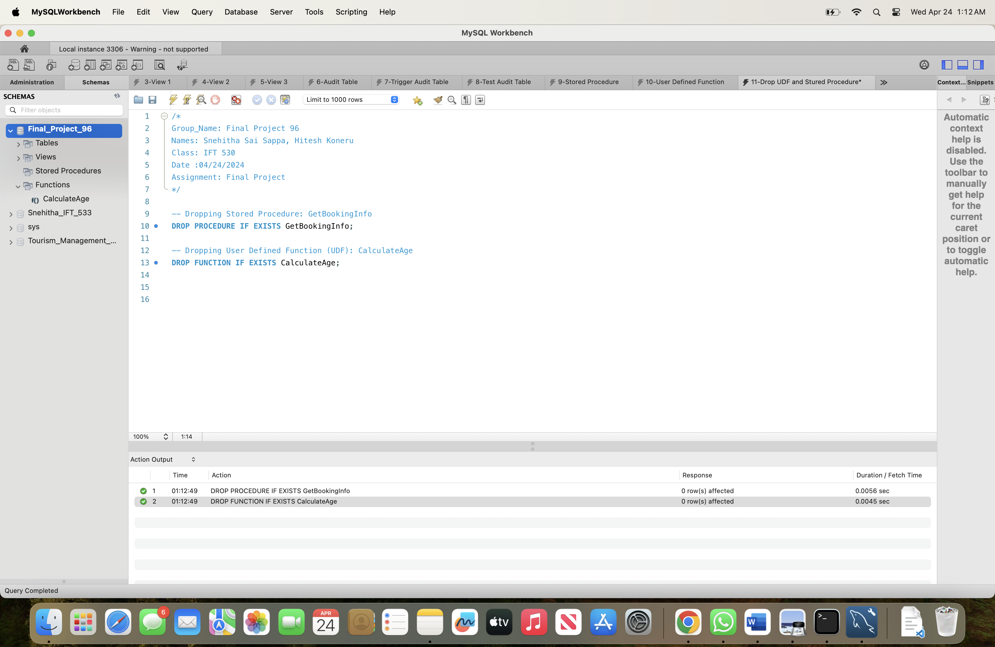



**Use of Cursor in Tourism Management System:** The key uses of GetTouristBookingDetails` cursor in the Tourism Management System database are:

1. The cursor procedure takes a `p_TouristID` parameter of type `INT`, which is the ID of the tourist whose booking details we want to retrieve.

2. It declares the variables to hold the fetched data: `v_BID` (booking ID), `v_BookingDate` (booking date), `v_TripStartDate` (trip start date), `v_TripEndDate` (trip end date), and `v_Amount` (booking amount).

3. It declares a cursor named `booking_cursor` that selects the booking data from the `BOOKING` table where the `TouristID` matches the `p_TouristID` parameter.

4. It declares a `CONTINUE HANDLER` to set the `done` variable to `TRUE` when the cursor reaches the end of the result set.

5. It opens the `booking_cursor` and enters a `booking_loop` loop to fetch the data row by row.

6. For each row fetched, it displays the booking details using a `SELECT` statement.

7. After the loop, it closes the `booking_cursor`.

When we call the `GetTouristBookingDetails` procedure with a tourist ID, it will execute the cursor and display the booking details for that tourist. This can be useful for retrieving and displaying the booking information for a specific tourist in Tourism Management System application.

**Create Cursor:**

/*

Group_Name: Final Project 96

Names: Snehitha Sai Sappa, Hitesh Koneru

Class: IFT 530

Date :04/24/2024

Assignment: Final Project

*/

-- Create Cursor Script

DELIMITER //

CREATE PROCEDURE GetTouristBookingDetails(IN p_TouristID INT)

BEGIN

DECLARE v_BID INT;

DECLARE v_BookingDate TIMESTAMP;

DECLARE v_TripStartDate DATE;

DECLARE v_TripEndDate DATE;

DECLARE v_Amount FLOAT;

DECLARE done INT DEFAULT FALSE;

DECLARE booking_cursor CURSOR FOR

SELECT BID, Booking_Date, TripStart_Date, TripEnd_Date, Amount

FROM BOOKING

WHERE TouristID = p_TouristID;

DECLARE CONTINUE HANDLER FOR NOT FOUND SET done = TRUE;

OPEN booking_cursor;

booking_loop: LOOP

FETCH booking_cursor INTO v_BID, v_BookingDate, v_TripStartDate, v_TripEndDate, v_Amount;

IF done THEN

LEAVE booking_loop;

END IF;

SELECT

v_BID AS 'Booking ID',

v_BookingDate AS 'Booking Date',

v_TripStartDate AS 'Trip Start Date',

v_TripEndDate AS 'Trip End Date',

v_Amount AS 'Amount';

END LOOP;

CLOSE booking_cursor;

END//

DELIMITER ;

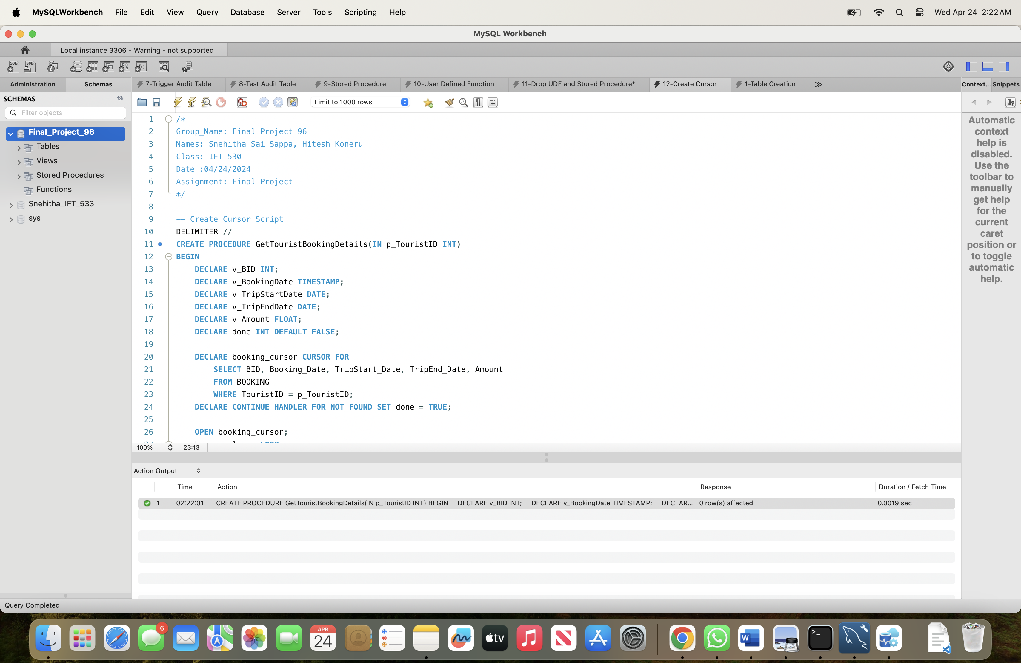

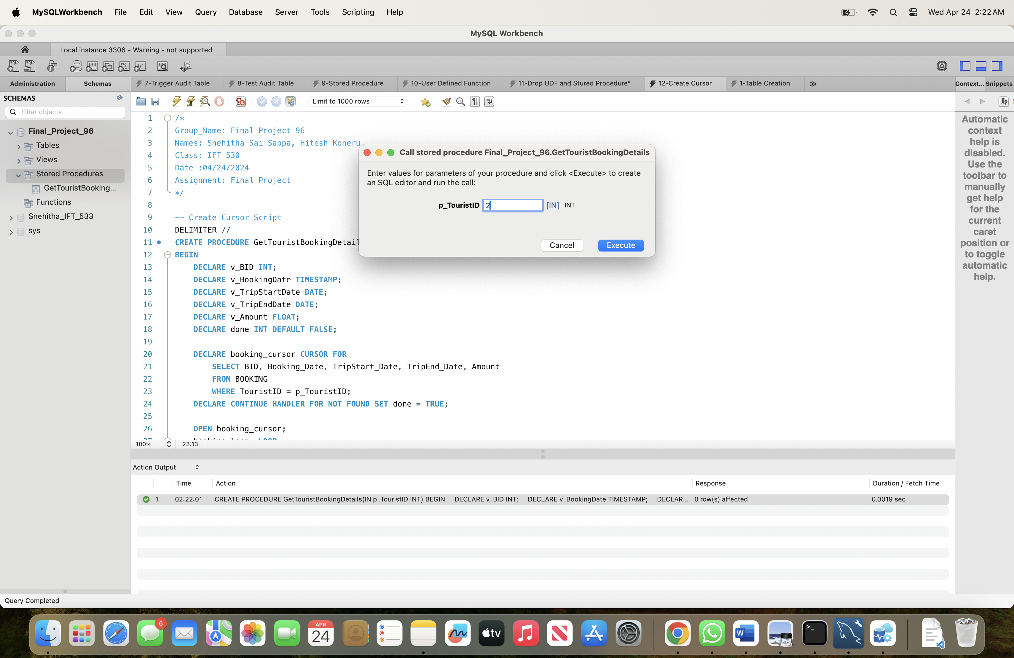

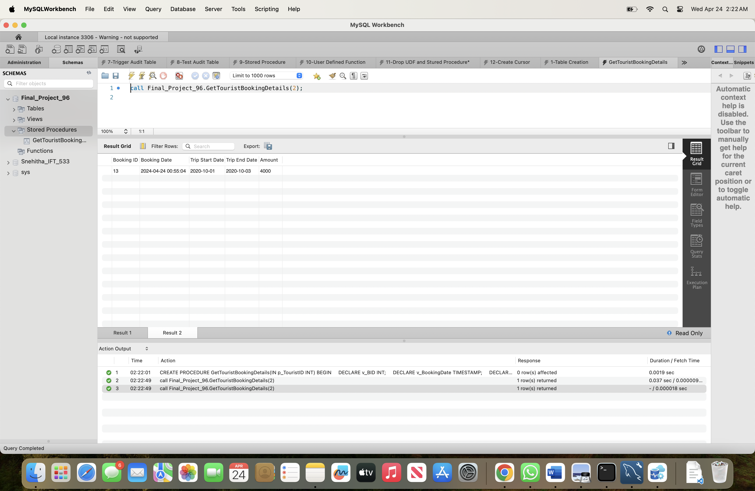

**Drop Cursor:**

/*

Group_Name: Final Project 96

Names: Snehitha Sai Sappa, Hitesh Koneru

Class: IFT 530

Date :04/24/2024

Assignment: Final Project

*/

DROP PROCEDURE GetTouristBookingDetails;

